### Info

May will update this in future you can check [here](https://docs.google.com/document/d/1n1nGljHSqtT0ggLKQivIvR39islQ8wN80_s1tpmBbhU/edit?usp=sharing)

### 

### Package

A package is an **independent unit** inside your application.

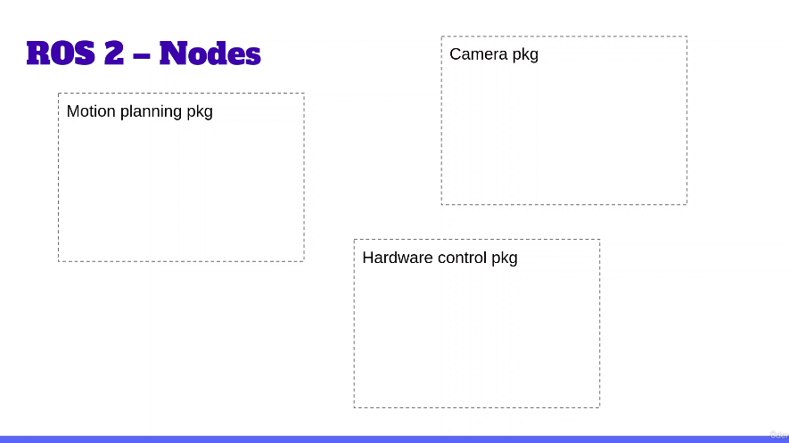

### Node

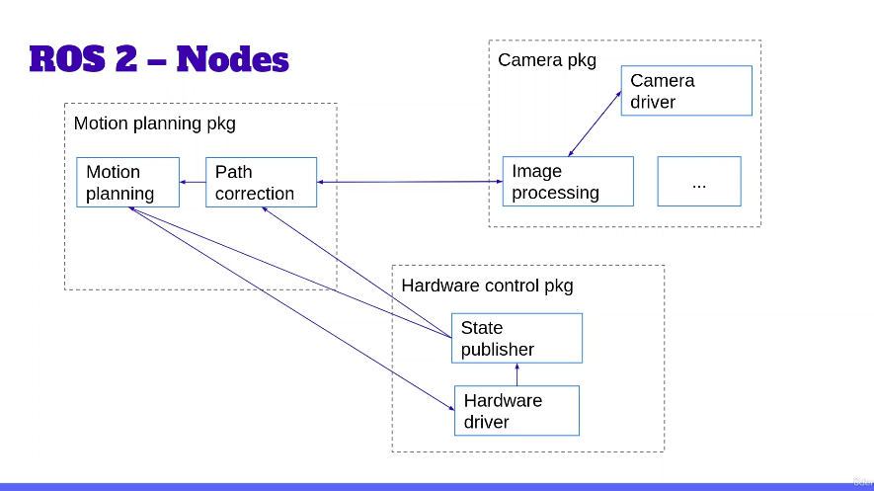

### 

### 1 Create Wokspace

mkdir ws_name

mkdir -p ws_name/src

### 2 Colcon Build (in ws)

* colcon build (Colocn is a build tool)
* colcon build --packages-select my_py_pkg
* colcon build --symlink-install (*ussing symbolic links)*

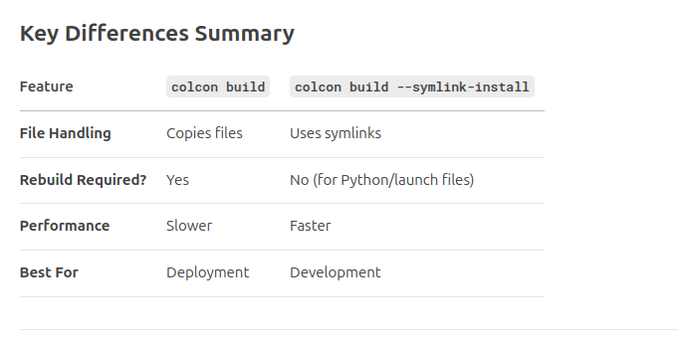

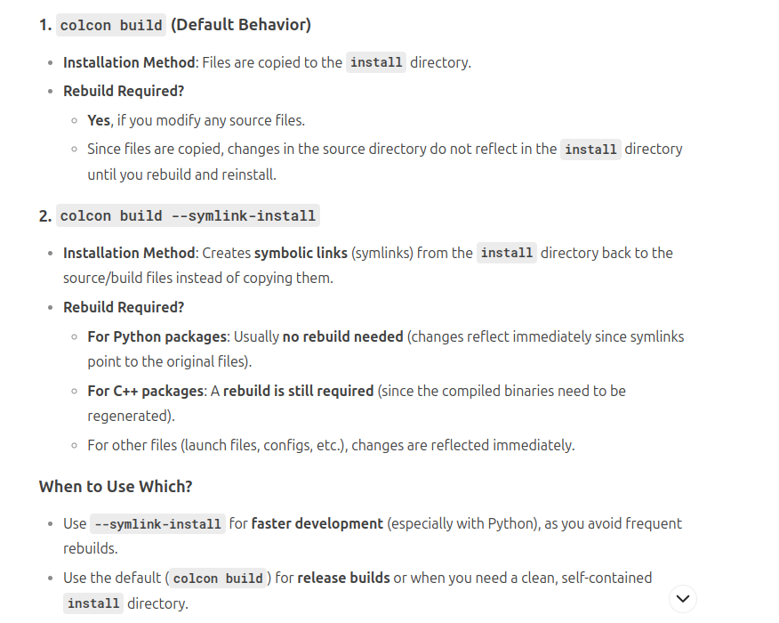

### 3 Accidentally build somewhere else

*in the same directory*

*rm -r build/ install/ log/ is (move directories and their contents* ***recursively)***

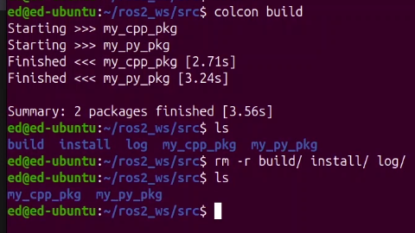

### 4 Source

*from ws*

source install/setup.bash

#### Global Source

gedit .bahrc (*if from home directory)*

gedit ~/.bahrc (*other than home directory)*

source ~/ros2_ws/install/setup.bash

### 5 Create python Package

*go to ws/src*

ros2 pkg create package_name --build-type ament_python --dependencies rclpy  
  
*\*ament is a build system*

*\*dependencies is a libraries on which my package is depending*

#### Open VS Code (Recommended)

*open from source (src) folder , because if open from different folder VS code may can’t track the changes of your system*

code.

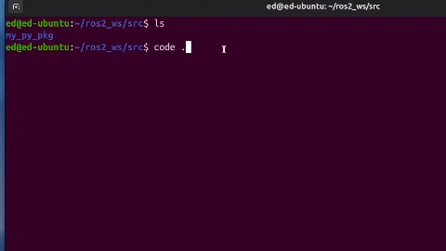

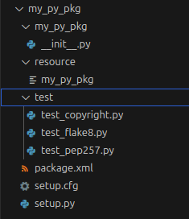

### 

#### package.xml

* Dependencies I have added
* Licence related to open source publication
* manifest.xml is equivalent in ROS1

### 6 Create C++ package

*go to ws/src*

ros2 pkg create package_name --build-type ament_cmake --dependencies rclcpp

#### CmakeLists.txt

set of build rules

#### package.xml

* dependencies I have added
* Licence related to open source publication

### 7 python node

cd ros2_ws/src/my_py_pkg

cd my_py_pkg

ls (*see –init–.py)*

touch my_first_node.py

*from src folder*

code .

*Make installed ROS extension*

*first write main function*

*python file completely not a node,node actually inside the python file*

#### Minimal code

#!/usr/bin/env python3 >>>>>>to set the interpreter as python3

import rclpy

from rclpy.node import Node

def main(args=None):

rclpy.init(args=args)

node = Node("py_test")

rclpy.shutdown()

if __name__ == "__main__":

main()

#### Adding Hello world

#!/usr/bin/env python3

import rclpy

from rclpy.node import Node

def main(args=None):

rclpy.init(args=args)

node = Node("py_test")

node.get_logger().info("Hello World")

rclpy.shutdown()

if __name__ == "__main__": #to run from terminal w/o calling main function

main()

*to make it as executable*

*got to node python file*

chmod +x my_first_node.py (change mode - chmod, to make it as a executable - +x, by user group or other)

*to run*

./my_first_node.py

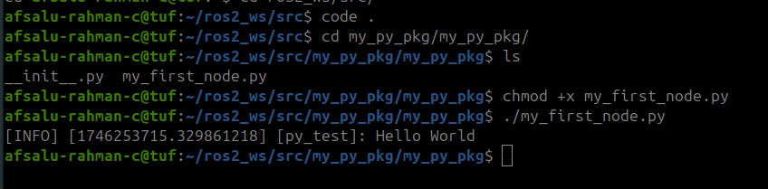

#### to keep it alive

*add*

rclpy.spin(node) *(until press ctrl+c)*

#### 

#### Install node

*go to setup.py*

*in console_scripts*

*before*

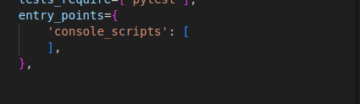

*after*

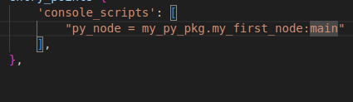

*to add more executable put comma(,) and i doble quote write executable (“”)*

*note:* ***py_node*** *is the executable*

*so after installation it can run from anywhere*

***colcon build and source***

##### run

eg; go to home directory

run



**executable:** py_node (while installing) used for running

**node name :** py_test

**file name :** my_first_node.py

source ~/.bashrc

ros2 run my_py_pkg py_node

**NOTE:Actually we can create multiple node within the same file but it is not recommended it is better to create separate files for each nodes**

#### Multiple Nodes

[**Multiple nodes in a s single file**](https://docs.google.com/document/d/1Ar0d8lBqVz5mY6BJn4kQNWmAyF0NI4d_aWWdBvw5uyc/edit?usp=sharing)

#### Publisher and Subscriber - My own

P[ublisher and Subscriber - My own](https://docs.google.com/document/d/131UT_WrHFbqSTghY0ANlcoUex3Zs2dhg0l6VXfLgWbU/edit?usp=sharing)

### 

### 8 with OPP

#### simple code template

#!/usr/bin/env python3

import rclpy

from rclpy.node import Node

class MyNode(Node):#inherit Node class

def __init__(self): #constructor

super().__init__("py_test")

self.get_logger().info("Hello World")

def main(args=None):

rclpy.init(args=args)

node = MyNode()

rclpy.spin(node)

rclpy.shutdown()

if __name__ == "__main__":

main()

#### Added timer function

#!/usr/bin/env python3

import rclpy

from rclpy.node import Node

class MyNode(Node):#inherit Node class

def __init__(self): #constructor

super().__init__("py_test")

self.get_logger().info("Hello World")

self.create_timer(0.5,self.timerCallback)#every 0.5 second hust give the mame of function, not call function

def timerCallback(self):

self.get_logger().info("Hi")

def main(args=None):

rclpy.init(args=args)

node = MyNode()

rclpy.spin(node)

rclpy.shutdown()

if __name__ == "__main__":

main()

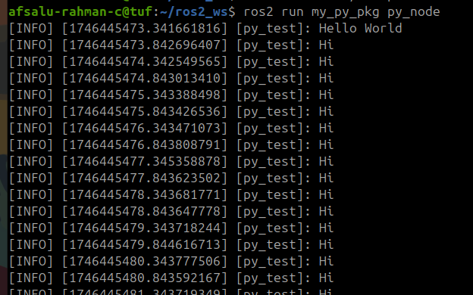

#### Adding counter

#!/usr/bin/env python3

import rclpy

from rclpy.node import Node

class MyNode(Node):#inherit Node class

def __init__(self): #constructor

super().__init__("py_test")

self.counter_ = 0

self.get_logger().info("Hello World")

self.create_timer(0.5,self.timerCallback)#every 0.5 second hust give the mame of function, not call function

def timerCallback(self):

self.get_logger().info("Hi" + str(self.counter_))

self.counter_ += 1

def main(args=None):

rclpy.init(args=args)

node = MyNode()

rclpy.spin(node)

rclpy.shutdown()

if __name__ == "__main__":

main()

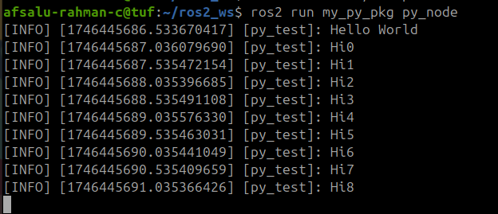

### 9 C++ Node

***Note****: Directory structure of cpp is different compared to python*

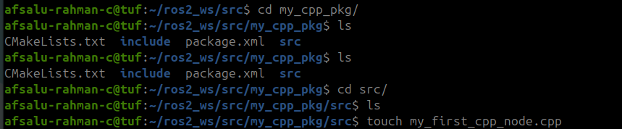

*open VS CODE*

code .

#### Minimal code

#include "rclcpp/rclcpp.hpp"

int main(int argc, char **argv){

rclcpp::init(argc, argv);

//your code here

rclcpp::shutdown();

return 0;

}

#### Adding hello world

#include "rclcpp/rclcpp.hpp"

int main(int argc, char **argv){

rclcpp::init(argc, argv);

auto node = std::make_shared<rclcpp::Node>("cpp_test");//creating a (smart pointer/ share pointer) for node

/* above line is equivalent to rclpy.Node (but C++ requires explicit memory management)

auto node >> automatically deduce the variable type

std:: >> standard C++ namespace

make_shared >> create an object and return a shared pointer to it

<rclcpp::Node()> >> specifying what type argument need to create

std::make_shared< >() >> Dynamically allocate memory for the node and create a **smart pointer** to it

*/

RCLCPP_INFO(node->get_logger(), "Hello World, Hi");

/*RCLCPP_INFO is a logging macro provided by ROS 2's Client Library for C++ (RCLCPP). It is used to print informational messages to the console and log files with the INFO severity level.

*/

rclcpp::shutdown();

return 0;

}

#### argc and argv

these are the command line arguments

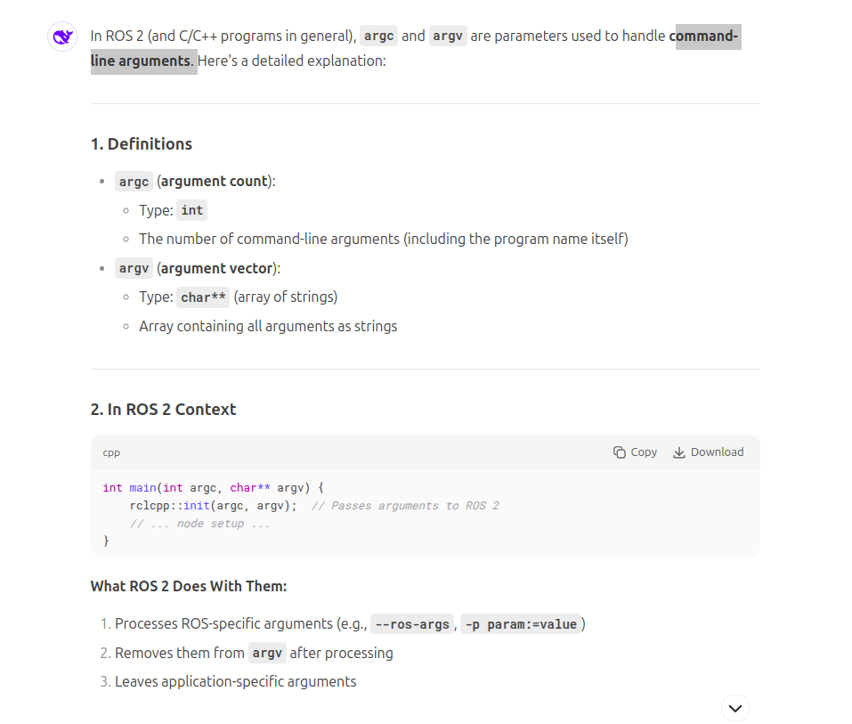

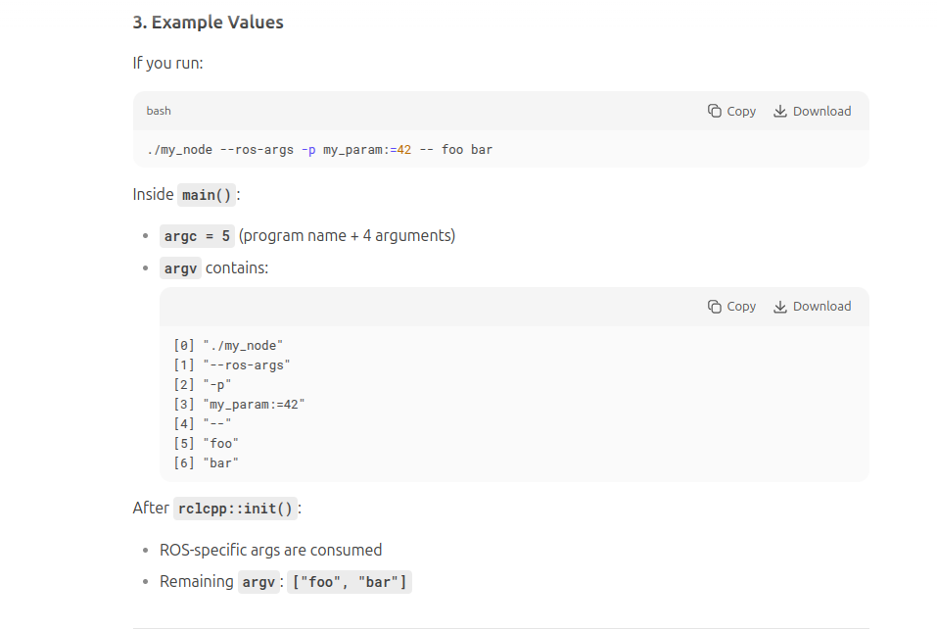

#### char **argv

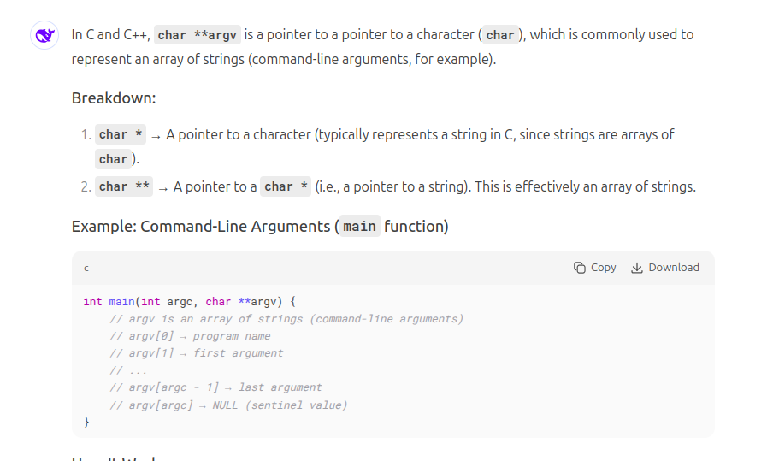

#### clean up in CmakeLists.txt

*remove from CmakeLists.txt*

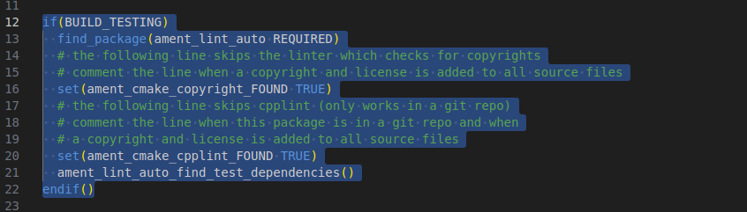

##### adding executable

add_executable(cpp_node src/my_first_node.cpp)

ament_target_dependencies(cpp_node rclcpp)

*Note:*

1. ***If I want to add other executable I should duplicate the above two line for new node***

##### adding install block

*Nore:*

1. *Only need to write one-time*
2. *not make any typo here*
3. *Install somewhere in the install folder*
4. *i****f you want to add other node add it in new line below cpp_node***

1. *install(TARGETS*
2. *cpp_node*
3. *DESTINATION lib/${PROJECT_NAME}*
4. *)*

**colcon build and source**

colcon build --packages-select my_cpp_pkg

*I get en error because of file name error*

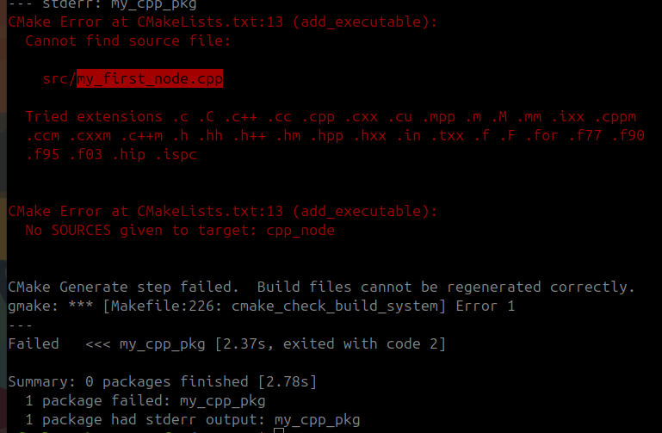

**Source**

source install/setup.bash

##### run

*NOTE: it is not possible to run cpp file from terminal as like python after making executable, because the cpp file must need to compile first*

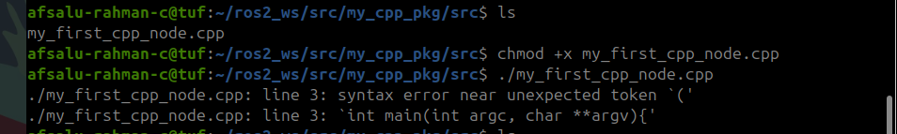

*running installed node*

ros2 run my_cpp_pkg cpp_node



*NOTE:*

*executable : cpp_node*

*file name : my_first_node.cpp*

*node_name : cpp_test*

### 10 With OOP

#### simple template

#include "rclcpp/rclcpp.hpp"

class MyNode : public rclcpp::Node /* MyNode is the derived class, inherited from rclcpp::Node */

{

public:

MyNode() : Node("cpp_test") //constructor

{

}

private:

}; //don't forget '}'

int main(int argc, char **argv){

rclcpp::init(argc, argv);

auto node = std::make_shared<MyNode>(); /*A shared pointer (std::shared_ptr in C++) is a smart pointer that manages the lifetime of a dynamically allocated object using reference counting. */

rclcpp::spin(node);

rclcpp::shutdown();

return 0;

}

#### With timer and counter

#include "rclcpp/rclcpp.hpp"

class MyNode : public rclcpp::Node

{

public:

MyNode() : Node("cpp_test"), counter_(0)

{

RCLCPP_INFO(this->get_logger(), "Hello World"); /* ‘this’ keyword ot mandatory but is is conventional inside the class */

timer_ = this->create_wall_timer(std::chrono::seconds(1),

std::bind(&MyNode::timerCallback, this)); /* register timerCallback with wall timer, wall timer is a real world timer not a simulation or CPU time*/

}

private:

void timerCallback()

{

RCLCPP_INFO(this->get_logger(), "Hi %d",counter_);

counter_ ++;

}

rclcpp::TimerBase::SharedPtr timer_;// TimerBase is the **base class** for all timers in ROS 2 C++.

int counter_;

}; //don't forget '}'

int main(int argc, char **argv){

rclcpp::init(argc, argv);

auto node = std::make_shared<MyNode>(); // Create an instance of MyNode

rclcpp::spin(node);

rclcpp::shutdown();

return 0;

}

### 11 OOP TEMPLATES

#### PYTHON

* #!/usr/bin/env python3
* import rclpy
* from rclpy.node import Node

* class MyCustomNode(Node): # MODIFY NAME
* def __init__(self):
* super().__init__("node_name") # MODIFY NAME

* def main(args=None):
* rclpy.init(args=args)
* node = MyCustomNode() # MODIFY NAME
* rclpy.spin(node)
* rclpy.shutdown()

* if __name__ == "__main__":
* main()

#### C++

### 

* #include "rclcpp/rclcpp.hpp"
* class MyCustomNode : public rclcpp::Node // MODIFY NAME
* {
* public:
* MyCustomNode() : Node("node_name") // MODIFY NAME
* {
* }
* private:
* };
* int main(int argc, char **argv)
* {
* rclcpp::init(argc, argv);
* auto node = std::make_shared<MyCustomNode>(); // MODIFY NAME
* rclcpp::spin(node);
* rclcpp::shutdown();
* return 0;
* }

### 12 ROS2 LANGUAGE LIBRARIES

### 

rcl - ros client library (pure c library)

under rcl ros middleware contain DDS(Data Distributed Service) --Handle all communication

rcl - lowest ros2 client library, bridge with ros2 middleware

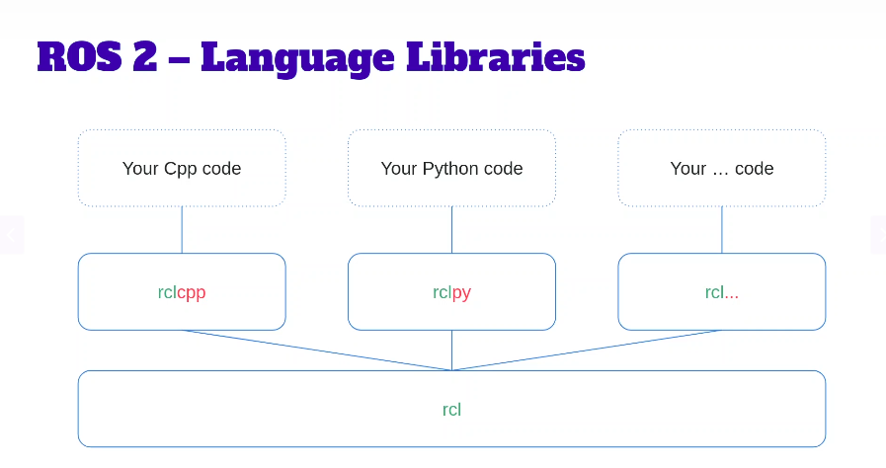base library same so core functionalities are same

not use directly ,use with rclcpp, rclpy

support other languages

rclnodejs, rcljava - but might not complete

# Section 4 – ROS2 Tools

### 4.1 Introspect your nodes with ros2 cli (Command Line Interface)

eg:

if error in autocomplete it is because likely due to improper source

ros2 run -h(to know or check the syntax or help )

* Note:in ROS everything in command line is considered to be with forward slash “/”

ros2 node list

ros2 node info /py_test (*give some more detailed explanation)*

ros2 node -h ( *if forget syntax )*

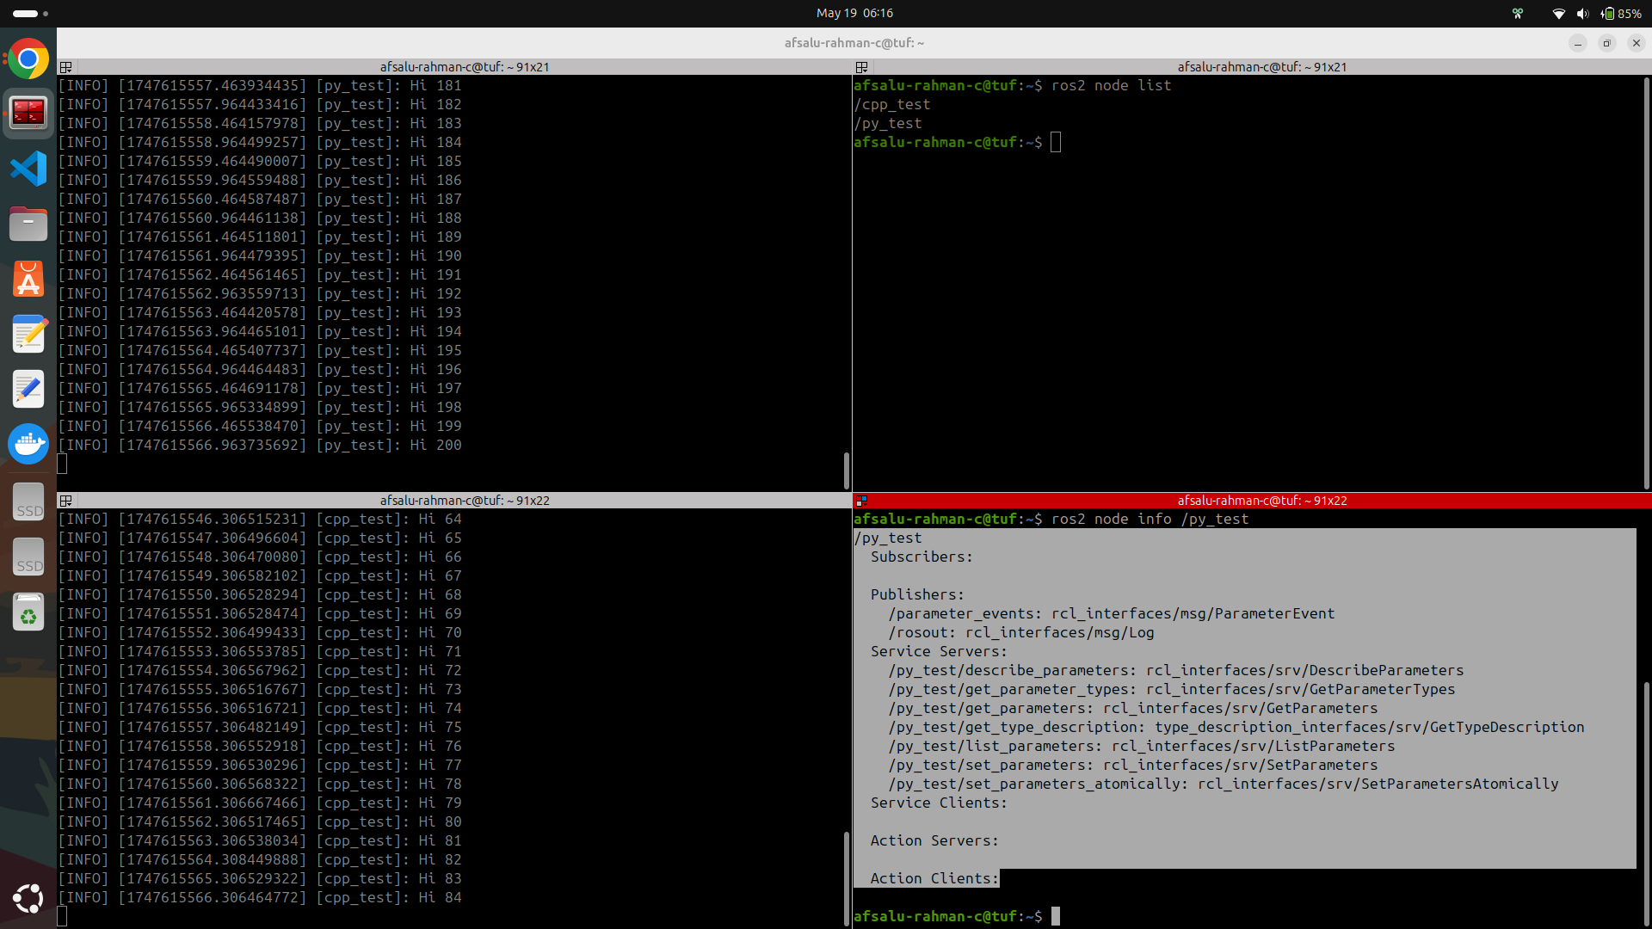

### 4.2 Rename a Node at Runtime

May need to run single node at multiple time concurrently, how can you do that without warning

*temporary naming*

ros2 run my_py_pkg py_node --ros-args -r __node:=abc (*double underscore)*

or

ros2 run my_py_pkg py_node --ros-args --remap __node:=abc

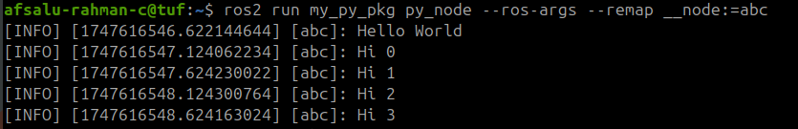

#### Example if multiple temperature sensor

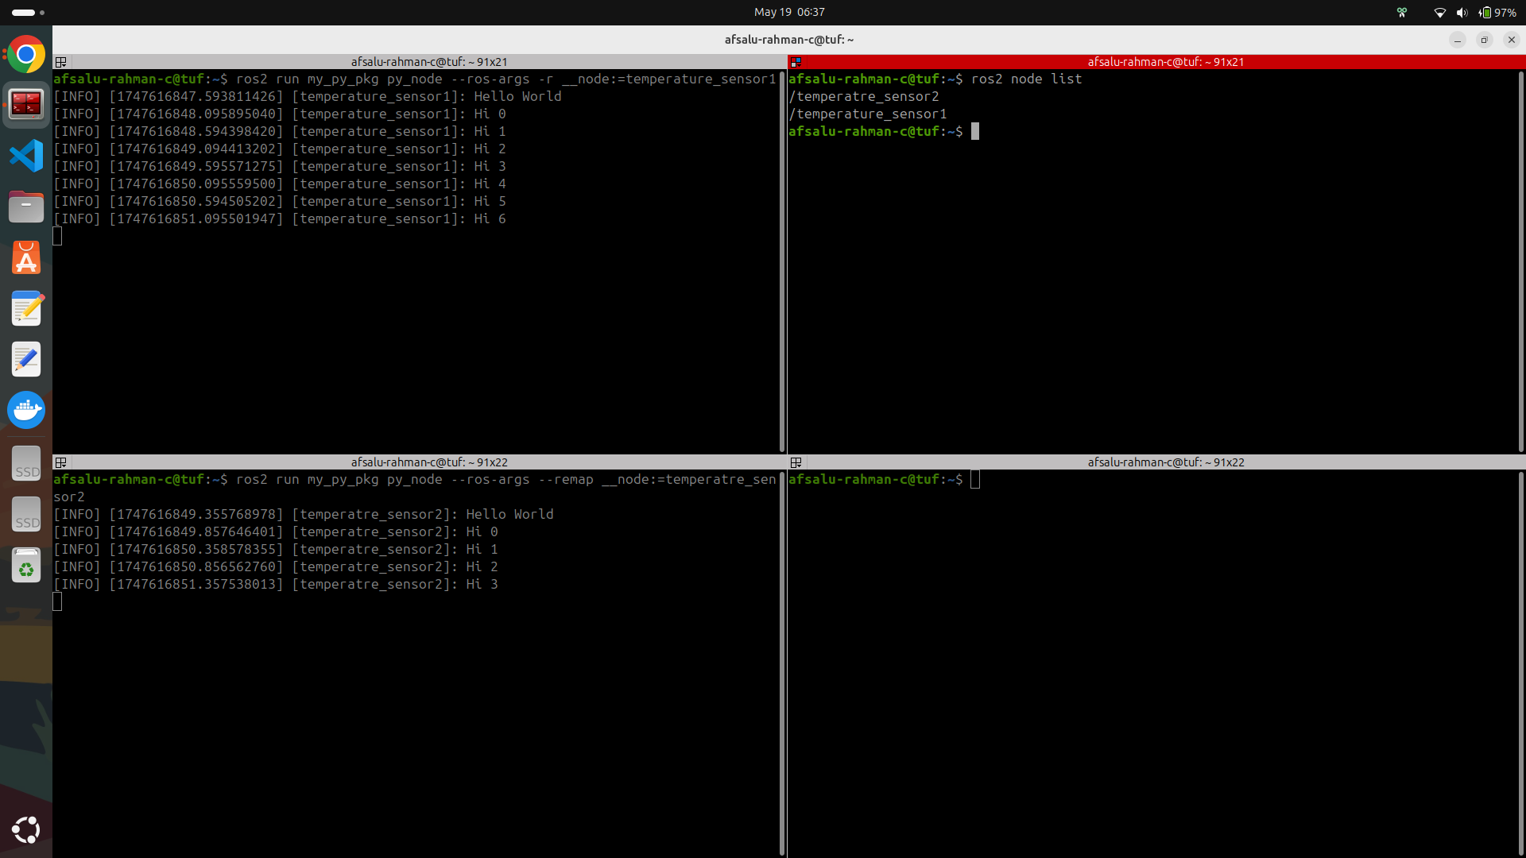

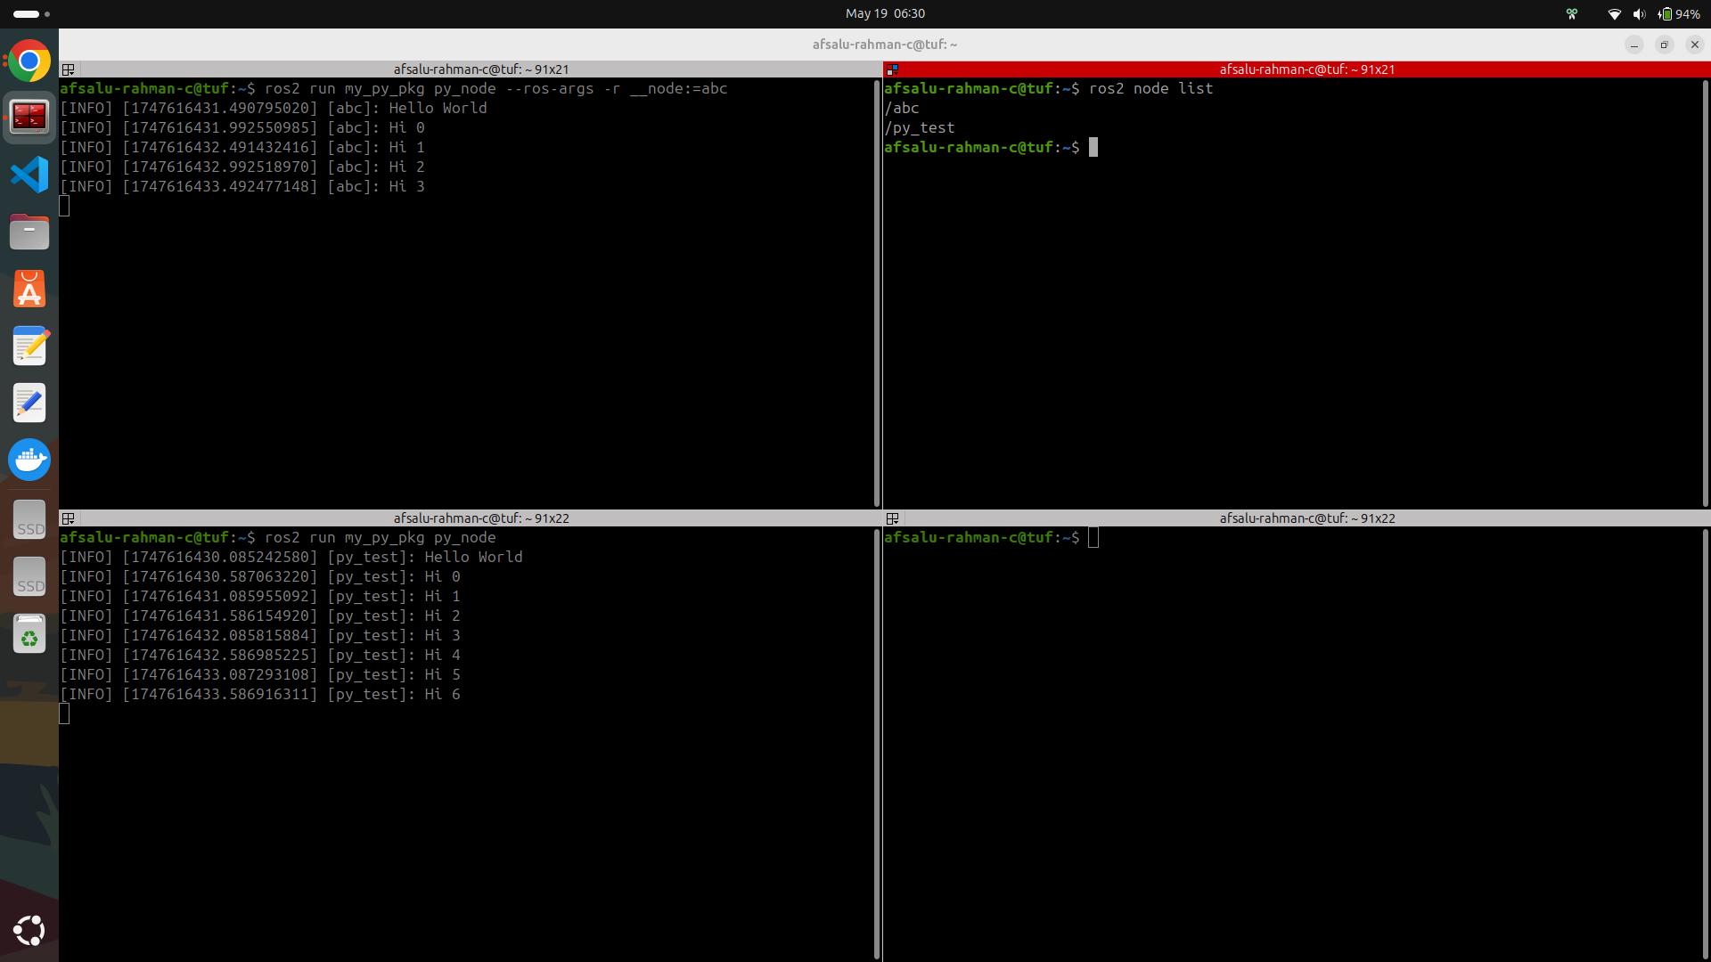

problem while running node with same name

# 

### 4.3 colcon

*we can build like*

colcon build

colcon build --packages-select my_py_pkg

#### For python files with symlink

*we can use symlink*

*NOTE:*

1. *It should be python package*
2. ***make sure that all files are executable*** *(chmod +x file names)*
3. *By this if edit code in src of python package able to run without build (useful in development stage)*
4. *WARNING : some times it may perform as not intended*

colcon build --packages-select my_py_pkg --symlink-install

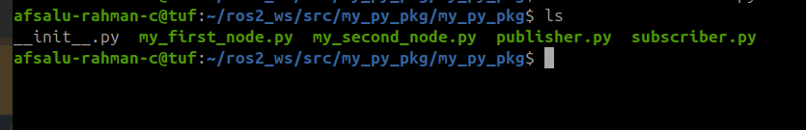

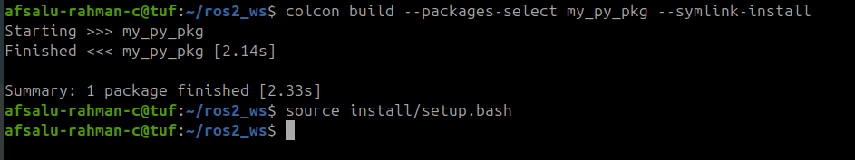

# 

### 4.4 rqt and rqt_graph

rqt is a **GUI framework that is able to load various plug-in tools as dockable windows**. There are currently no plug-ins selected. To add plug-ins, select items from the Plugins menu.

You may also save a particular arrangement of plug-ins as a *perspective* using the Perspectives menu

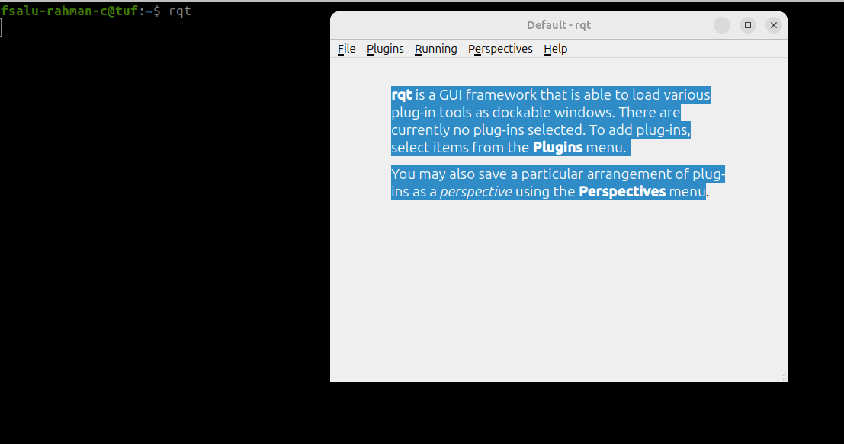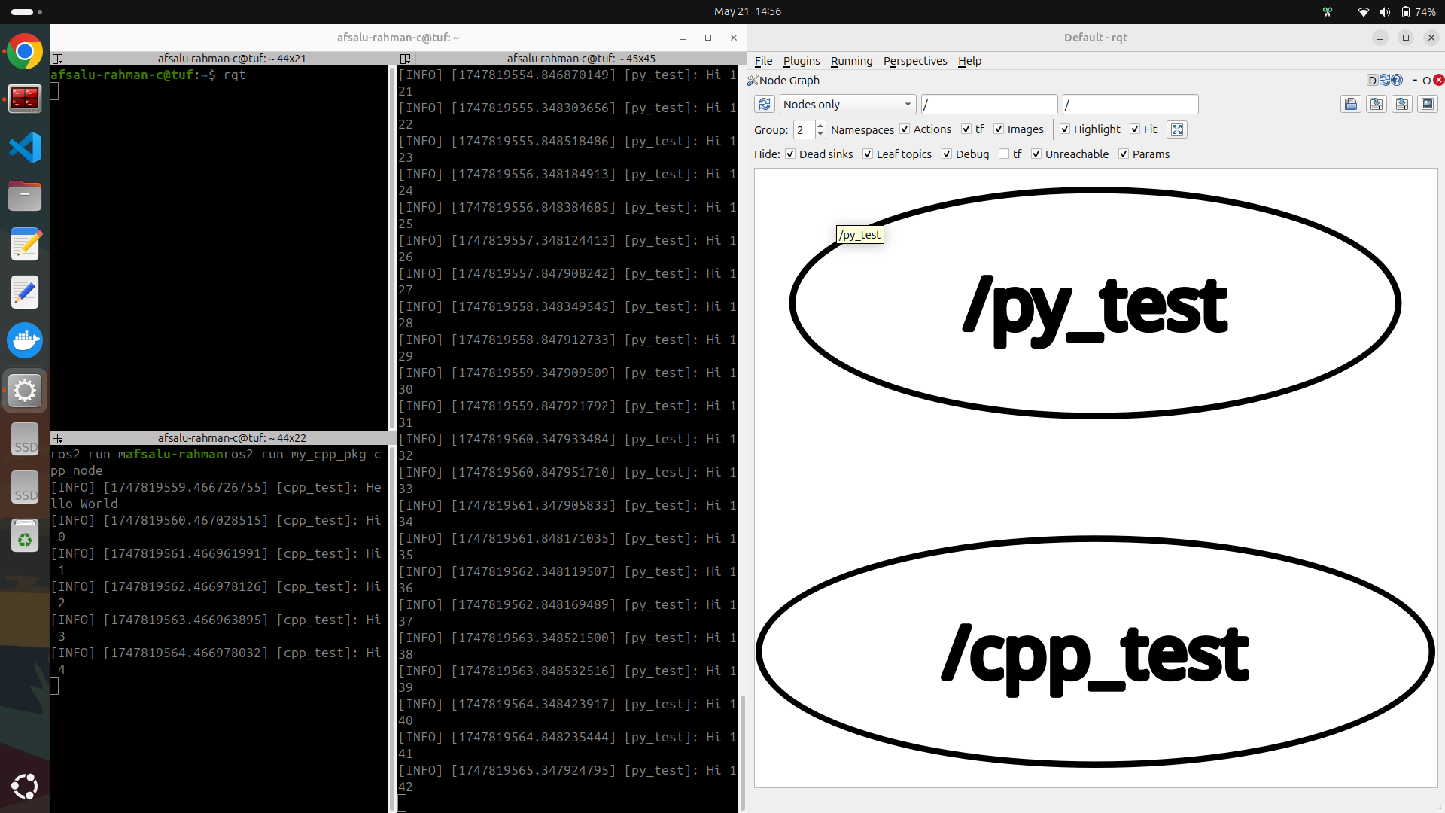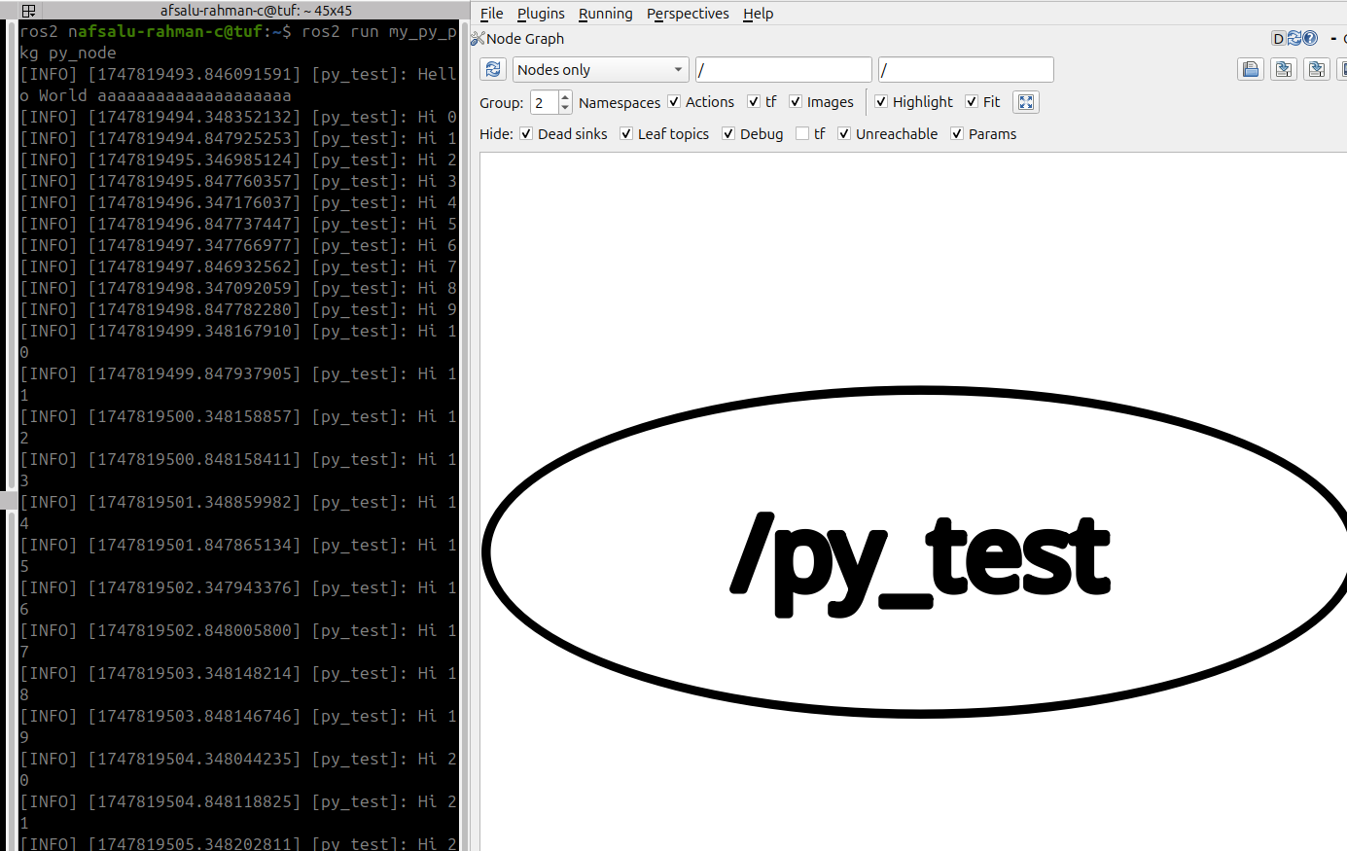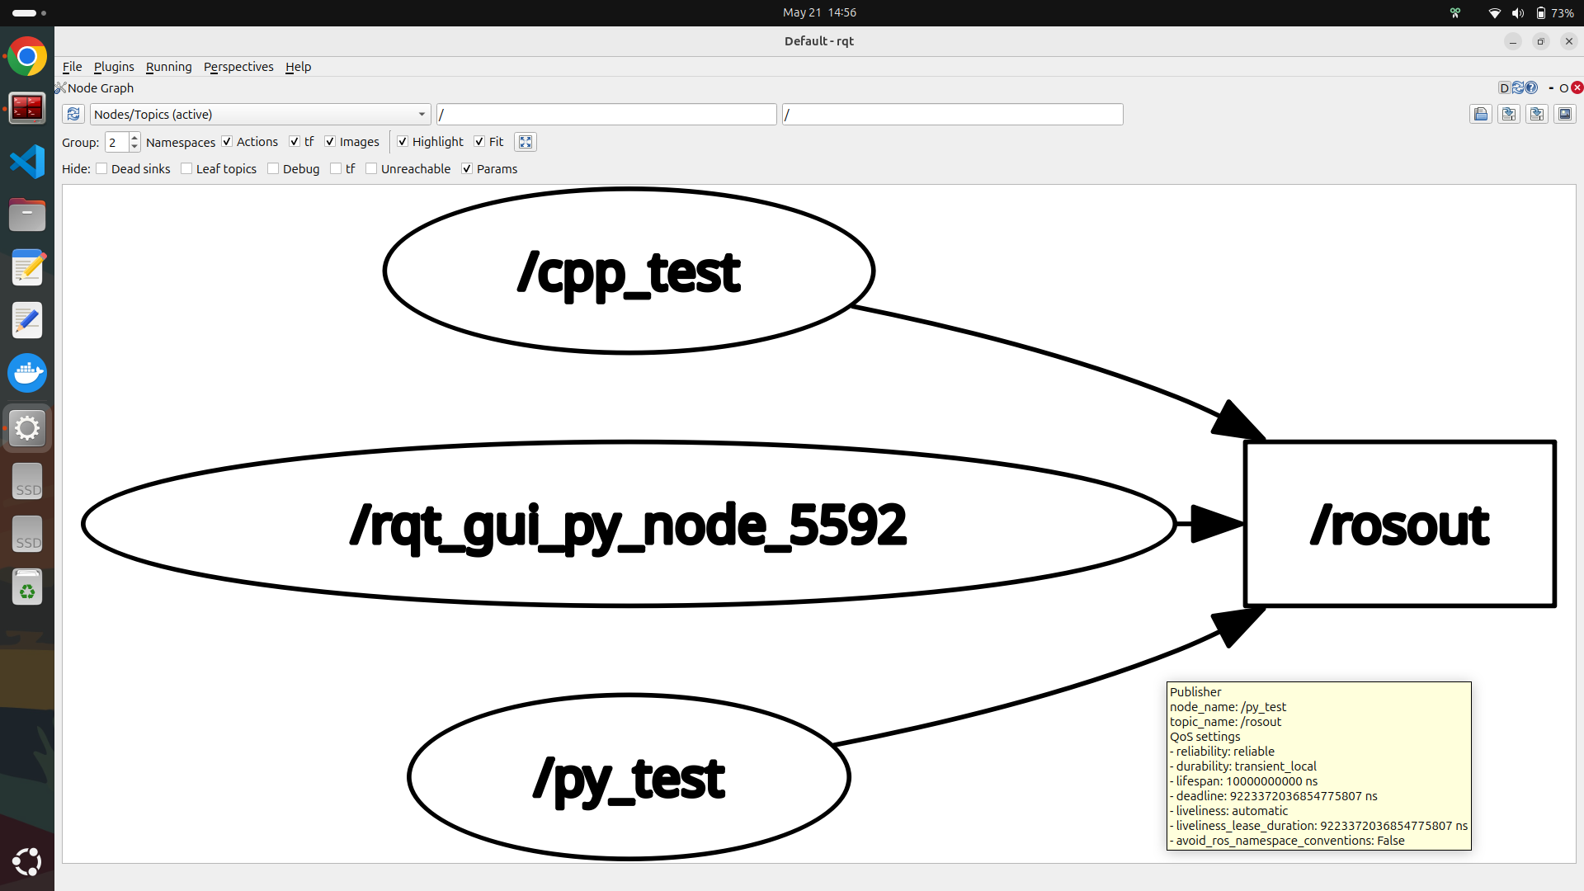

#### /rosout

rosout is a **special logging mechanism** that collects and displays log messages from all ROS nodes. It's similar to a centralized logging system.

### 4.5 turtlesim

ros2 run turtlesim turtlesim_node

ros2 run turtlesim turtle_teleop_key

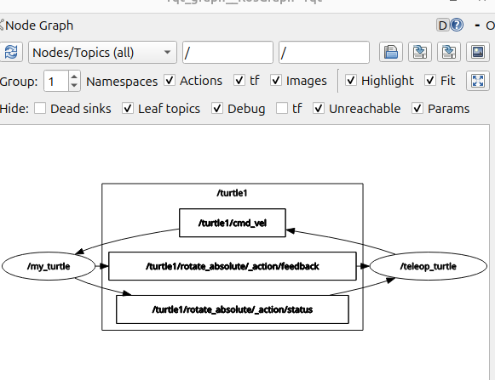

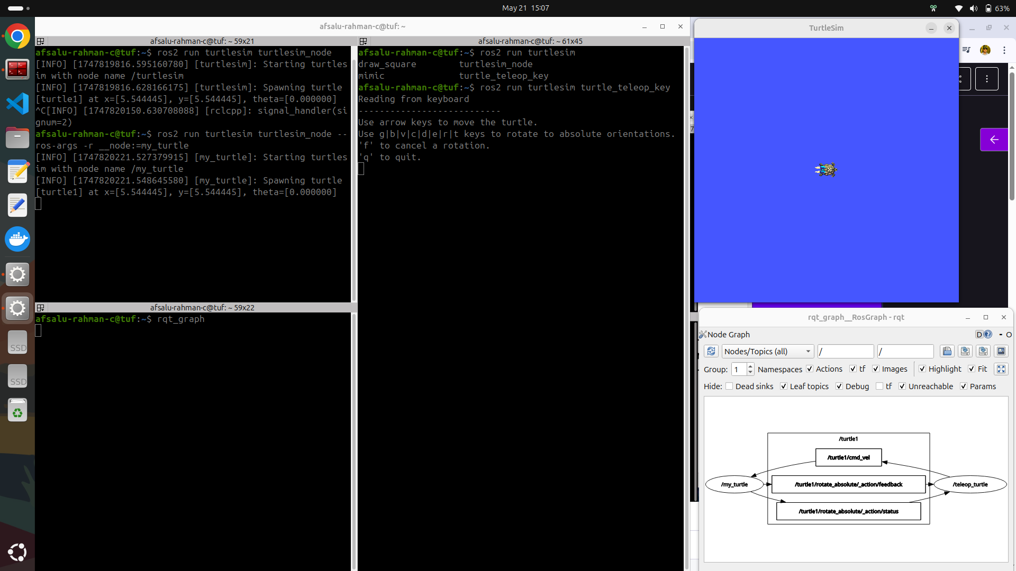

### 4.6 Activity 01

# 

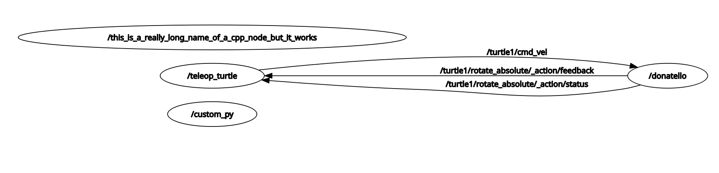

### 4.7 Solution

ros2 run my_py_pkg py_node --ros-args -r __node:=custom_py

ros2 run my_cpp_pkg cpp_node --ros-args -r __node:=this_is_a_really_big_nodd_but_it_works

ros2 run turtlesim turtlesim_node -ros-args -r __node:=donatello

ros2 run turtlesim turtle_teleop_key

### 4.8 Conclusion

**Section Conclusion**

In this section you’ve discovered 2 important tools you’ll use for any ROS 2 application you develop: the ros2 cli (Command Line Interface), and rqt with all its plugins. During the course you’ll continue to practice with those tools, and you’ll discover more of them.

You also discovered the Turtlesim package, containing a simplified 2D robot, which will be very useful to apply what you learn throughout the course.

So, with the last section on nodes + the activities from this section, you already have a good foundation and you can:

* Create a custom node in your own package (Python and Cpp)
* Compile and run your nodes
* Launch and debug your nodes with different tools
* Run existing nodes from other packages

Now, the next logical step is to see how those nodes can communicate between each other. And… That’s just what’s coming in the next section on ROS 2 Topics.

# Section 5 Topic Communication

### 5.1 Intro

It is now the time to explore ROS communication features.

At the end of this section you will be able to make your nodes communicate between each other, using ROS 2 Topics.

Here’s what you’ll do in this section:

* Understand what is a ROS 2 topic thanks to a real life analogy
* Write your own Topic (publisher/subscriber) in both Python and Cpp
* Debug topics with ROS 2 tools
* Experiment on Turtlesim

And finally, you’ll work on an activity to practice on everything you’ve seen until this point.

### 

### 5.2 What is a ROS 2 Topic?

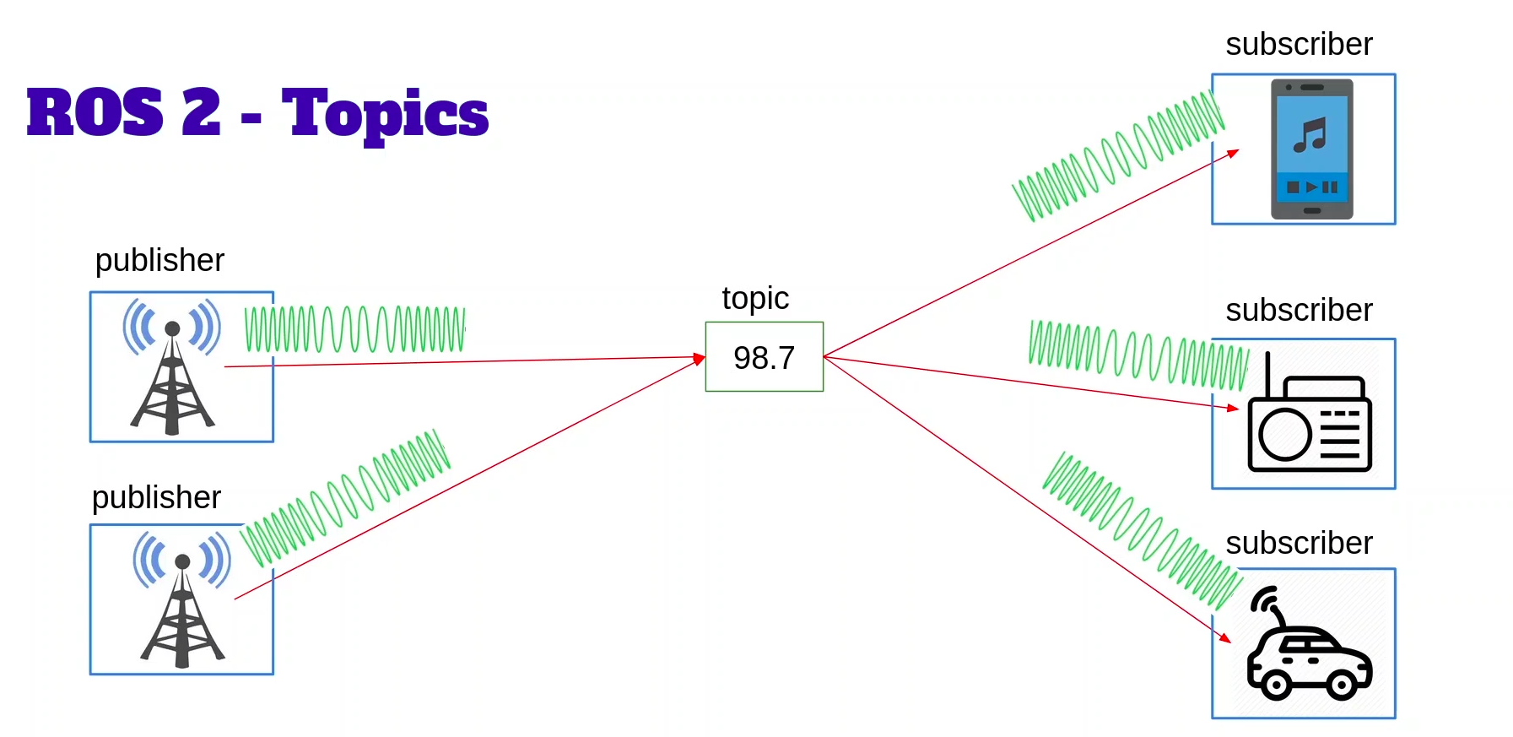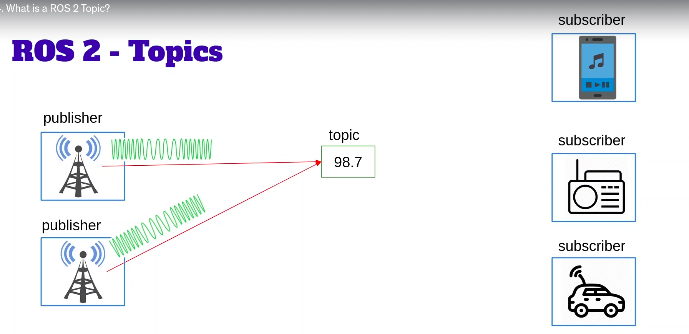

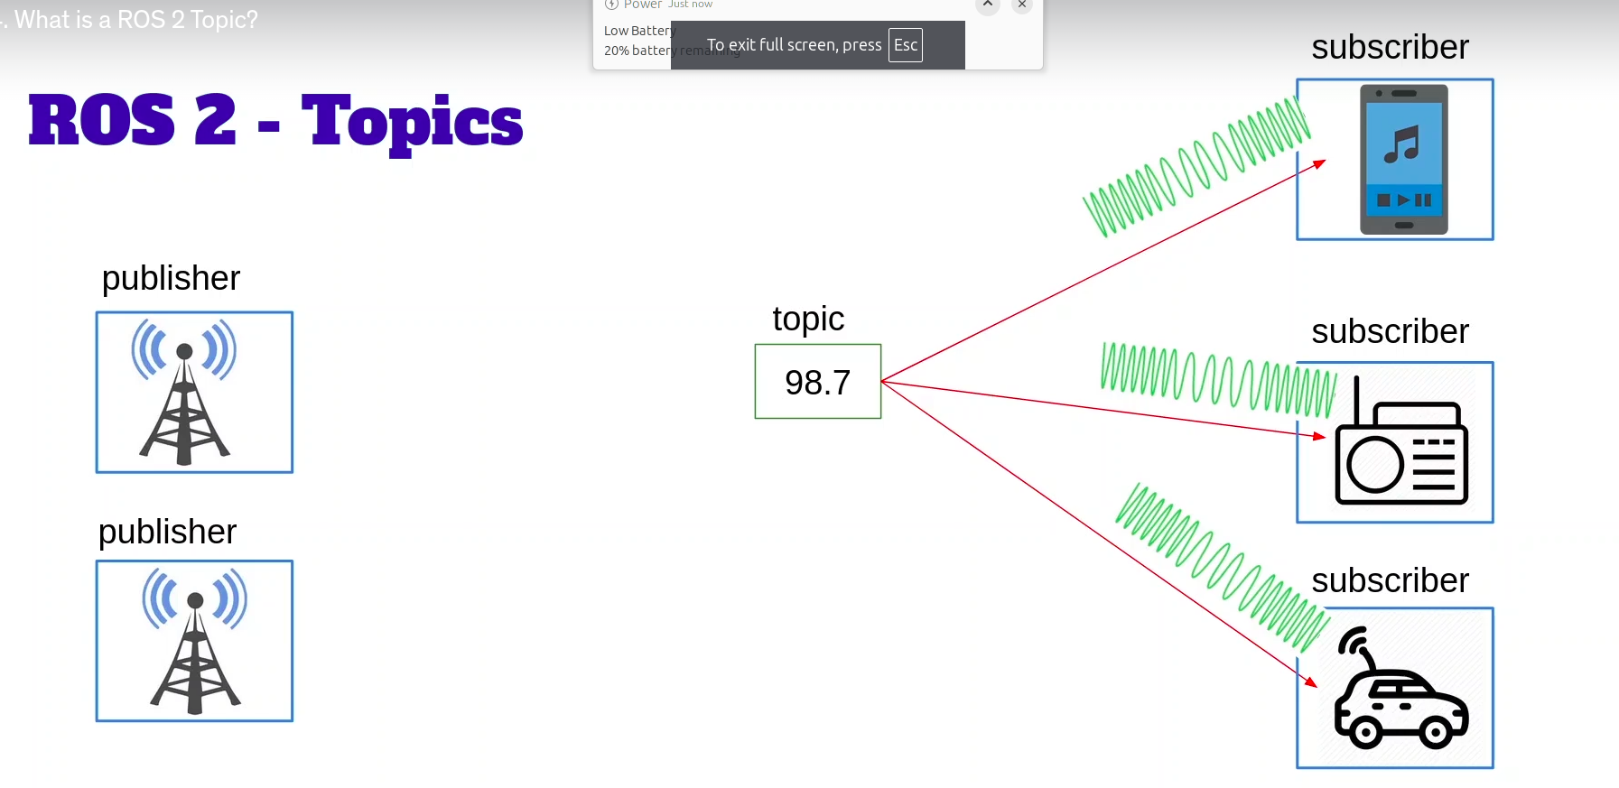a publisher can publish to different topic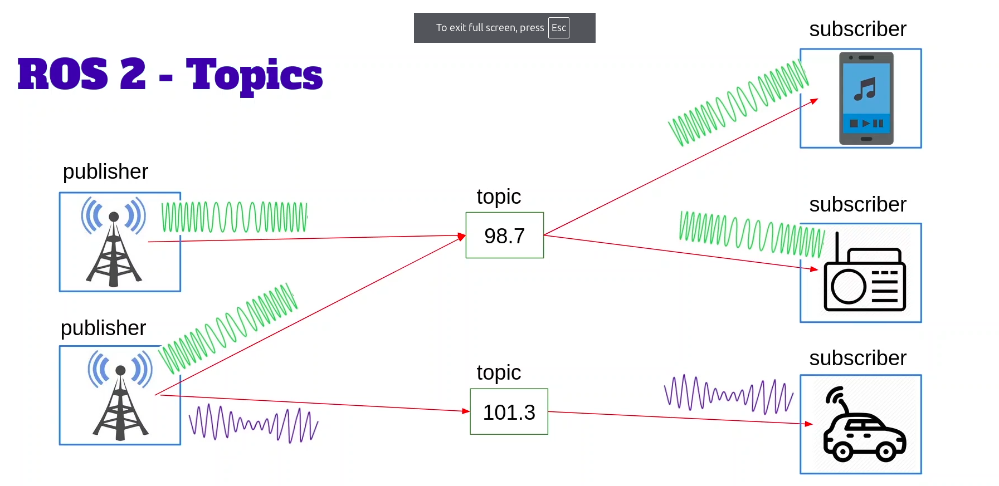a subscriber can be publisher and subscriber at same time 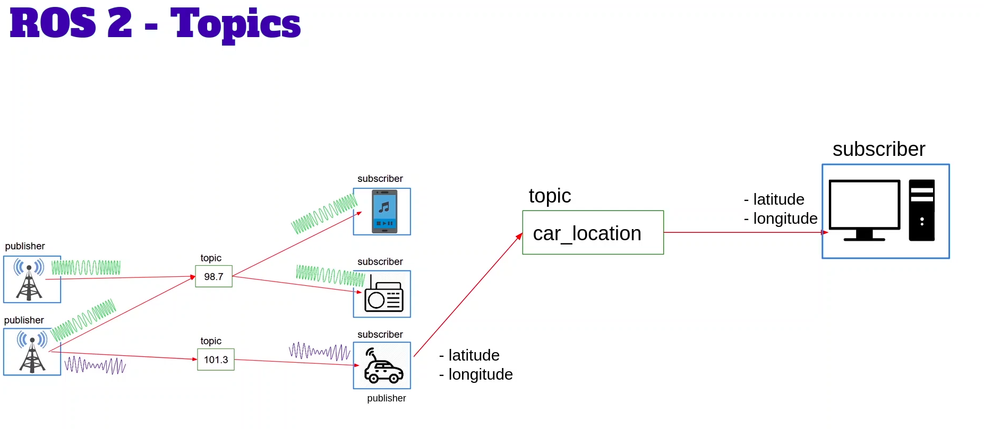

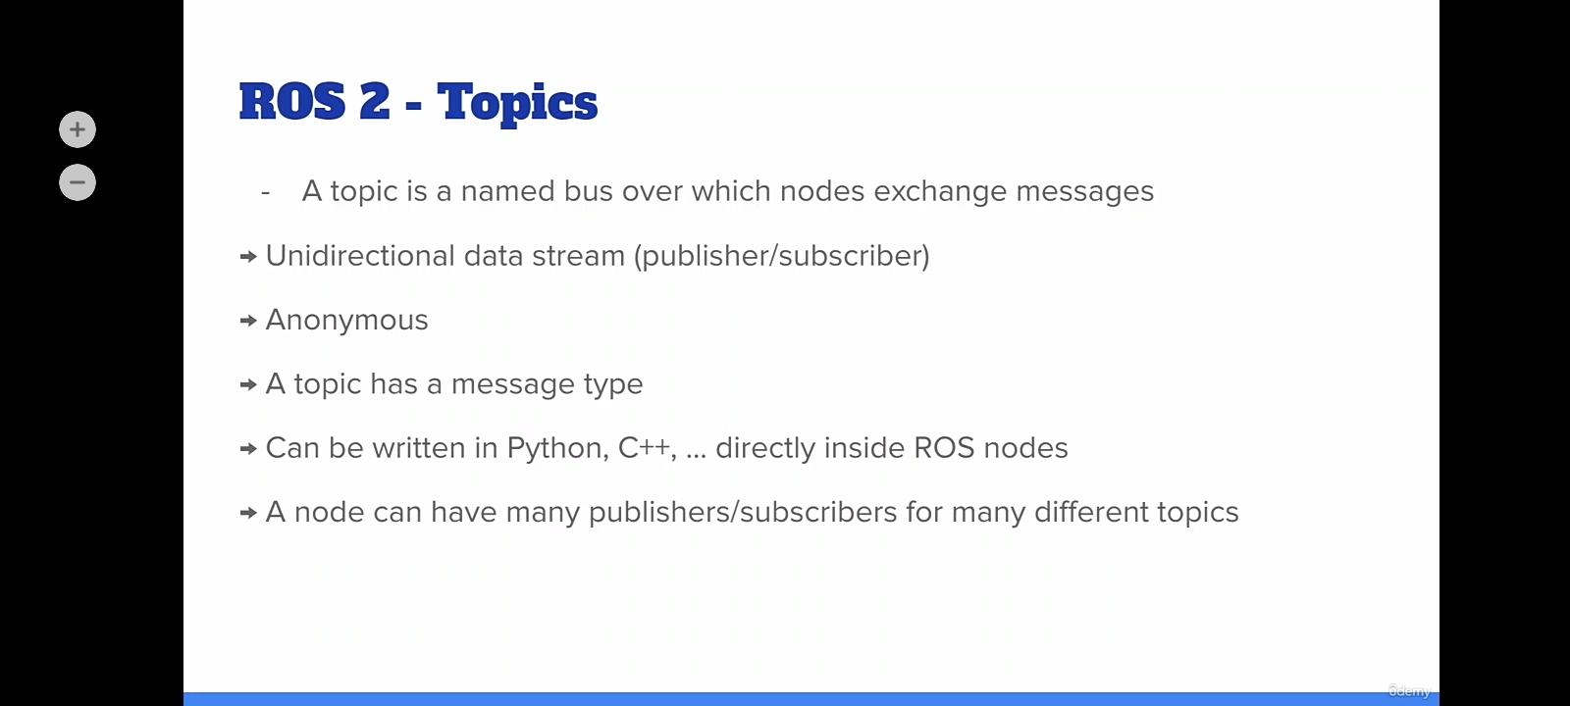

### 5.3 Write a Python Publisher

touch robot_news_station.py

chmod +x robot_news_station.py (is will also help to build with symlink)

#### ROS2 Interface

ROS 2 interfaces define the communication contracts between nodes. They **specify how nodes exchange data with each other**, ensuring compatibility between publishers and subscribers, service clients and servers, and action clients and servers.

ros2 interface show example_interfaces/msg/String

It is needed to import in code

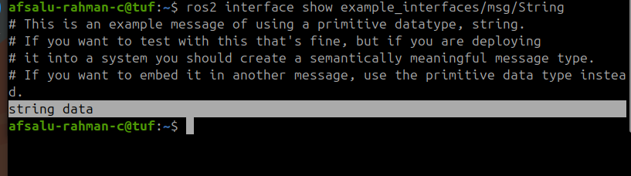

field is “data”

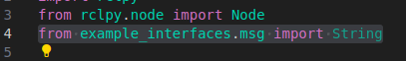

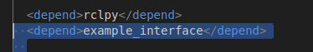

self.publisher_ = self.create_publisher(String, "robot_news", 10)

“/” is not mandatory in topic (robot_news)

10 is the queue size, this buffer is used when there is a network lose like that)

create executable in [setup.py](http://setup.py)



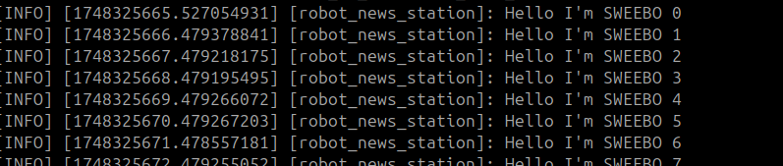

*NOTE: Add example_interface.. dependencies in package.xml*

#### code

#!/usr/bin/env python3

import rclpy

from rclpy.node import Node

from example_interfaces.msg import String

class RobotNewsStationNode(Node):

def __init__(self):

super().__init__("robot_news_station")

self.publisher_ = self.create_publisher(String, "robot_news", 10)

self.timer_ = self.create_timer(1,self.publish_news)

self.i = 0

self.robot_name_ = "R2D2"

def publish_news(self):

msg = String()

msg.data = f"Hello I'm {self.robot_name_} {self.i}" #data is the field

self.publisher_.publish(msg)

self.get_logger().info(msg.data)

self.i = self.i + 1

def main(args=None):

rclpy.init(args=args)

node = RobotNewsStationNode()

rclpy.spin(node)

rclpy.shutdown()

if __name__ == "__main__":

main()

### 5.4 Write a Python Subscriber

touch [smartphone.py](http://smartphone.py)

chmod +x smartphone.py

deleted __pyacahe__.py (The __pycache__ directory is automatically created by Python when a module is imported. It stores **compiled bytecode files** for Python source files.

)

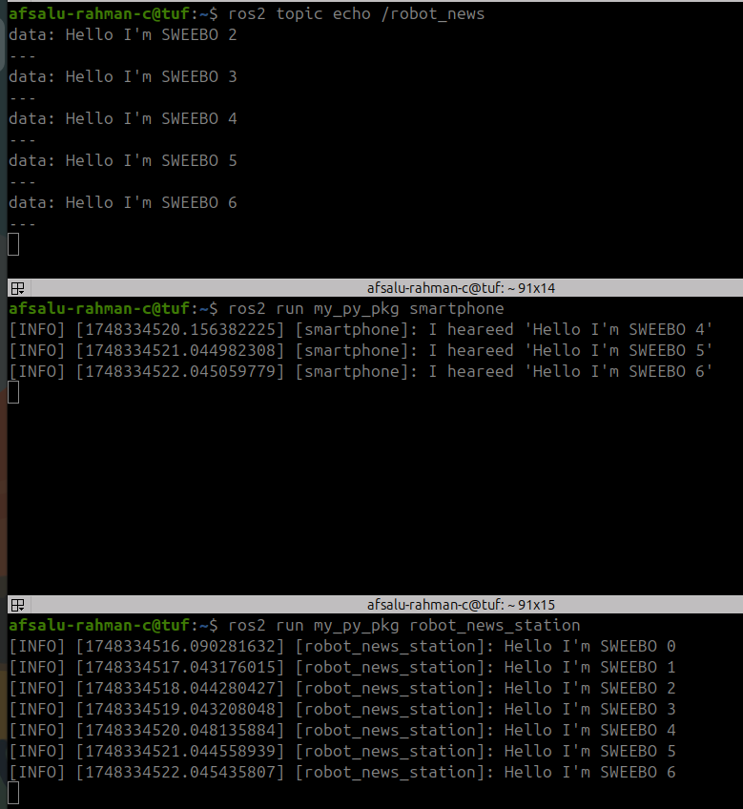

#### code

#!/usr/bin/env python3

import rclpy

from rclpy.node import Node

from example_interfaces.msg import String

class SmartPhoneNode(Node):

def __init__(self):

super().__init__("smartphone")

self.subscriber_ = self.create_subscription(String, "robot_news", self.callback_robot_news, 10)

def callback_robot_news(self, msg: String): # NOTE THE NAMING STYLE

self.get_logger().info(f"I heareed '{msg.data}'")

def main(args=None):

rclpy.init(args=args)

node = SmartPhoneNode()

rclpy.spin(node)

rclpy.shutdown()

if __name__ == "__main__":

main()

### 5.5 Write a C++ Publisher

Add example_interfaces package in both package.xml and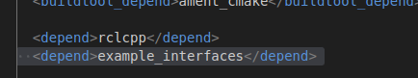

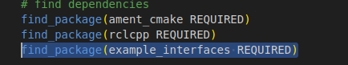

Adding executable and installing the node in CMakeLists.txt

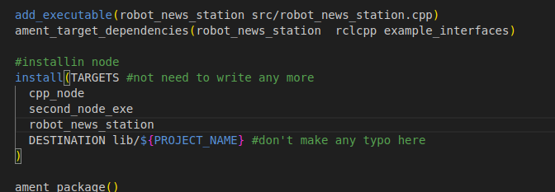

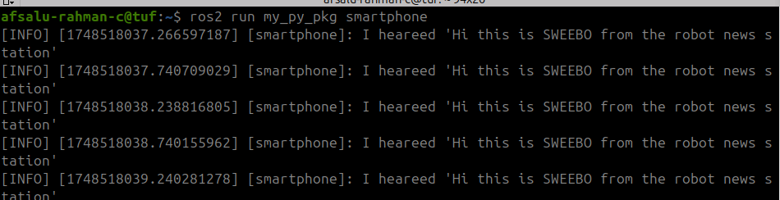



#### code

#include "rclcpp/rclcpp.hpp"

#include "example_interfaces/msg/string.hpp"

using namespace std::chrono_literals; // this is for time (0.5s)

class RobotNewsStationNode : public rclcpp::Node

{

public:

RobotNewsStationNode() : Node("robot_news_station"), robot_name_("R2D2")

{

publisher_ = this->create_publisher<example_interfaces::msg::String>("robot_news",10);

timer_ = this->create_wall_timer(0.5s, std::bind(&RobotNewsStationNode::publisheNews,this));

RCLCPP_INFO(this->get_logger(),"Robot news station has been started");

}

private:

void publisheNews()

{

auto msg = example_interfaces::msg::String(); //by default variable are auto - stored in stack

msg.data = std::string("Hi this is ") + robot_name_ + std::string(" from the robot news station");

publisher_->publish(msg);

}

std::string robot_name_;

rclcpp::Publisher<example_interfaces::msg::String>::SharedPtr publisher_; // '_' for to say as this is an attribute

rclcpp::TimerBase::SharedPtr timer_;

};

int main(int argc, char **argv)

{

rclcpp::init(argc, argv);

auto node = std::make_shared<RobotNewsStationNode>();

rclcpp::spin(node);

rclcpp::shutdown();

return 0;

}

### 5.6 Write a C++ Subscriber

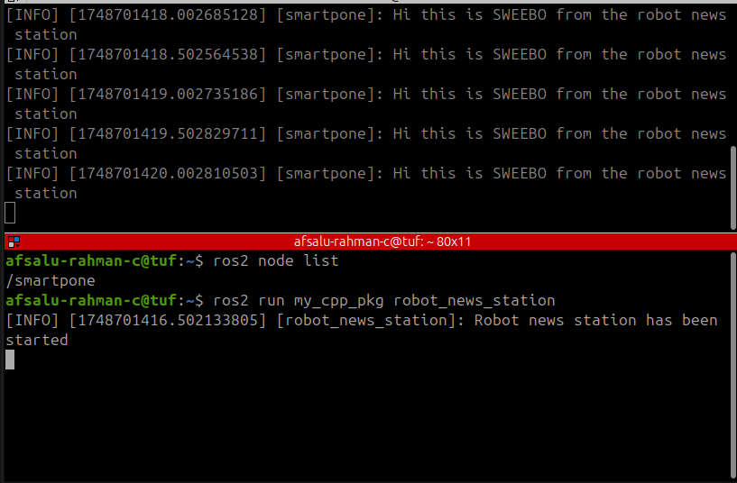

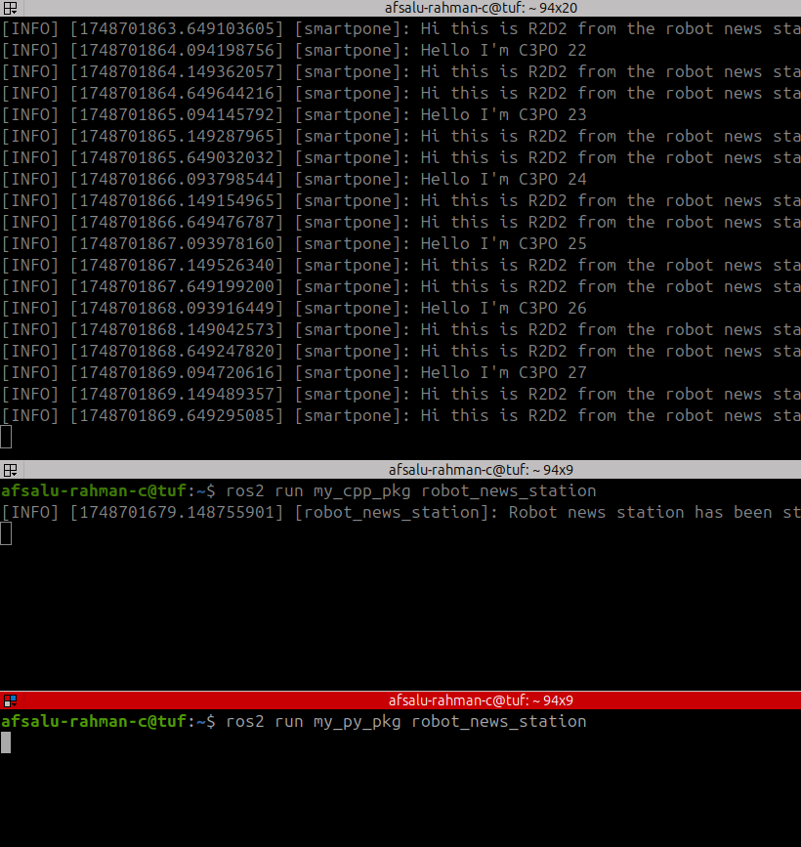

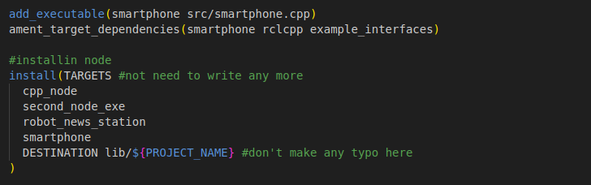

#### code

#include "rclcpp/rclcpp.hpp"

#include "example_interfaces/msg/string.hpp"

using namespace std::placeholders;

class SmartphoneNode : public rclcpp::Node

{

public:

SmartphoneNode() : Node("smartphone")

{

subsriber_ = this->create_subscription<example_interfaces::msg::String>(

"robot_news", 10,

std::bind(&SmartphoneNode::callbackRobotNews, this, _1)); //for 2 argument std::placeholders::_1, "std::placeholders::_2 are needed"

RCLCPP_INFO(this->get_logger(), "Smartphone has been started.");

}

private:

void callbackRobotNews(const example_interfaces::msg::String::SharedPtr msg) // callback followed by topic name 'RobotNews'

{

RCLCPP_INFO(this->get_logger(),"%s", msg->data.c_str()); //cast to string

}

rclcpp::Subscription<example_interfaces::msg::String>::SharedPtr subsriber_;

};

int main(int argc, char **argv)

{

rclcpp::init(argc, argv);

auto node = std::make_shared<SmartphoneNode>();

rclcpp::spin(node);

rclcpp::shutdown();

return 0;

}

***Wrong***: RCLCPP_INFO(this->get_logger(), "std::string(msg->data)");

#### C++ publisher VS subscriber

**Publisher**

1. chrono_literals
2. Publish news function
3. Wall timer - 2 arguments in bind

**Subscriber**

1. placeholders
2. callback_topic_name function
3. Subscription - in bind 3 arguments (_1 as well)
4. Declaration with in the function like

const example_interfaces::msg::String::SharedPtr msg

### 5.7 Introspect ROS 2 Topics with Command Line Tools

If I log to node it also going to publish in /rosout topic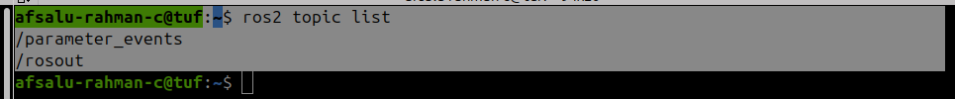

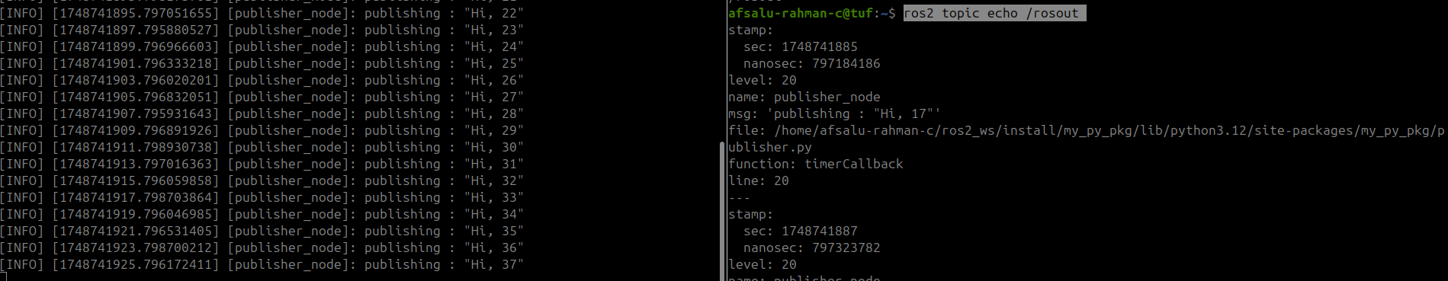

ros2 interface show example_interfaces/msg/String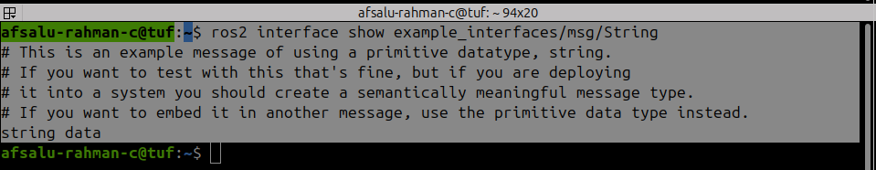

#### frequency of msg communication

ros2 topic hz /robot_news

*give how much data is publishing*

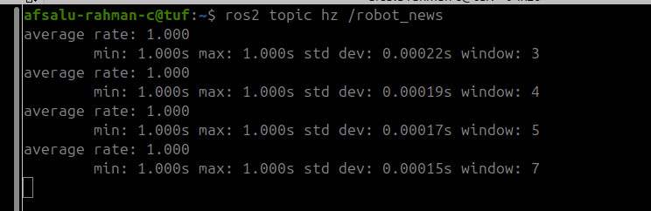

#### bandwidth

ros2 topic bw /robot_news

*how big the message is give by this*

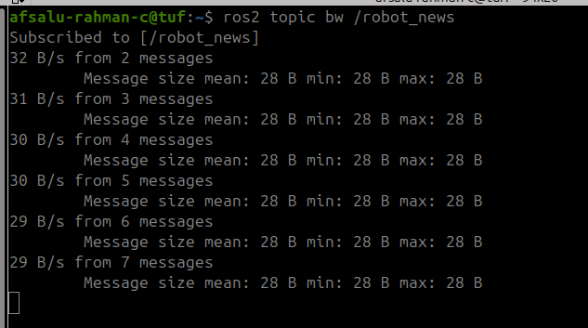

#### Publishing to a topic from terminal

ros2 topic pub -r 5 /robot_news example_interfaces/msg/String "{data: 'Hello from terminal'}"

-r means rate and 5 is the value

*only going to work for simple data type*

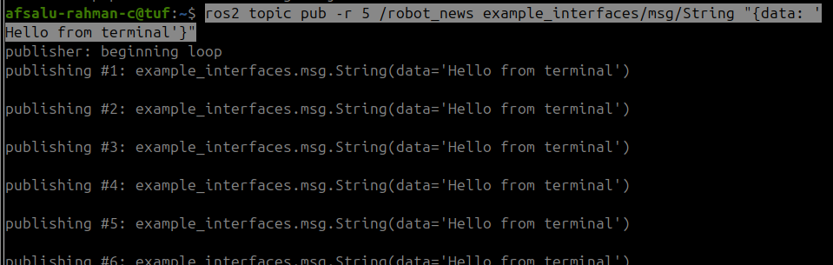

receiving from both publisher

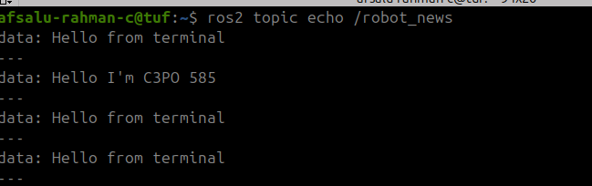

we can also introspect same information from node

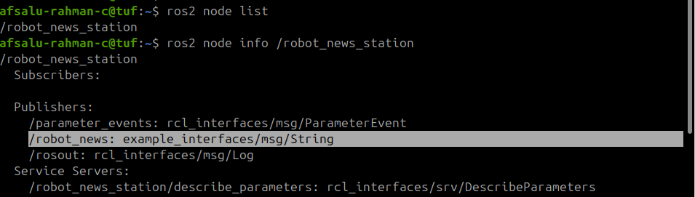

### 5.8 Remap a Topic at Runtime

#### renaming a node

ros2 run my_py_pkg robot_news_station --ros-args -r __node:=my_station

#### renaming a node and topic

ros2 run my_py_pkg robot_news_station --ros-args -r __node:=my_station -r robot_news:=abc



*NOTE : ‘*--ros-args’ only need once

#### changing topic name at runtime

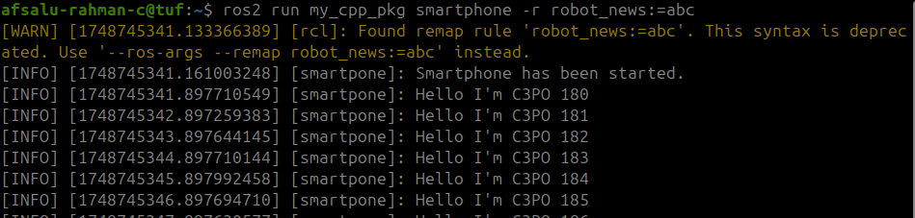

### 5.9 Monitor Topics With rqt and rqt_graph

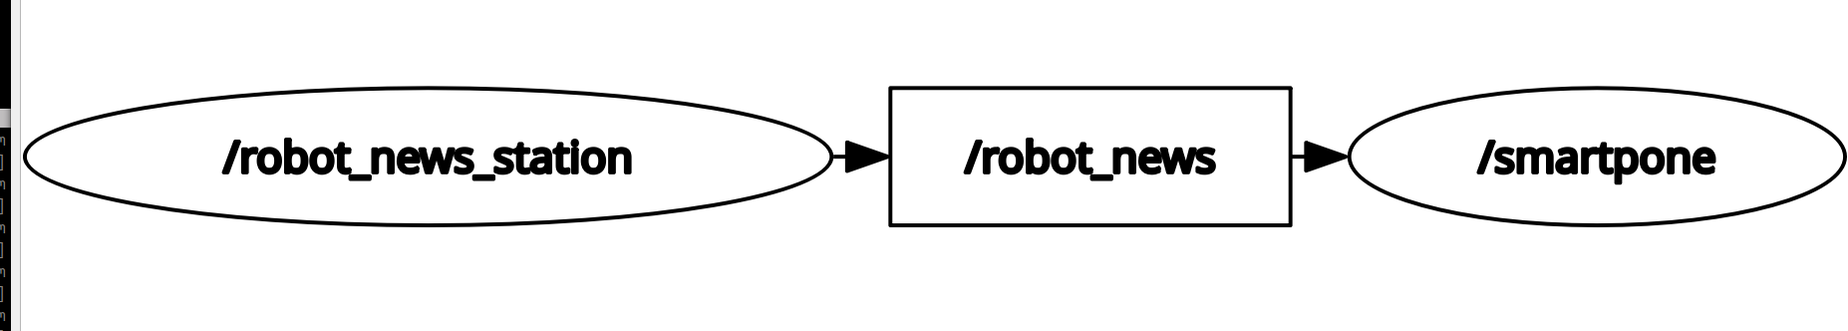

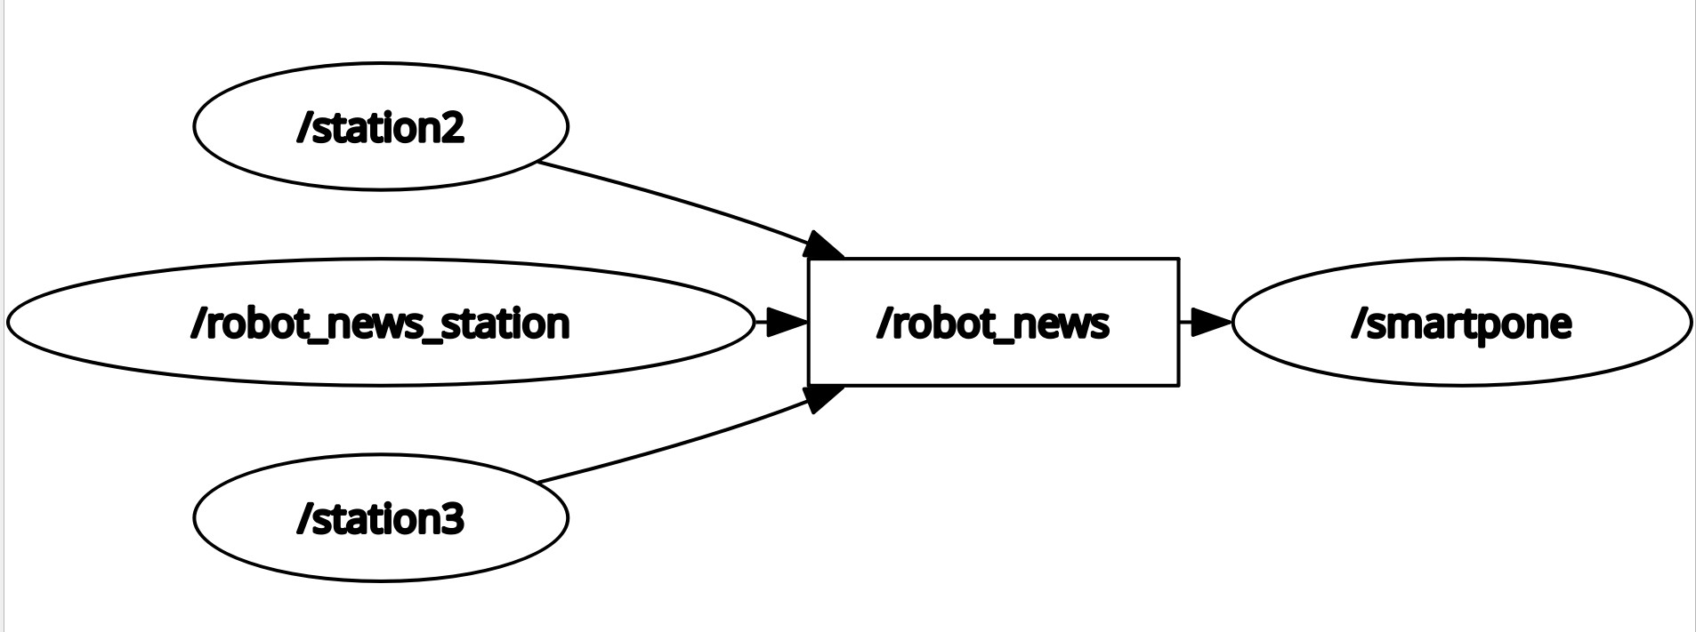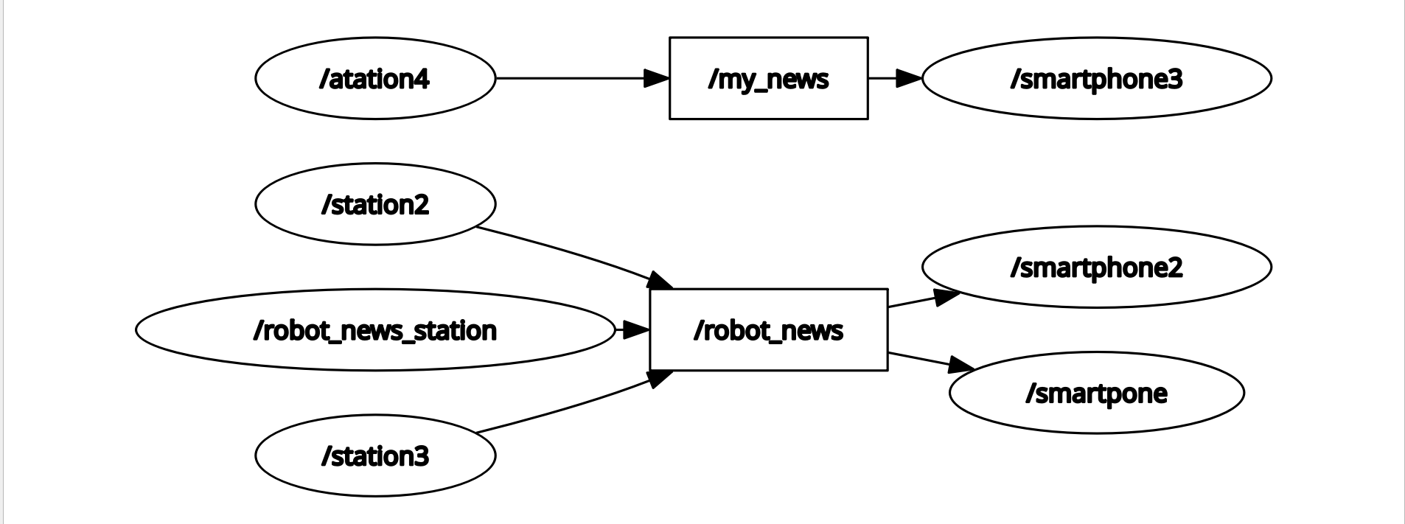

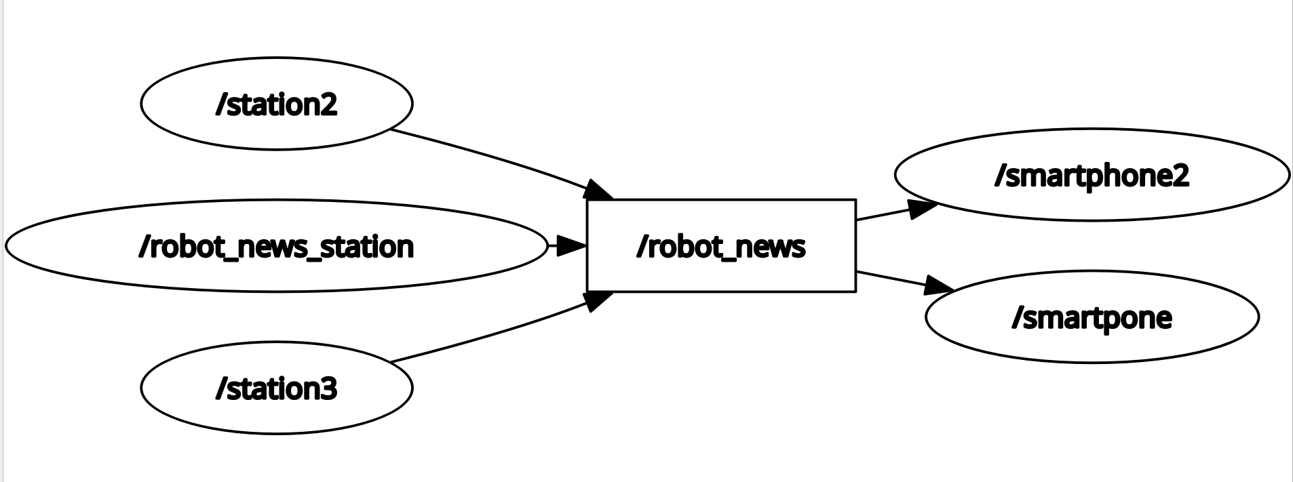

### 5.10 Experiment on Topics with Turtlesim

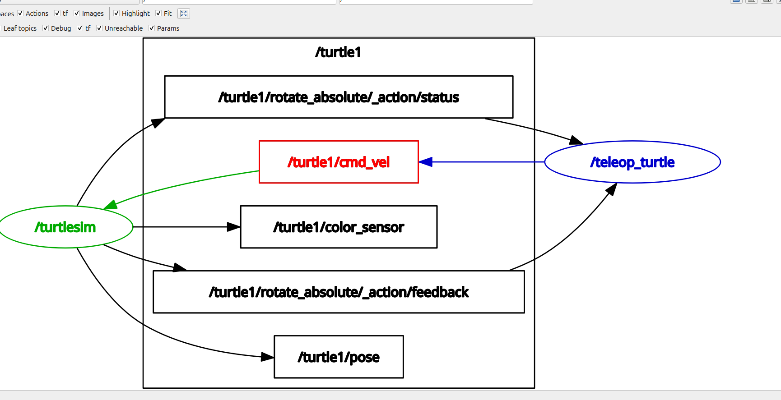

ros2 node info /turtlesim

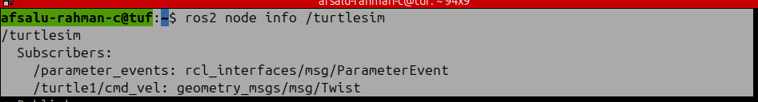

ros2 node info /teleop_turtle

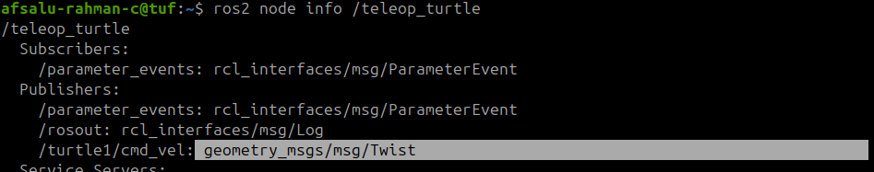

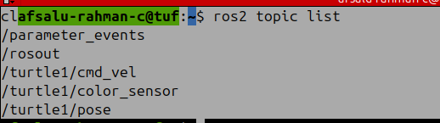

ros2 interface show geometry_msgs/msg/Twist

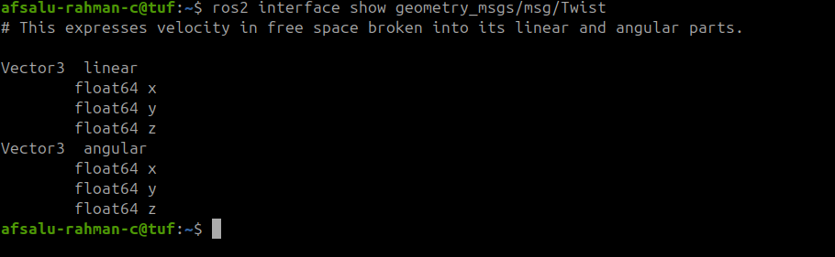

we can rotate the turtle by linear x and angular z

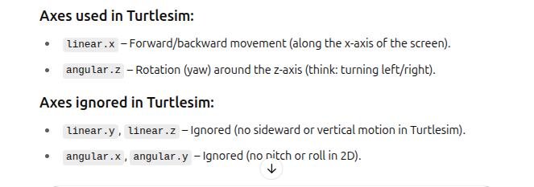

ros2 topic pub -r 2 /turtle1/cmd_vel geometry_msgs/msg/Twist "{linear: {x: 1.0}, angular: {z: 1.0}}"

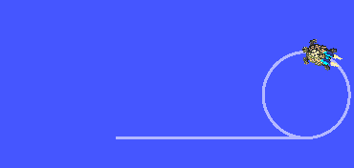

#### My activity

*terminal 1*

ros2 run turtlesim turtlesim_node

*terminal 2*

*ros2 service call /spawn turtlesim/srv/Spawn "{x: 5.544444561004639, y: 5.544444561004639, theta: 0.0, name:* ***'turtle2'****}"* (x: 5.544444561004639, y: 5.544444561004639, theta: 0.0 is the default location)

*terminal3*

timeout 6.283185307179586 ros2 topic pub -r 1 turtle1/cmd_vel geometry_msgs/msg/Twist "{linear: {x: 1}, angular: {z: 1}}"

*radius = v/w =1/1 = 1m*

*time to completion of one rotation = 2*pi*r / w = 2*pi*1 / 1 = 2*pi*

*so timeout = 2*pi = 6.283185307179586*

*terminal 4*

timeout 6.283185307179586 ros2 topic pub -r 1 **turtle2**/cmd_vel geometry_msgs/msg/Twist "{linear: {x: 1}, angular: {**z: -1**}}"

[*Refer*](https://chatgpt.com/share/683c26e9-6388-800d-b241-c35611eb3979)

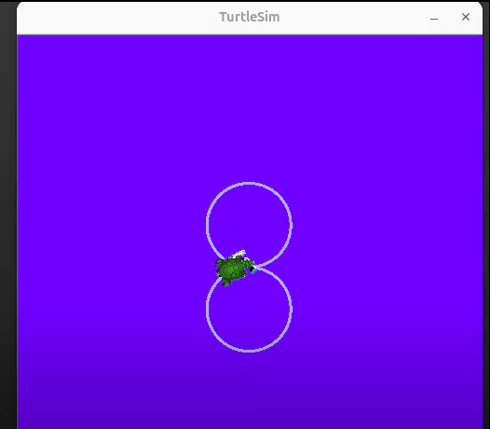

### 5.11 Activity 02 - ROS2 Topics

#### Activity 02 - ROS2 Topics

It’s time for a new activity on ROS 2 topics.

Here is a representation of the graph you should get at the end.

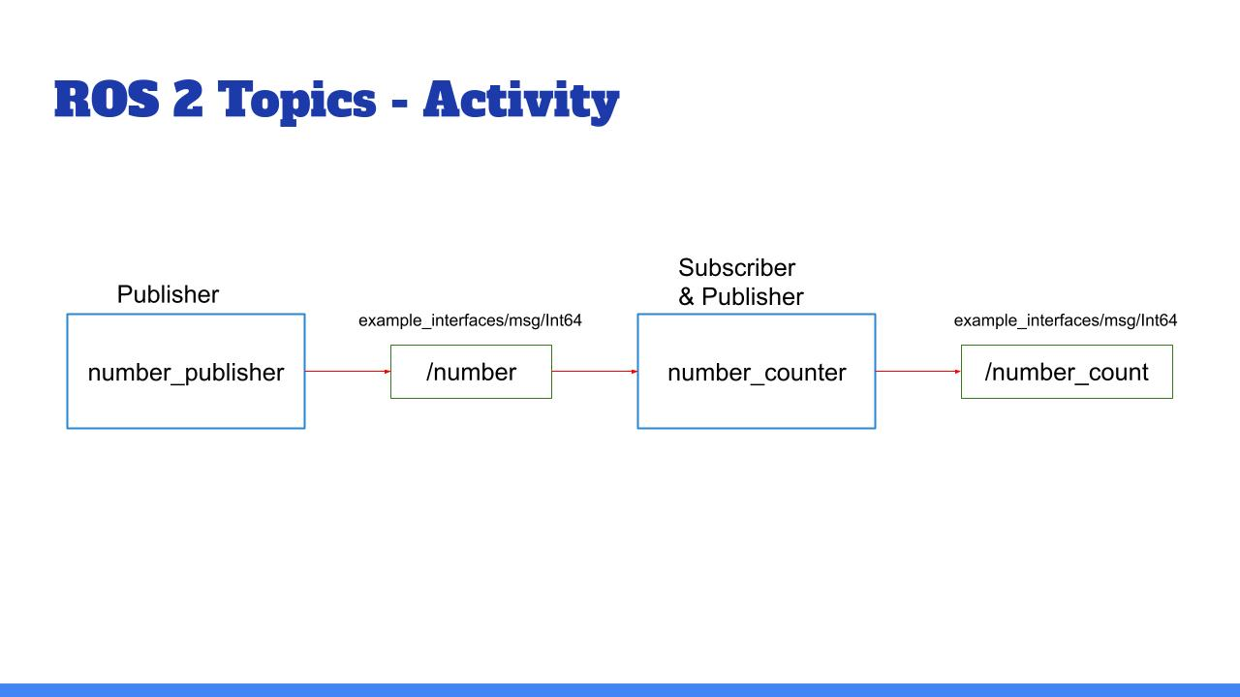

The blue boxes are nodes and the green boxes are topics.

And here’s the final result you should get in the terminal (of course the numbers may be different):

__________________________________________

ros2 topic echo /number_count

data: 38

---

data: 40

---

data: 42

---

__________________________________________

You’ll create 2 nodes from scratch. In the first one you’ll have 1 publisher, and in the second one, 1 publisher & 1 subscriber.

* The number_publisher node publishes a number (always the same) on the “/number” topic, with the existing type example_interfaces/msg/Int64.
* The number_counter node subscribes to the “/number” topic. It keeps a counter variable. Every time a new number is received, it’s added to the counter. The node also has a publisher on the “/number_count” topic. When the counter is updated, the publisher directly publishes the new value on the topic.

A few hints:

* Check what to put into the example_interfaces/msg/Int64 with the “ros2 interface show” command line tool.
* It may be easier to do the activity in this order: first create the number_publisher node, check that the publisher is working with “ros2 topic”. Then create the number_counter, focus on the subscriber. And finally create the last publisher.
* In the number_counter node, the publisher will publish messages directly from the subscriber callback.

And now, let’s get to work! :)

Make sure you really spend some time on this activity, even if you can’t finish it. That’s the only way you will truly progress.

You can do this activity in both Python and Cpp. In fact, you could write the first node in Python, and the second in Cpp, and vice versa!

I’ll see you in the next lecture for the solution.

### My python solution

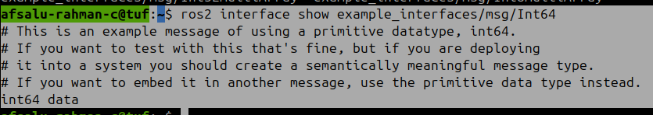

#### number_publisher.py

#!/usr/bin/env python3

import rclpy

from rclpy.node import Node

from example_interfaces.msg import Int64

class NumberPublisherNode(Node):

def __init__(self):

super().__init__("number_publisher")

self.timer_ = self.create_timer(1,self.publish_number)

self.publisher_ = self.create_publisher(Int64,"number",10)

def publish_number(self):

msg = Int64()

msg.data = 50

self.publisher_.publish(msg)

def main(args=None):

rclpy.init(args=args)

node = NumberPublisherNode()

rclpy.spin(node)

rclpy.shutdown()

if __name__ == "__main__":

main()

#### number_counter.py

#!/usr/bin/env python3

import rclpy

from rclpy.node import Node

from example_interfaces.msg import Int64

class NumberCounterNode(Node):

def __init__(self):

super().__init__("number_counter")

self.subscriber_ = self.create_subscription(Int64,"number",self.callback_number,10)

self.counter_ = 0

self.get_logger().info("Counter Receiver has been started")

self.publisher_ = self.create_publisher(Int64,"number_count",10)

def callback_number(self, msg:Int64):

if msg.data == 50:

self.counter_ += 1

self.get_logger().info(f"Number of messages recived = {self.counter_}")

msg2 = Int64()

msg2.data = self.counter_

self.publisher_.publish(msg2)

def main(args=None):

rclpy.init(args=args)

node = NumberCounterNode()

rclpy.spin(node)

rclpy.shutdown()

if __name__ == "__main__":

main()

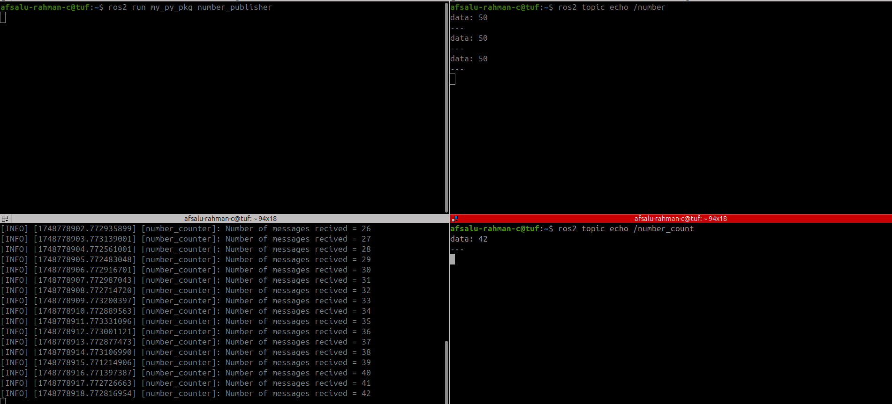

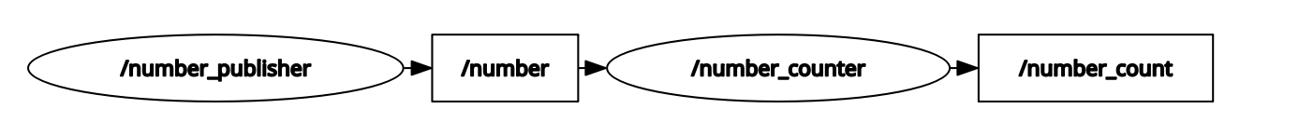

### My C++ solution

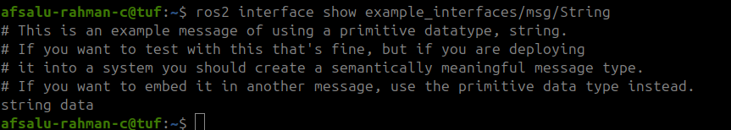

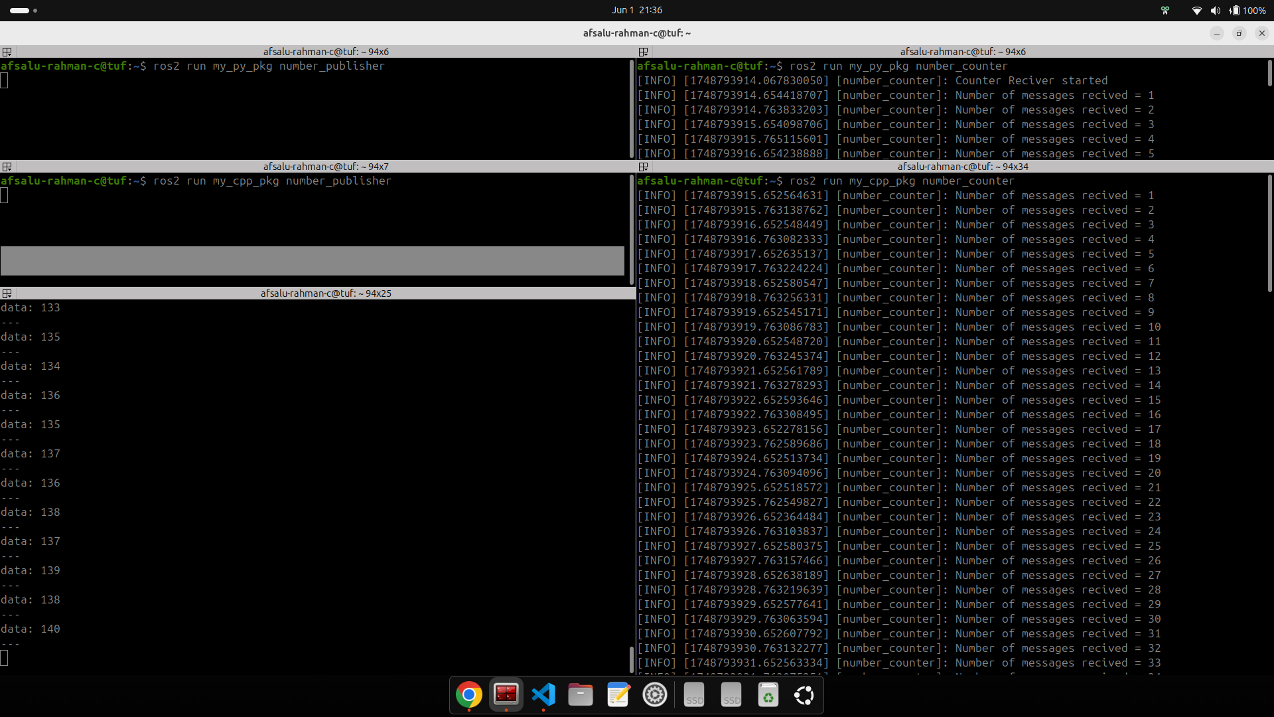

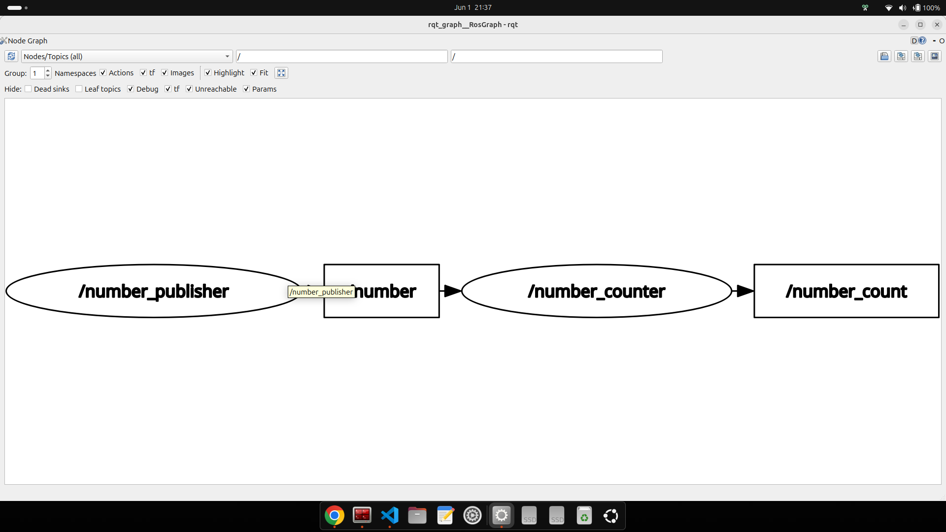

### number_publisher.cpp

#include "rclcpp/rclcpp.hpp"

#include "example_interfaces/msg/int64.hpp"

using namespace std::chrono_literals;

class NumberPublisherNode : public rclcpp::Node

{

public:

NumberPublisherNode() : Node("number_publisher")

{

publisher_ = this->create_publisher<example_interfaces::msg::Int64>("number",10);

timer_ = this->create_wall_timer(1s, std::bind(&NumberPublisherNode::PublishNumber,this));

}

private:

void PublishNumber()

{

auto msg = example_interfaces::msg::Int64();

msg.data = 50;

publisher_->publish(msg);

}

rclcpp::Publisher<example_interfaces::msg::Int64>::SharedPtr publisher_;

rclcpp::TimerBase::SharedPtr timer_;

};

int main(int argc, char **argv)

{

rclcpp::init(argc, argv);

auto node = std::make_shared<NumberPublisherNode>();

rclcpp::spin(node);

rclcpp::shutdown();

return 0;

}

### number_counter.cpp

#include "rclcpp/rclcpp.hpp"

#include "example_interfaces/msg/int64.hpp"

using namespace std::placeholders;

class NumberCounterNode : public rclcpp::Node

{

public:

NumberCounterNode() : Node("number_counter"), counter_(0) // constrctor initialization is recommended

{

subscriber_ = this->create_subscription<example_interfaces::msg::Int64>(

"number",10,

std::bind(&NumberCounterNode::callbackNumber, this,_1));

publisher_ = this->create_publisher<example_interfaces::msg::Int64>("number_count",10);

}

private:

void callbackNumber(const example_interfaces::msg::Int64 msg) //means that the msg object is passed by value as a constant

{

if(msg.data == 50)

{

counter_++;

RCLCPP_INFO(this->get_logger(), "Number of messages recived = %ld",counter_);

auto msg2 = example_interfaces::msg::Int64();

msg2.data = counter_;

publisher_->publish(msg2);

}

}

rclcpp::Subscription<example_interfaces::msg::Int64>::SharedPtr subscriber_;

rclcpp::Publisher<example_interfaces::msg::Int64>::SharedPtr publisher_;

std::int64_t counter_;

};

int main(int argc, char **argv)

{

rclcpp::init(argc, argv);

auto node = std::make_shared<NumberCounterNode>();

rclcpp::spin(node);

rclcpp::shutdown();

return 0;

}

### 5.14 Extra: Replay Topic Data with Bags

Use for **recording and playing back the data**

you can save the data from a topic and replay as many times want

*select a directory*

*ex: home directory*

*terminal1*

ros2 run my_py_pkg number_publisher

*t2*

ros2 run my_py_pkg number_count

*t3*

mkdir bags

ros2 bag -h

ros2 bag record /number_count (Record with topic name)

Press ctrl + c to stop recording

ls

rosbag2_2025_06_02-08_40_50

cd rosbag2_2025_06_02-08_40_50

metadata.yaml

rosbag2_2025_06_02-08_40_50_0.mcap (contain message information)

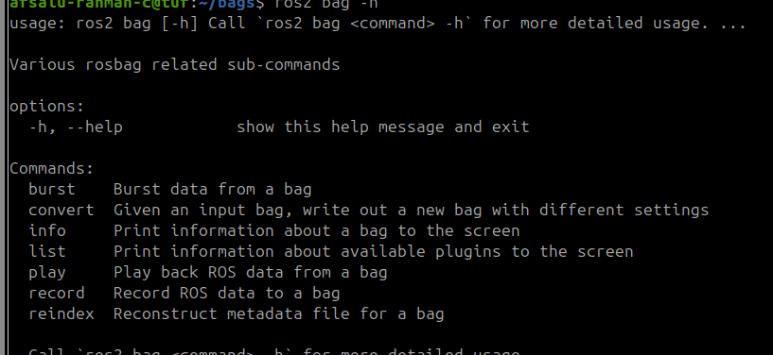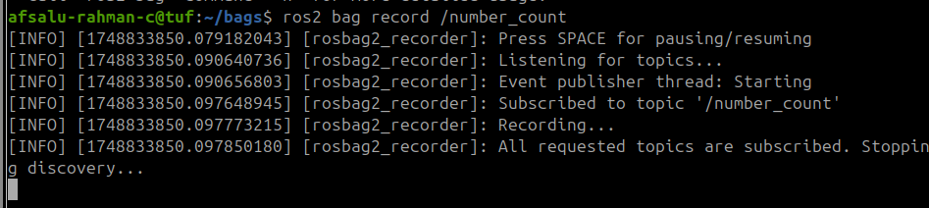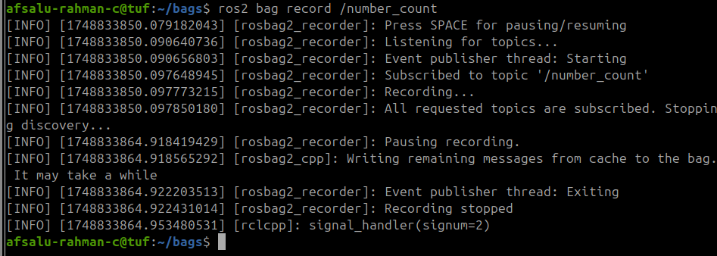

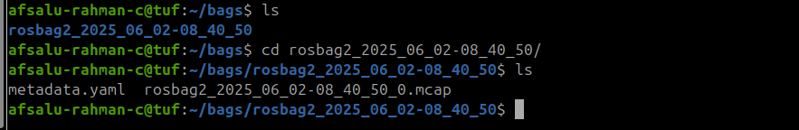

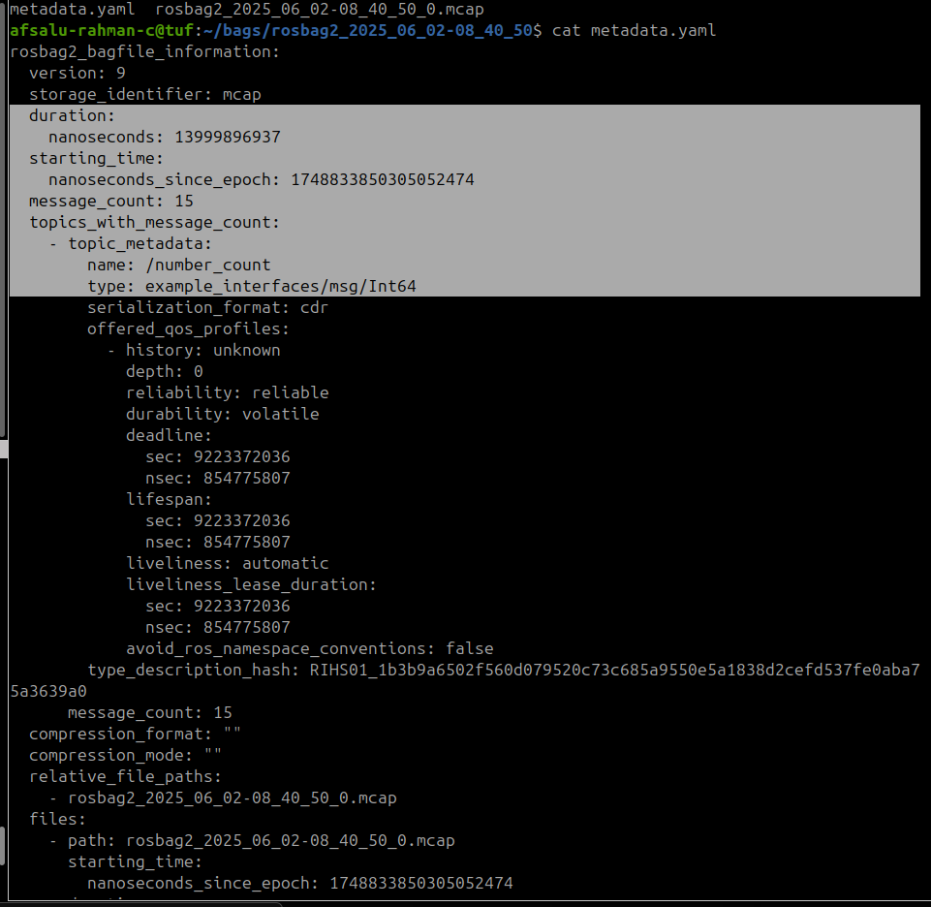



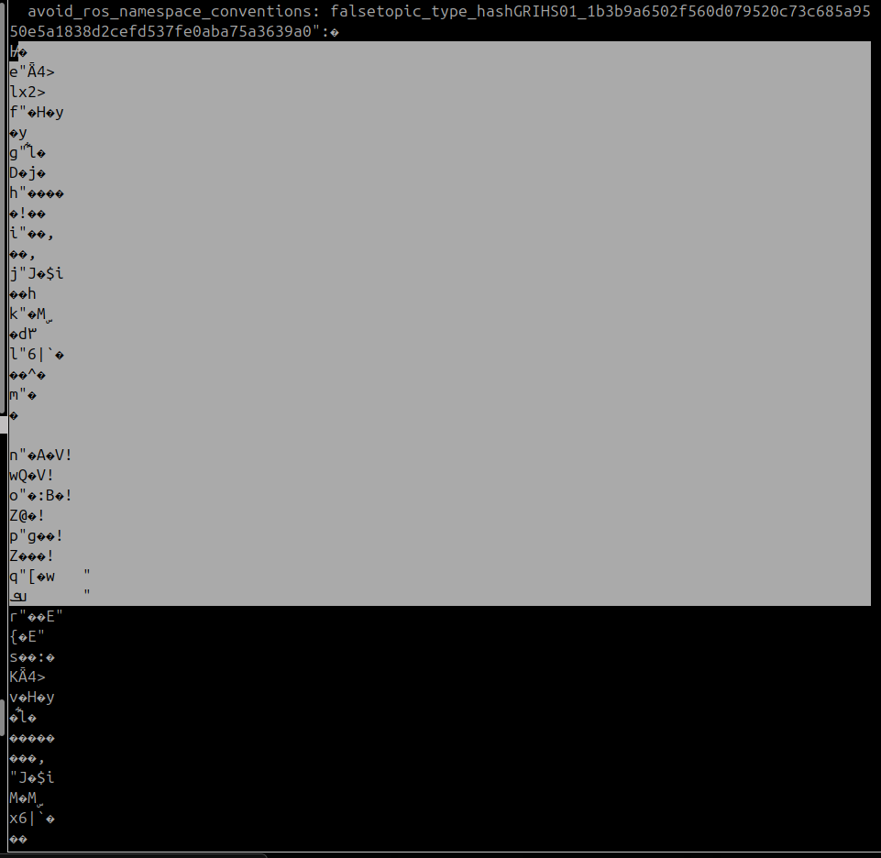

ros2 bag record -o test /number_count (for custom folder and name to save)

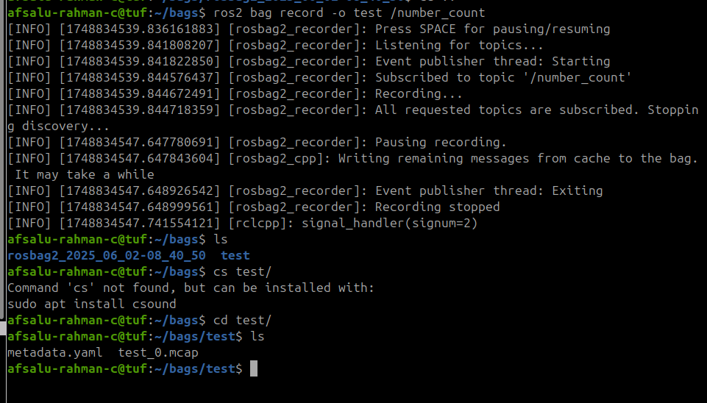

ros2 bag info test/ (quick infromation)

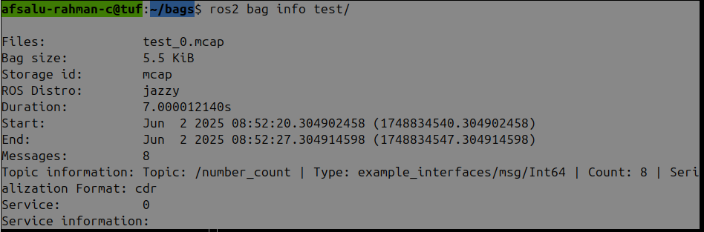

ros2 bag play test/

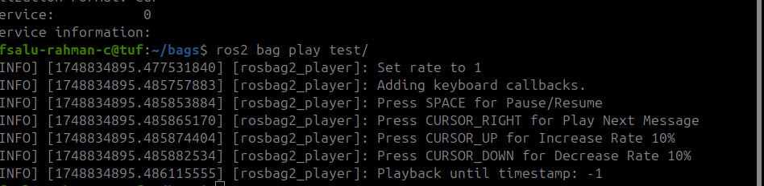

without a publisher and subscriber **we can see the recorded data with topic echo command**

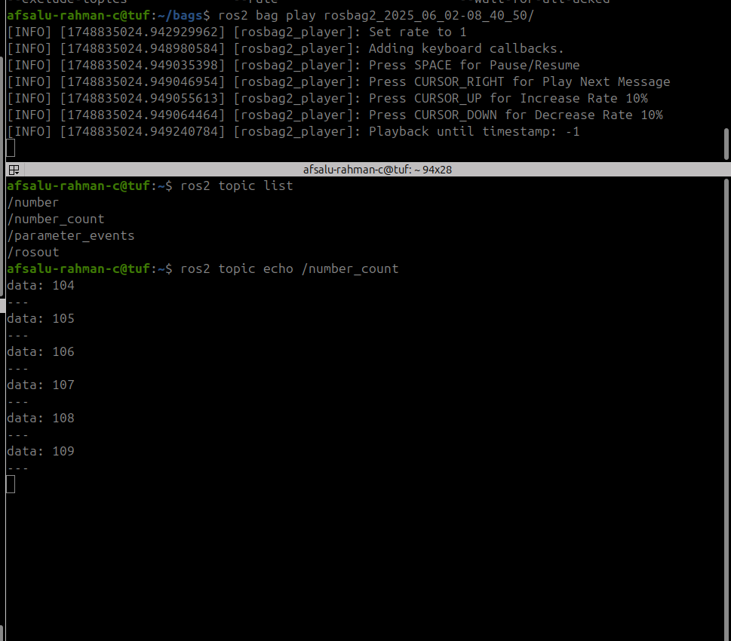

recording two topic data at same time

ros2 bag record -o test1 /number /number_count

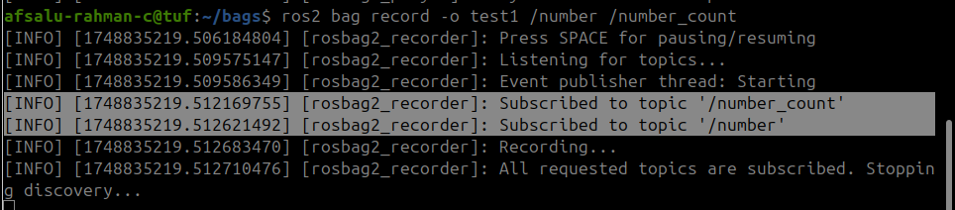

### 5.15 Conclusion

**Section Conclusion**

In this section you have seen how to use ROS 2 Topics to communicate between your nodes.

Now, you can already create more complex applications!

To recap, a topic is:

* **A named bus over which nodes exchange messages**
* **Used for unidirectional data streams**
* **Anonymous: publishers don’t know who is subscribing, and subscribers don’t know who is publishing.**

To implement topics in your ROS 2 application:

* First create a node (or start from an existing one), then inside your node you can create any number of publishers/subscribers.
* A publisher and subscriber must publish/subscribe to the **same topic name, and use the same data type**. Those are the 2 conditions for successful topic communication.
* Then, once you’ve added some publishers/subscribers in your nodes, just launch your nodes, and the communication starts! You can **debug them using the “ros2” command line tool, as well as rqt**.

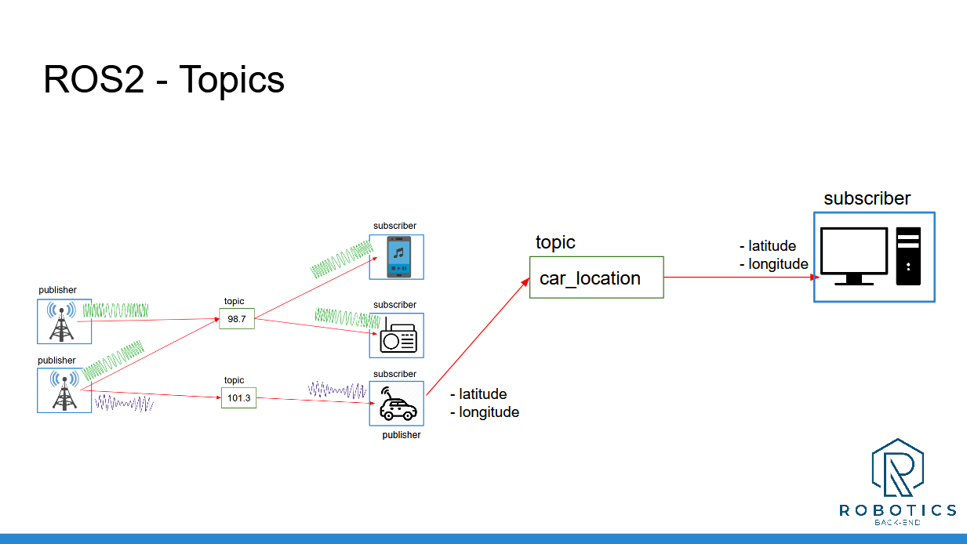

Note: your **topic names should start with a letter (“98.7” is not a valid topic name, it was just used to introduce the concept with a real life analogy**).

By using nodes, you can easily separate your code into different independent modules, one for each part of your application. And with topics, you can make them communicate.

And now, after Topics, the next logical step is to look at ROS 2 Services. That’s what we’ll see in the next section.

___________________________________

Download the complete code for this section (this is the code from all previous sections + the current one).

# 

# Section 6 - Service communication

### 6.1 Intro

Intro

The **two most important communication features in ROS 2 are Topics and Services.**

**Topics are used for data streams, and Services for a client/server interaction**.

At the end of this section you’ll be able to make your nodes communicate with ROS2 Services.

Here’s what you’ll do:

Understand what ROS Services are, and when to use them, thanks to a real life analogy.

Write your own Service (client + server) in both Python and C++.

Introspect Services from the terminal.

Experiment on Turtlesim.

And, as usual, you will finish the section with an activity, based on all the code you’ve written so far.

When you feel ready, let’s get started!

### 6.2 What is ROS2 service

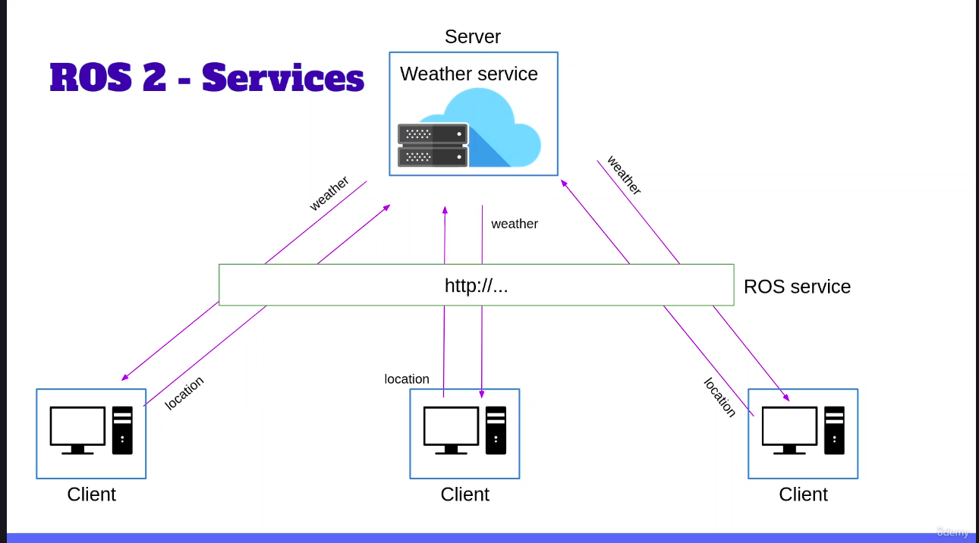

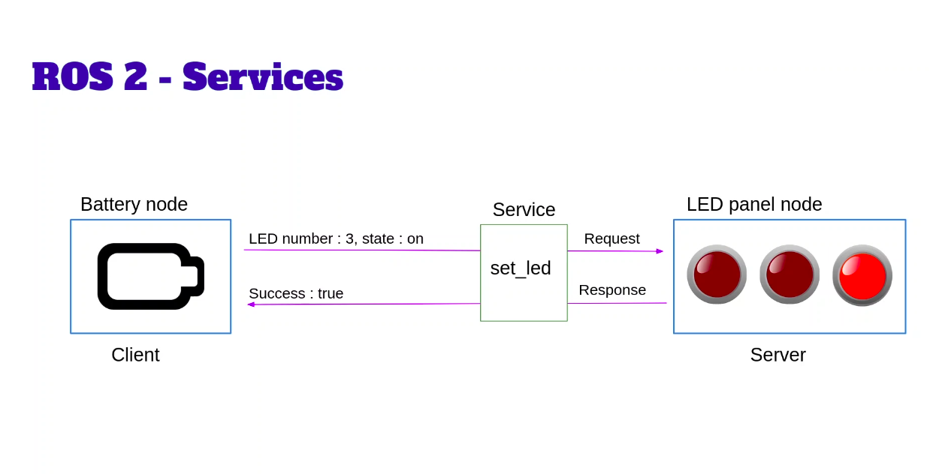

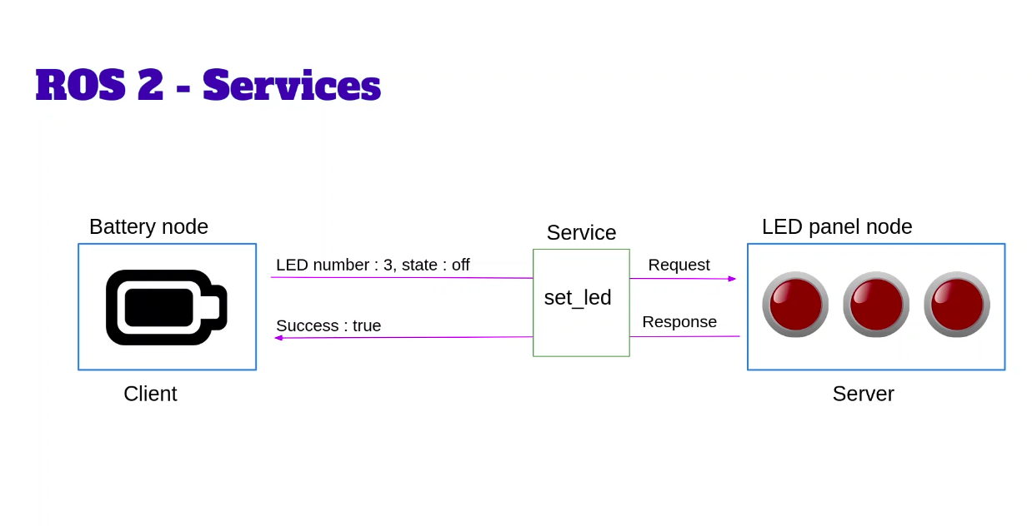

ROS2 service can be **Synchronous** and **Asynchronous**

In synchronous client block until the response get

When asynchronous, the client will send a request and then register a callback function for the response

Also, a service is **defined by a name and a pair of messages.**

So two messages here.

One message is the **request**, the other one is the **response**.

To conclude, you can see that services offer a nice complementarity with topics.

Topics will be used for unidirectional data streams and services will be used when you need a client server communication.

# 

### 6.3 Write Python service server

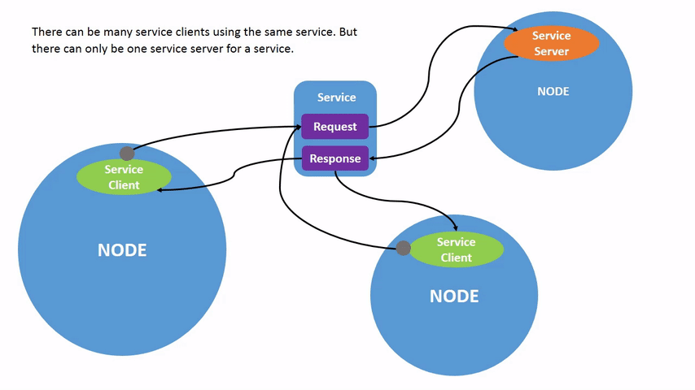

Because a service is defined by a name and an interface, the interface we will use.

ros2 interface show example_interfaces/srv/AddTwoInts

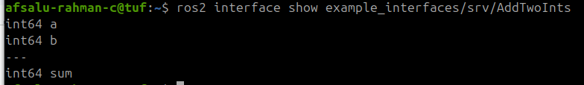

from client need a and b from server get sum

creating python file

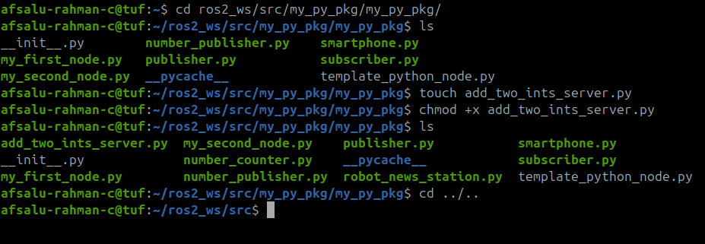

in code it is **better to use service name as verb** because client server communication mainly used in action based cases   
  
eg: turin ON/OFF motor

ros2 run my_py_pkg add_two_ints_server

ros2 node info /add_two_ints_server

ros2 service list

*another terminal*

ros2 service call /add_two_ints example_interfaces/srv/AddTwoInts "{a: 3, b: 7}" (suitable for only simple service, not for array like that)

we can see in terminal 1

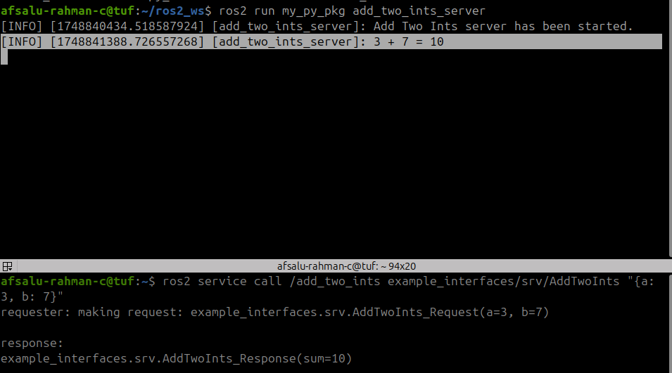

#### code

#!/usr/bin/env python3

import rclpy

from rclpy.node import Node

from example_interfaces.srv import AddTwoInts

class AddTwoIntsServerNode(Node):

def __init__(self):

super().__init__("add_two_ints_server")

self.server_ = self.create_service(

AddTwoInts,"add_two_ints", self.callback_add_two_ints) //add_two_ints is service name

self.get_logger().info("Add Two Ints server has been started.")

def callback_add_two_ints(self, request: AddTwoInts.Request, response: AddTwoInts.Response):

response.sum = request.a + request.b

self.get_logger().info(str(request.a) + " + " +

str(request.b) + " = " + str(response.sum))

return response #Don't forget "may you can't find this misteake"

def main(args=None):

rclpy.init(args=args)

node = AddTwoIntsServerNode()

rclpy.spin(node)

rclpy.shutdown()

if __name__ == "__main__":

main()

*NOTE: Don't forget the ‘return’ of callback function*

*Server side request and response are defined*

***Server:***

*request: AddaTwoInts.Request*

*response:AddTwoInts.Response*

*Client side only request is defined*

***Client***

*request = AddTwoInts.Request*

### 6.4 Write a Python Service Client - no OOP

ros2 run my_py_pkg add_two_ints_client_no_oop 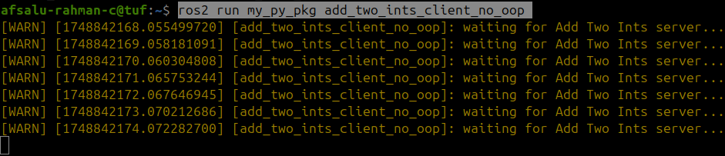

when run server node

ros2 run my_py_pkg add_two_ints_server

client is stopped to show the warning ⚠️

[Synchronous and asynchronous client server communication in ROS2](https://chatgpt.com/share/6845580e-c9d0-800d-be52-ad7fb74fe5ae)

In this course it is recommended to use asynchronous communication.

client.call >> is synchronous

client.call_async >> is asynchronous

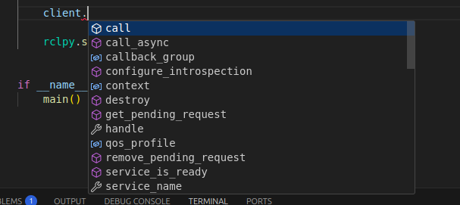

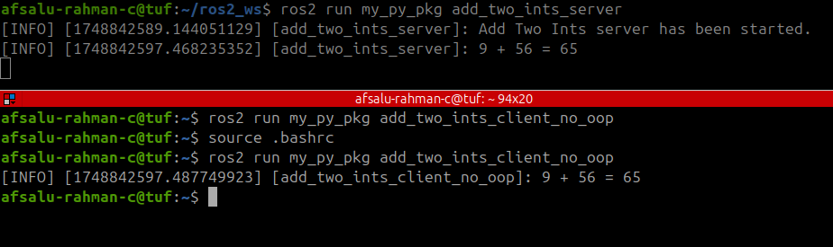

#### code

#!/usr/bin/env python3

import rclpy

from rclpy.node import Node

from example_interfaces.srv import AddTwoInts

def main(args=None):

rclpy.init(args=args)

node = Node("add_two_ints_client_no_oop")

client_ = node.create_client(AddTwoInts,"add_two_ints") #created with ‘node’ object

'''

may show error while running if server not running

'''

while not client_.wait_for_service(1.0): #display after every one second

node.get_logger().warn("waiting for Add Two Ints server...")

request = AddTwoInts.Request()

request.a = 9

request.b = 56

future = client_.call_async(request) #return a object in future

rclpy.spin_until_future_complete(node, future) #run until future is complete

response = future.result()

node.get_logger().info(str(request.a) + " + " +

str(request.b) + " = " + str(response.sum))

rclpy.shutdown()

if __name__ == "__main__":

main()

***NOTE***: above python client script can be used as the template to test , because may be introspecting from terminal is a mess

Small changes in code are needed according to them.

### 6.5 Write a Python Service Client - OOP

rclpy.spin_until_future_complete(node, future)

So if we use that we are basically going to make a node spin while it is already spinning.

And that can lead to very weird behaviors.(unconventional)

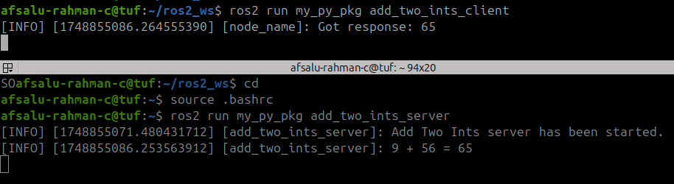

#### code initial

#!/usr/bin/env python3

import rclpy

from rclpy.node import Node

from example_interfaces.srv import AddTwoInts

class AddTwoIntsClient(Node):

def __init__(self):

super().__init__("add_two_ints_client")

self.client_ = self.create_client(AddTwoInts,"add_two_ints")

def call_add_two_ints(self, a, b):

while not self.client_.wait_for_service(1.0): #wait for 1 seconds

self.get_logger().warn("waiting for Add Two Ints server...")

request = AddTwoInts.Request()

request.a = a

request.b = b

future = self.client_.call_async(request)

future.add_done_callback(self.callback_call_add_two_ints)

def callback_call_add_two_ints(self, future):

response = future.result()

self.get_logger().info("Got response: " + str(response.sum))

def main(args=None):

rclpy.init(args=args)

node = AddTwoIntsClient()

node.call_add_two_ints(2, 7)

rclpy.spin(node)

rclpy.shutdown()

if __name__ == "__main__":

main()

*Compared to no oop , oop method have two extra function with “call_add_two_ints’ for implementation and “callback_call_add_two_ints” for future object implementation*

*Above code is working, if I try to add request in ‘callback_call_add_two_ints’ it will show error.*

error before adding the partial Because the future add on callback got an unexpected keyword argument because you've added an extra argument here.

Note:

So just remember that if you want to add extra arguments to a callback with add-on callback for a future object, you need to add the **partial function here from func tools.**

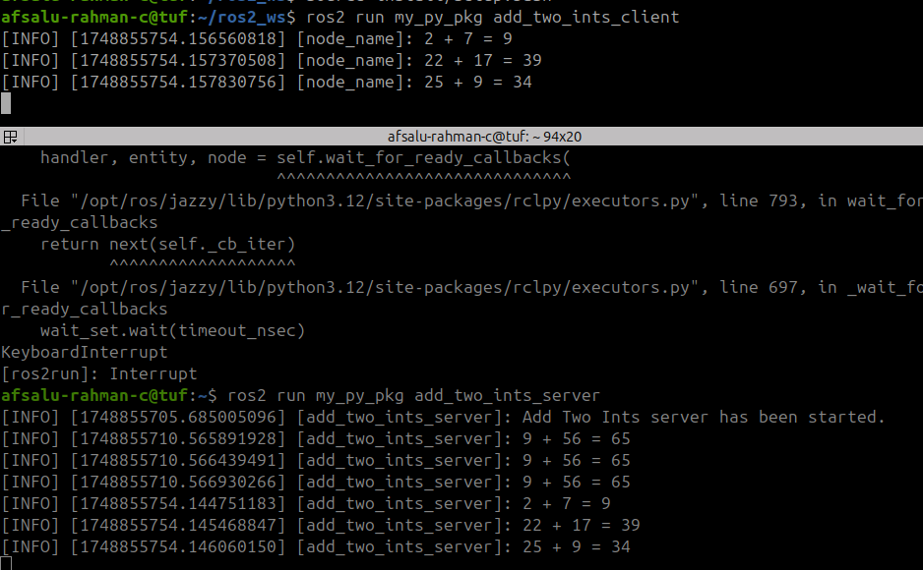

#### code last

#!/usr/bin/env python3

import rclpy

from rclpy.node import Node

from example_interfaces.srv import AddTwoInts

from functools import partial

class AddTwoIntsClient(Node):

def __init__(self):

super().__init__("node_name")

self.client_ = self.create_client(AddTwoInts,"add_two_ints")

def call_add_two_ints(self, a, b):

while not self.client_.wait_for_service(1.0): #wait for 1 seconds

self.get_logger().warn("waiting for Add Two Ints server...")

request = AddTwoInts.Request()

request.a = a

request.b = b

future = self.client_.call_async(request)

future.add_done_callback(

partial(self.callback_call_add_two_ints, request=request))

def callback_call_add_two_ints(self, future, request):

response = future.result()

self.get_logger().info(str(request.a) + " + " +

str(request.b) + " = " + str(response.sum))

def main(args=None):

rclpy.init(args=args)

node = AddTwoIntsClient()

node.call_add_two_ints(2, 7)

node.call_add_two_ints(22, 17)

node.call_add_two_ints(25, 9)

rclpy.spin(node)

rclpy.shutdown()

if __name__ == "__main__":

main()

one client can request multiple times and server will respond to the request

***Inshort***

1. Server and client have callback function (in client only for oop)
2. OOP code in client is preferred
3. Partial function in client(OOP) is needed for multiple arguments
4. In OOP client in additional there is a extra callback for future object handling and result printing

### 6.6 write C++ Server

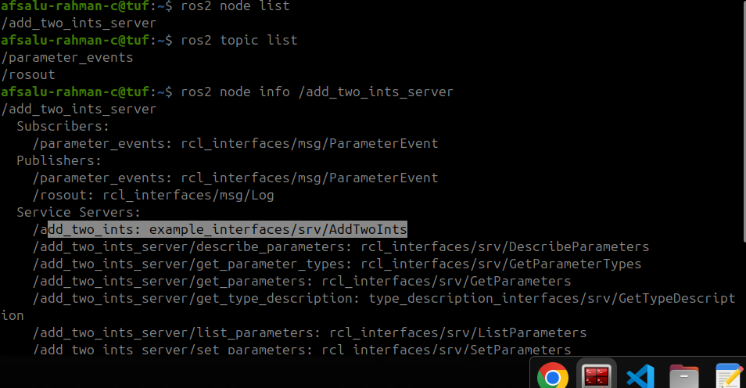

Worked with python client

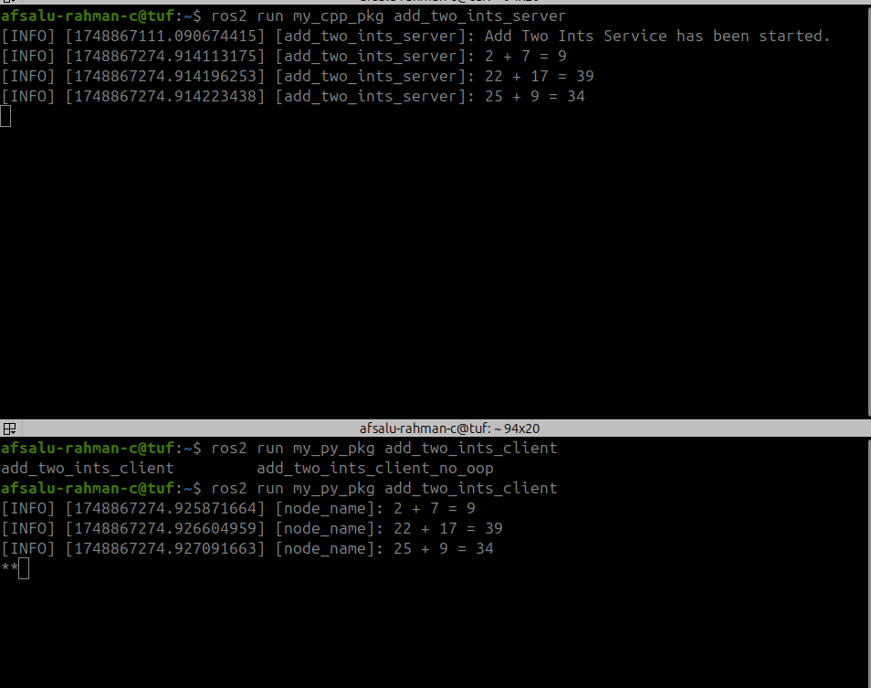

#### code

#include "rclcpp/rclcpp.hpp"

#include "example_interfaces/srv/add_two_ints.hpp"

using namespace std::placeholders;

class AddTwoIntsServerNode : public rclcpp::Node

{

public:

AddTwoIntsServerNode() : Node("add_two_ints_server")

{

server_ = this->create_service<example_interfaces::srv::AddTwoInts>(

"add_two_ints",

std::bind(&AddTwoIntsServerNode::callbackAddTwoInts, this, _1, _2)); //FOR request and response need to pass to the function

RCLCPP_INFO(this->get_logger(),"Add Two Ints Service has been started.");

}

private:

void callbackAddTwoInts(const example_interfaces::srv::AddTwoInts::Request::SharedPtr request,

const example_interfaces::srv::AddTwoInts::Response::SharedPtr response)

{

response->sum = request->a + request->b;

RCLCPP_INFO(this->get_logger(), "%d + %d = %d",

(int)request->a, (int)request->b, (int)response->sum);

}

rclcpp::Service<example_interfaces::srv::AddTwoInts>::SharedPtr server_;

};

int main(int argc, char **argv)

{

rclcpp::init(argc, argv);

auto node = std::make_shared<AddTwoIntsServerNode>();

rclcpp::spin(node);

rclcpp::shutdown();

return 0;

}

**using namespace std::placeholders;**

As like **subscriber** in topic based communication

Server side request and response are defined

**Server**:

const example_interfaces::srv::AddTwoInts::Request::SharedPtr request,

const example_interfaces::srv::AddTwoInts::Response::SharedPtr response

Client side only request is defined

**Client**

auto request = std::make_shared<example_interfaces::srv::AddTwoInts::Request>();

### 6.7 Write a C++ Service Client - no OOP

*terminal 1*

ros2 run my_cpp_pkg add_two_ints_clent_no_oop

*terminal 2*

ros2 run my_cpp_pkg add_two_ints_server

#include "rclcpp/rclcpp.hpp"

#include "example_interfaces/srv/add_two_ints.hpp"

using namespace std::chrono_literals;

int main(int argc, char **argv)

{

rclcpp::init(argc, argv);

auto node = std::make_shared<rclcpp::Node>("add_two_ints_client_no_oop");

auto client_ = node->create_client<example_interfaces::srv::AddTwoInts>("add_two_ints");

while (!client_->wait_for_service(1s))

{

RCLCPP_WARN(node->get_logger(),"Waiting for the server ...");

}

auto request = std::make_shared<example_interfaces::srv::AddTwoInts::Request>();

//with shared ptr , not like 'auto msg = example_interfaces::msg::Int64();'

request->a = 9;

request->b = 45;

auto future = client_->async_send_request(request); //send request asynchronusly

rclcpp::spin_until_future_complete(node, future);

auto response = future.get();

RCLCPP_INFO(node->get_logger(), "%d + %d = %d",

(int)request->a, (int)request->b, (int)response->sum);

rclcpp::shutdown();

return 0;

}

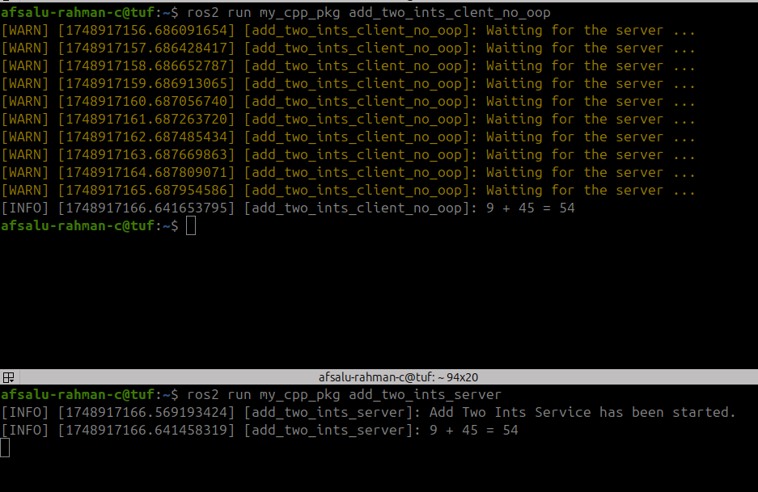

#### code

**using namespace std::chrono_literals;**

As like **publisher** in topic based communication  
  
***Note***

We can use it as template for testing, as like python, but may be preferred because of less time consuming due to symlink install

### 6.8 C++ server with OOP



#### code

#include "rclcpp/rclcpp.hpp"

#include "example_interfaces/srv/add_two_ints.hpp"

using namespace std::placeholders;

using namespace std::chrono_literals;

class AddTwoIntsClientNode : public rclcpp::Node

{

public:

AddTwoIntsClientNode() : Node("add_two_ints_client_node")

{

client_ = this->create_client<example_interfaces::srv::AddTwoInts>("add_two_ints");

}

void callAddTwoInts(int a, int b)

{

while (!client_->wait_for_service(1s))

{

RCLCPP_WARN(this->get_logger(),"Waiting for the server ...");

}

auto request = std::make_shared<example_interfaces::srv::AddTwoInts::Request>();

request->a = a;

request->b = b;

client_->async_send_request(

request,std::bind(&AddTwoIntsClientNode::callbackAddTwoInts, this, _1));

}

private:

void callbackAddTwoInts(rclcpp::Client<example_interfaces::srv::AddTwoInts>::SharedFuture future) // declared as like server or client declaration

{

auto response = future.get();

RCLCPP_INFO(this->get_logger(),"Sum %d", (int)response->sum);

}

rclcpp::Client<example_interfaces::srv::AddTwoInts>::SharedPtr client_;

};

int main(int argc, char **argv)

{

rclcpp::init(argc, argv);

auto node = std::make_shared<AddTwoIntsClientNode>();

node->callAddTwoInts(10, 6);

node->callAddTwoInts(-8, 6);

node->callAddTwoInts(3, 16);

node->callAddTwoInts(10, 96);

rclcpp::spin(node);

rclcpp::shutdown();

return 0;

}

Compared to no oop , oop method have two extra function with “callAddTwoInts’ for implementation and “callbackAddTwoInts” for future object implementation

***Note:***

rclcpp::Client<example_interfaces::srv::AddTwoInts>::SharedFuture future

***SharedFuture*** is used

**No oop client declaration: auto client_ = node->create_client<example_interfaces::srv::AddTwoInts>("add_two_ints");**

**oop client declaration :** rclcpp::Client<example_interfaces::srv::AddTwoInts>::SharedPtr client_;

***Note:***

Comparing C++ and python server in C++ there is no return (void function) as like python for callback function

py

def callback_add_two_ints(self, request: AddTwoInts.Request, response: AddTwoInts.Response):

response.sum = request.a + request.b

self.get_logger().info(str(request.a) + " + " +

str(request.b) + " = " + str(response.sum))

return response #Don't forget "may you can't find this misteake"

C++

void callbackAddTwoInts(const example_interfaces::srv::AddTwoInts::Request::SharedPtr request,

const example_interfaces::srv::AddTwoInts::Response::SharedPtr response)

{

response->sum = request->a + request->b;

RCLCPP_INFO(this->get_logger(), "%d + %d = %d",

(int)request->a, (int)request->b, (int)response->sum);

}

### 6.9 Introspect Services with the ros2 Command Line

afsalu-rahman-c@tuf:~$ ros2 service

**call info**

**echo list**

**find type**

--include-hidden-services

afsalu-rahman-c@tuf:~$ ros2 service -h

usage: ros2 service [-h] [--include-hidden-services]

Call `ros2 service <command> -h` for more detailed usage.

...

Various service related sub-commands

options:

-h, --help show this help message and exit

--include-hidden-services

Consider hidden services as well

Commands:

**call Call a service**

**echo Echo a service**

**find Output a list of available services of a given type**

**info Print information about a service**

**list Output a list of available services**

**type Output a service's type**

Call `ros2 service <command> -h` for more detailed usage.

afsalu-rahman-c@tuf:~$

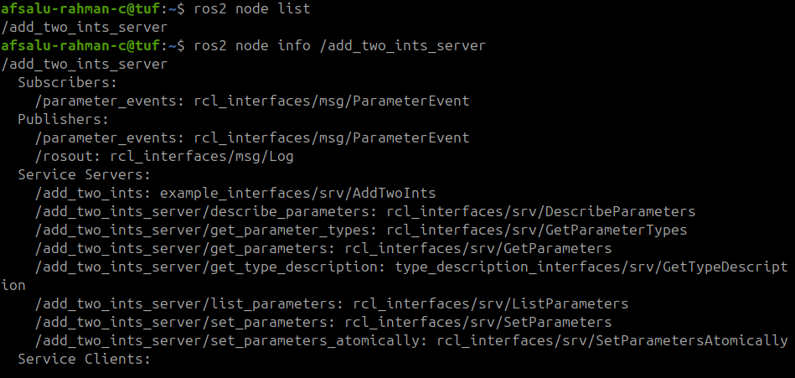

afsalu-rahman-c@tuf:~$ ros2 service list

**/add_two_ints**

/add_two_ints_server/describe_parameters

/add_two_ints_server/get_parameter_types

/add_two_ints_server/get_parameters

/add_two_ints_server/get_type_description

/add_two_ints_server/list_parameters

/add_two_ints_server/set_parameters

/add_two_ints_server/set_parameters_atomically

7 additional services

afsalu-rahman-c@tuf:~$ ros2 service info /add_two_ints

Type: example_interfaces/srv/AddTwoInts

Clients count: 0

Services count: 1

afsalu-rahman-c@tuf:~$ ros2 service type /add_two_ints

example_interfaces/srv/AddTwoInts

afsalu-rahman-c@tuf:~$

afsalu-rahman-c@tuf:~$ ros2 interface show example_interfaces/srv/AddTwoInts

int64 a

int64 b

---

int64 sum

afsalu-rahman-c@tuf:~$ ros2 service call /add_two_ints example_interfaces/srv/AddTwoInts

**a:\ 0\^Jb:\ 0\ -r**  --rate --stdin

afsalu-rahman-c@tuf:~$ ros2 service call /add_two_ints example_interfaces/srv/AddTwoInts

***a:\ 0\^Jb:\ 0\ -r is quite difficult to use***

afsalu-rahman-c@tuf:~$ ros2 service call /add_two_ints example_interfaces/srv/AddTwoInts "{a: 5, b: 7}"

*NOTE :* "{a: 5, b: 7}", care the space

#### With rqt

*terminal* rqt

*close initial terminal plugins->service->service caller->*

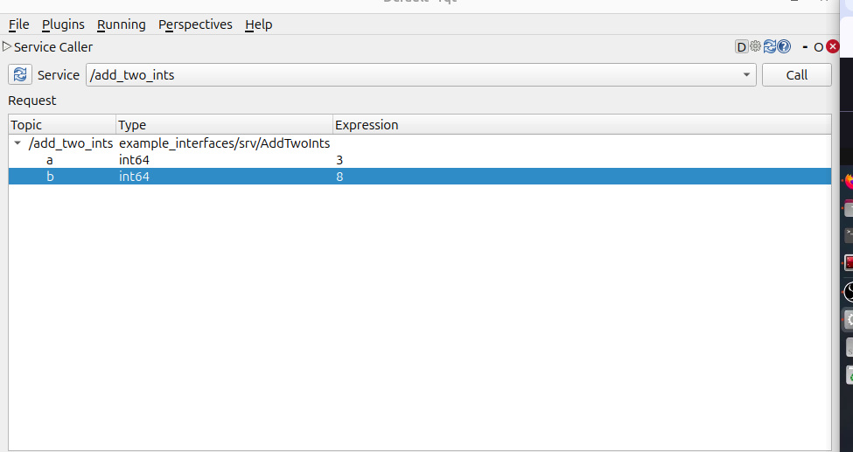

*call*

*will get the result*

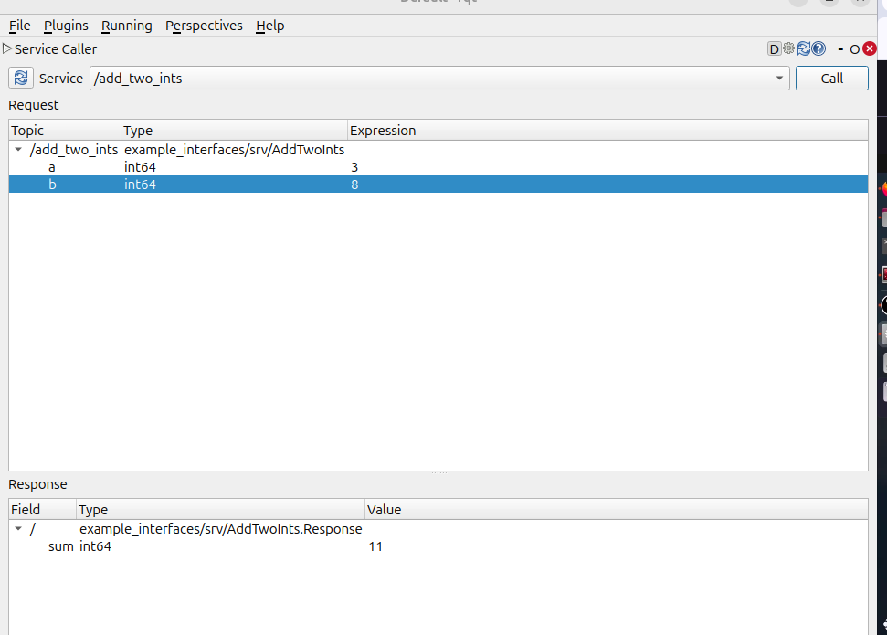

### 6.10 Remap a Service at Runtime

afsalu-rahman-c@tuf:~$ ros2 run my_py_pkg add_two_ints_server --ros-args -r add_two_ints:=abx

*Note: it is similar to remaling topic at runtime*

afsalu-rahman-c@tuf:~$ ros2 service list

/abx

afsalu-rahman-c@tuf:~$ ros2 run my_py_pkg add_two_ints_client --ros-args -r add_two_ints:=abx

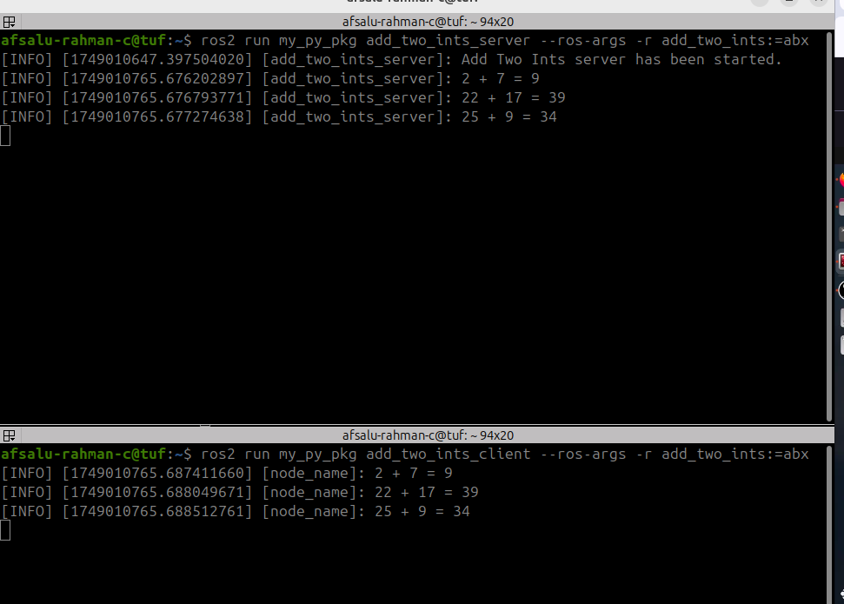

### 6.11 Experiment on Services with Turtlesim

ros2 run turtlesim turtlesim_node

ros2 run turtlesim turtle_teleop_key

ros2 service list

**/clear**

**/kill**

**/reset**

**/spawn**

/teleop_turtle/describe_parameters

/teleop_turtle/get_parameter_types

/teleop_turtle/get_parameters

/teleop_turtle/get_type_description

/teleop_turtle/list_parameters

/teleop_turtle/set_parameters

/teleop_turtle/set_parameters_atomically

**/turtle1/set_pen**

**/turtle1/teleport_absolute**

**/turtle1/teleport_relative**

/turtlesim/describe_parameters

/turtlesim/get_parameter_types

/turtlesim/get_parameters

/turtlesim/get_type_description

/turtlesim/list_parameters

/turtlesim/set_parameters

/turtlesim/set_parameters_atomically

(lot of among 7 of in our interests)

#### clear

ros2 service type /clear

std_srvs/srv/Empty

ros2 interface show std_srvs/srv/Empty

--- *(nothing to pass)*

ros2 service call /clear std_srvs/srv/Empty

response:

std_srvs.srv.Empty_Response()

(log see terminal 1 we can see the path of turtle will erase)

[INFO] [1749011856.123491820] [turtlesim]: Clearing turtlesim.

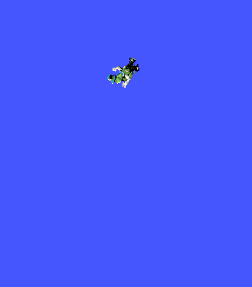

#### spawn

ros2 service type /spawn

turtlesim/srv/Spawn

ros2 interface show turtlesim/srv/Spawn

float32 x

float32 y

float32 theta

string name # Optional. A unique name will be created and returned if this is empty

---

string name

ros2 service call /spawn turtlesim/srv/Spawn “{x: 5.0, y: 5.0, name: ‘my_turtle’}”

[INFO] [1749012156.366526486] [turtlesim]: Spawning turtle [my_turtle] at x=[5.000000], y=[5.000000], theta=[0.000000]

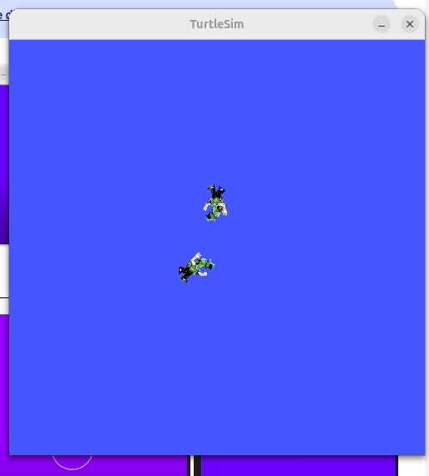

#### kill

ros2 service type /kill

turtlesim/srv/Kill

ros2 interface show turtlesim/srv/Kill

string name

---

afsalu-

ros2 service call /kill turtlesim/srv/Kill “{name: ‘my_tutrtle’}”

requester: making request: turtlesim.srv.Kill_Request(name='my_turtle')

response:

turtlesim.srv.Kill_Response()

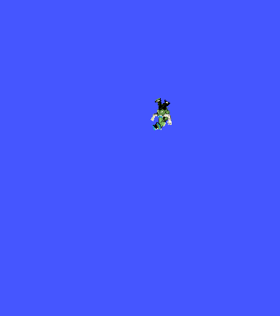

### 6.12 Activity 03 - ROS 2 Services

Let’s practice with ROS 2 Services!

You will start from the Topic activity you did in the last section on Topics.

Here is what you got:

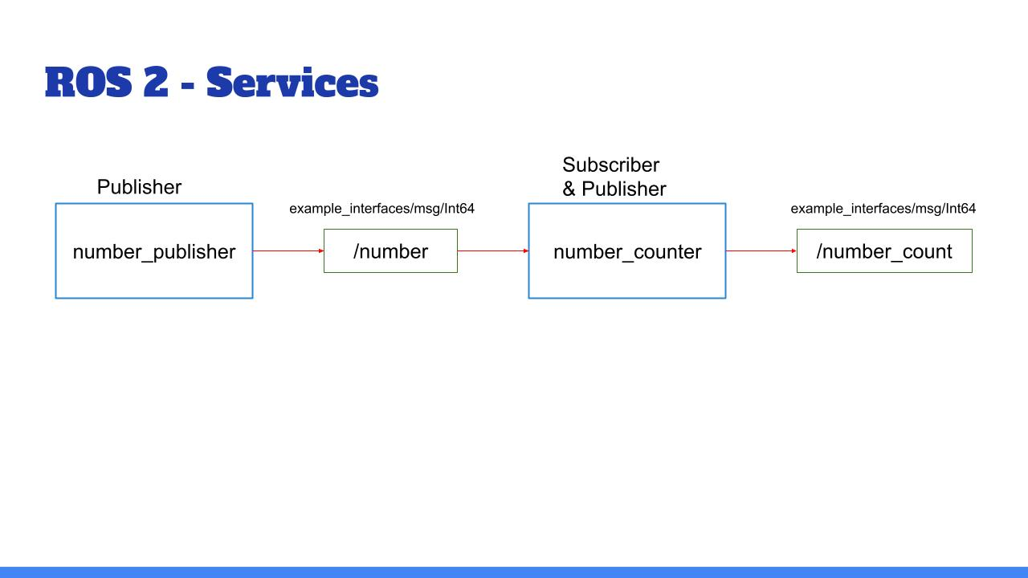

Quick recap:

* The node “number_publisher” publishes a number on the /”number” topic.
* The node “number_counter” gets the number, adds it to a counter, and publishes the counter on the “/number_count” topic.

And now, here is what you’ll add:

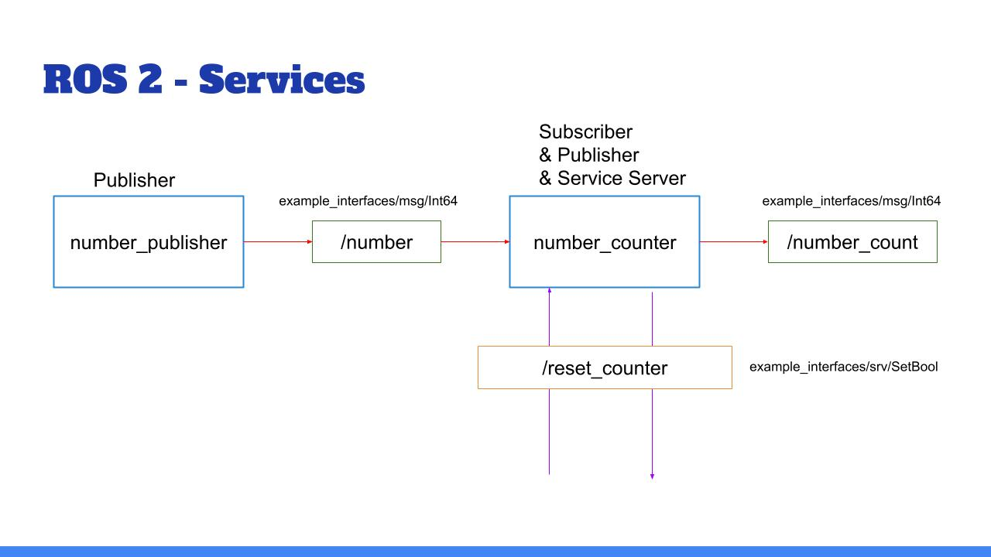

Add a functionality to reset the counter to zero:

* Create a service server inside the “number_counter” node.
* Service name: “**/reset_counter**”
* Service type: example_interfaces/srv/SetBool. Use “ros2 interface show” to discover what’s inside!
* When the server is called, you check the boolean data from the request. If true, you set the counter variable to 0.

We will then call the service directly from the command line. You can also decide - for more practice - to create your own custom node to call this “/reset_counter” service.

And of course, as always, you can do the activity for both the Python and Cpp versions.

I’ll see you in the next lecture for the solution.

#### My Py solution

afsalu-rahman-c@tuf:~$ ros2 interface show example_interfaces/srv/SetBool

# This is an example of a service to set a boolean value.

# This can be used for testing but a semantically meaningful

# one should be created to be built upon.

bool data # e.g. for hardware enabling / disabling

---

bool success # indicate successful run of triggered service

string message # informational, e.g. for error messages

**Service calling from terminal**

afsalu-rahman-c@tuf:~$ ros2 service call /reset_counter example_interfaces/srv/SetBool "{data: true}"

requester: making request: example_interfaces.srv.SetBool_Request(data=True)

response:

example_interfaces.srv.SetBool_Response(success=True, message='number_counter SET to zero')

afsalu-rahman-c@tuf:~$ ros2 service call /reset_counter example_interfaces/srv/SetBool "{data: false}"

requester: making request: example_interfaces.srv.SetBool_Request(data=False)

response:

example_interfaces.srv.SetBool_Response(success=False, message='number_counter NOT SET to zero')

#### code

#!/usr/bin/env python3

import rclpy

from rclpy.node import Node

from example_interfaces.msg import Int64

from example_interfaces.srv import SetBool

class NumberCounterNode(Node):

def __init__(self):

super().__init__("number_counter")

self.subscriber_ = self.create_subscription(Int64,"number",self.callback_number,10)

self.counter_ = 0

self.get_logger().info("Counter Reciver started")

self.publisher_ = self.create_publisher(Int64,"number_count",10)

**self.server_ = self.create_service(**

**SetBool,"reset_counter",self.callback_reset_counter)**

def callback_number(self, msg:Int64):

if msg.data == 50:

self.counter_ += 1

self.get_logger().info(f"Number of messages recived = {self.counter_}")

msg2 = Int64()

msg2.data = self.counter_

self.publisher_.publish(msg2)

def callback_reset_counter(self, request: SetBool.Request, response: SetBool.Response):

if request.data == True:

self.counter_ = 0

response.message = "number_counter SET to zero"

response.success = True

else:

response.message = "number_counter NOT SET to zero"

response.success = False

return response #this is IMPORTANT

def main(args=None):

rclpy.init(args=args)

node = NumberCounterNode()

rclpy.spin(node)

rclpy.shutdown()

if __name__ == "__main__":

main()

#### My cpp solution

afsalu-rahman-c@tuf:~$ ros2 service call /reset_counter example_interfaces/srv/SetBool "{data: true}"

requester: making request: example_interfaces.srv.SetBool_Request(data=True)

response:

example_interfaces.srv.SetBool_Response(success=True, message='conter SET to zero')

afsalu-rahman-c@tuf:~$ ros2 service call /reset_counter example_interfaces/srv/SetBool "{data: false}"

requester: making request: example_interfaces.srv.SetBool_Request(data=False)

response:

example_interfaces.srv.SetBool_Response(success=False, message='conter NOT SET to zero')

#### code

#include "rclcpp/rclcpp.hpp"

#include "example_interfaces/msg/int64.hpp"

#include "example_interfaces/srv/set_bool.hpp"

using namespace std::placeholders;

class NumberCounterNode : public rclcpp::Node

{

public:

NumberCounterNode() : Node("number_counter"), counter_(0) // constructor initialization is recommended

{

subscriber_ = this->create_subscription<example_interfaces::msg::Int64>(

"number",10,

std::bind(&NumberCounterNode::callbackNumber, this,_1));

publisher_ = this->create_publisher<example_interfaces::msg::Int64>("number_count",10);

**server_ = this->create_service<example_interfaces::srv::SetBool>("reset_counter",**

**std::bind(&NumberCounterNode::callbackResetNumber,this,_1,_2));**

}

private:

void callbackNumber(const example_interfaces::msg::Int64 msg) //means that the msg object is passed by value as a constant

{

if(msg.data == 50)

{

counter_++;

RCLCPP_INFO(this->get_logger(), "Number of messages recived = %ld",counter_);

auto msg2 = example_interfaces::msg::Int64();

msg2.data = counter_;

publisher_->publish(msg2);

}

}

void callbackResetNumber(const example_interfaces::srv::SetBool::Request::SharedPtr request,

const example_interfaces::srv::SetBool::Response::SharedPtr response)

{

if (request->data == true)

{

counter_ = 0;

response->message = "conter SET to zero";

response->success = true;

}

else

{

response->message = "conter NOT SET to zero";

response->success = false;

}

}

rclcpp::Subscription<example_interfaces::msg::Int64>::SharedPtr subscriber_;

rclcpp::Publisher<example_interfaces::msg::Int64>::SharedPtr publisher_;

std::int64_t counter_;

**rclcpp::Service<example_interfaces::srv::SetBool>::SharedPtr server_;**

};

int main(int argc, char **argv)

{

rclcpp::init(argc, argv);

auto node = std::make_shared<NumberCounterNode>();

rclcpp::spin(node);

rclcpp::shutdown();

return 0;

}

### 6.14 Conclusion

In this section you have discovered ROS2 Services, and seen how you can use them to add client/server communications between your nodes.

To recap, Services are:

Used for client/server types of communication.

Synchronous or asynchronous (though it’s re**commended to use them asynchronously**, even if you decide to wait after in the thread).

Anonymous: a client does not know which node is behind the service, it just calls the service. And the server does not know which nodes are clients, it just receives requests and responds to them.

To implement Services inside your nodes:

Create a node or start from an existing one. Add as many Service servers as you want (all with different names)

When you call a Service server from a Service client, make sure that the **Service name, as well as the Service type (request + response) are identical.**

You can **only create one server for a Service, but you can create many clients.**

**When you want to add a new communication between your nodes, ask yourself this question: “Am I just sending some data, or do I expect a response after I send the message?”. This will tell you if you need to use a Topic or a Service. And, as you progress with ROS2, it will eventually become quite obvious for you.**

So, now you can create nodes and make them communicate between each other. But, you’ve only used existing messages so far. What if you need to use other message types for your Topics and Services?

Well, in this case, you’ll need to build your own message types, and that’s what we’ll see in the next section.

__________________________________

# Section 7 - Custom Interface(msg, srv)

### 7.1 Intro

ROS 2 interfaces are the messages and services you use with your topics and services.

For now you’ve only used existing interfaces so you could focus on learning how topics and services work.

Now, it’s time to learn how to use your own message/service types!

At the end of this section you’ll be able to:

Create and build your own interfaces with msg and srv definitions

Use those interfaces with your topics and services

You will also do a complete activity to work on nodes, topics, services, and custom interfaces.

But first, let’s see what ROS 2 interfaces are.

### 7.2 What is ROS2 interface

And well you can see topics and services as the communication layer tool, and the interfaces or the

messages are the actual content that you send.

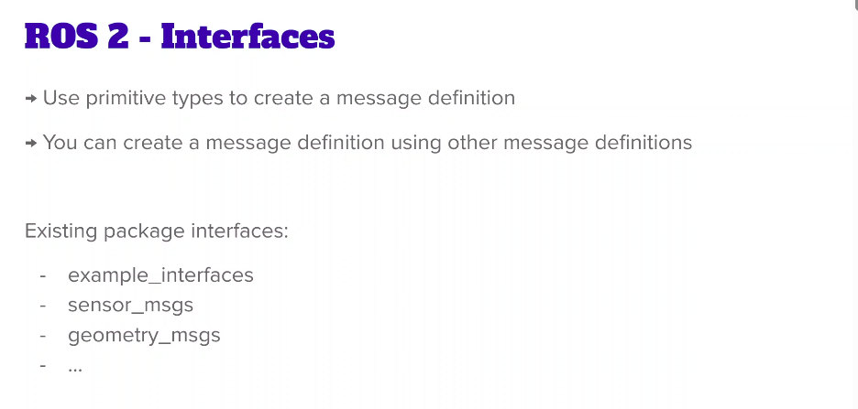

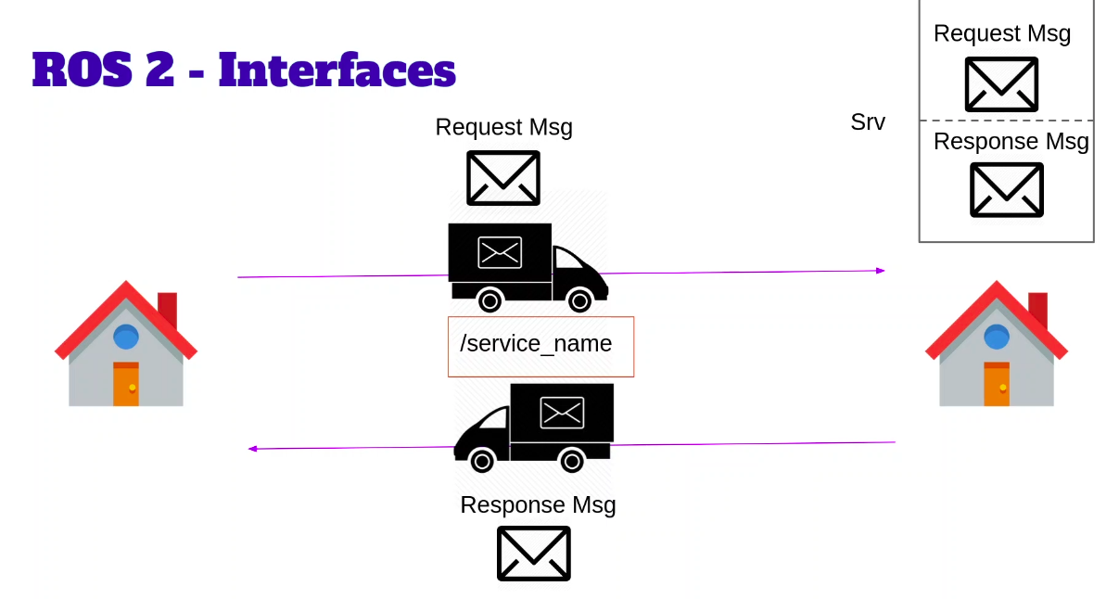

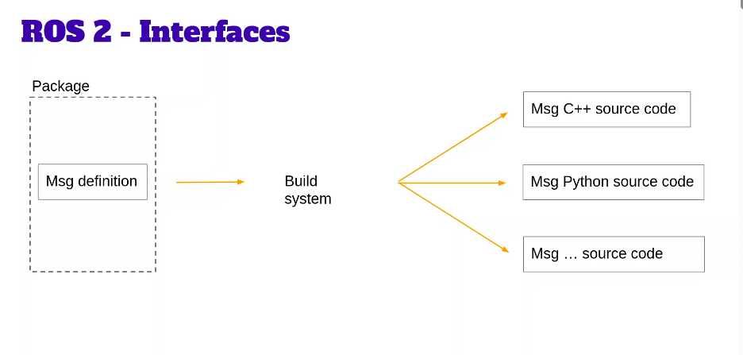

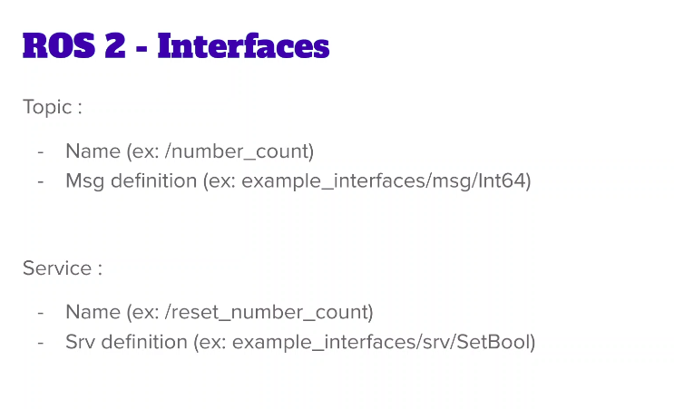

[Find below in](https://docs.ros.org/en/foxy/Concepts/About-ROS-Interfaces.html)

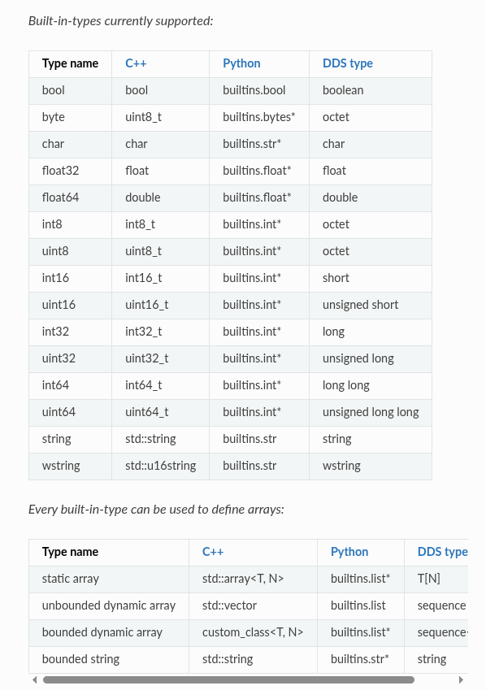

[We can find existing packages - GitHub (ExistingInterface)](https://github.com/ros2/example_interfaces/tree/jazzy)

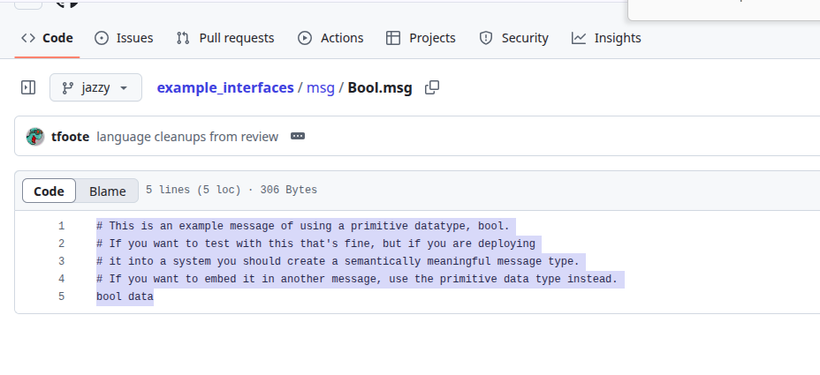

sudo apt install ros-jazzy-shape-msgs (replace ‘_’ with ‘-’)

[Common Interface GitHub](https://github.com/ros2/common_interfaces/tree/jazzy)

some of them install while installing ros

if I want I can install manually, by

to install shape_msgs

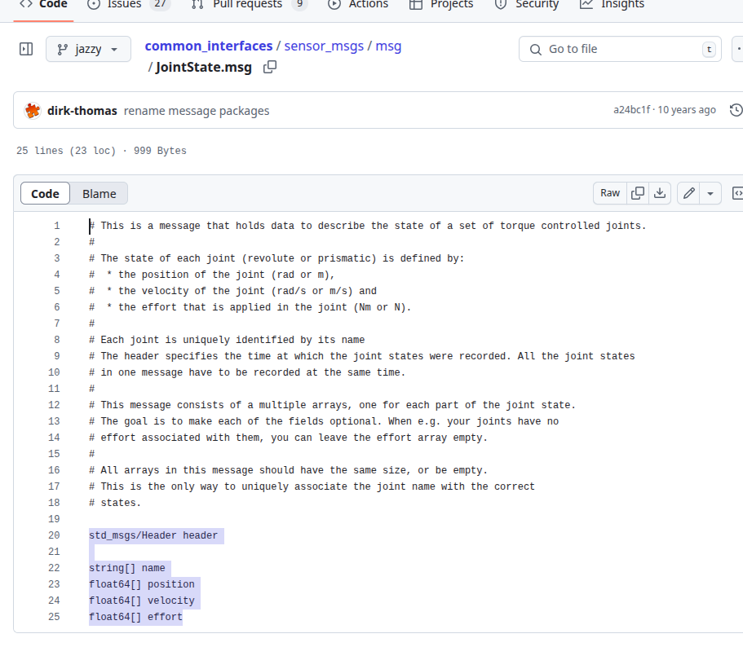

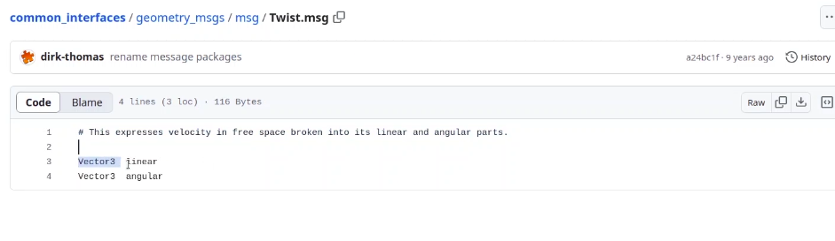

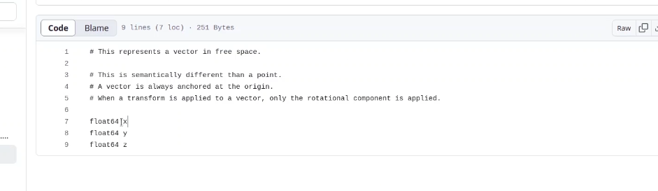

Note: we can include message inside service but vice versa not

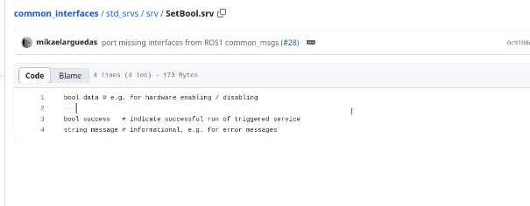

### 7.3 Create and Build Your First Custom Msg

**Note**:

1. If you want you can create the interface anywhere but it is recommended to create in a separate package
2. It is better to create package with name robot_name_interface like model here my_robot_interfaces
3. If you just create a package with “ros2 pkg create my_robot_interfaces” wil create a default package in c++

After creation of package include and src folder are removed

<**buildtool**_depend>rosidl_default_generators</buildtool_depend>

<**exec**_depend>rosidl_default_runtime</exec_depend>

<**member**_of_group>rosidl_interface_packages</member_of_group>

in package.xml file add above 3 lines, these are taken from internet

[ROS2 Create Custom Message (Msg/Srv)](https://roboticsbackend.com/ros2-create-custom-message/)

Also in CMkakeLIsts.txt added

find_package(rosidl_default_generators REQUIRED)

rosidl_generate_interfaces(${PROJECT_NAME}

"your custom interfaces will be here"

"one per line"

"no comma for separating lines"

)

ament_export_dependencies(rosidl_default_runtime)

cleaned CMakeLists.txt added below line from above site

Created msg directory and added HardwareStaus.msg file as below to show while running the “ros interface show my_robot_interfaces/msg/HardwareStatus” command

float64 temperature

bool are_motors_ready

string debug_message

and added the path to CMakeLists.txt

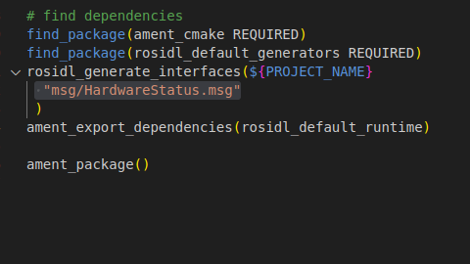

After build

afsalu-rahman-c@tuf:~$ r**os2 interface show my_robot_interfaces/msg/HardwareStatus**

float64 temperature

bool are_motors_ready

string debug_message

### 7.4 Use Your Custom Msg in a Python Node

Created new python file as “hardware_status_publisher.py” with executable

added dependency in package.xml as

in code imported the from my_robot_interfaces.msg import HardwareStatus

***Note***:if vs code not detecting (see by color, reopen from sourced terminal)

<depend>my_robot_interface</depend>

#### code

#!/usr/bin/env python3

import rclpy

from rclpy.node import Node

from my_robot_interfaces.msg import HardwareStatus

class HardwareStatusPublisherNode(Node):

def __init__(self):

super().__init__("hardware_status_pubisher")

self.hw_status_pub_ = self.create_publisher(HardwareStatus,"hardware_status", 10)

self.timer_ = self.create_timer(1.0,self.publish_hw_status)

self.get_logger().info("Hw publish has been started.")

def publish_hw_status(self):

msg = HardwareStatus()

msg.temperature = 43.7

msg.are_motors_ready = True

msg.debug_message = "Nothing special"

self.hw_status_pub_.publish(msg)

def main(args=None):

rclpy.init(args=args)

node = HardwareStatusPublisherNode()

rclpy.spin(node)

rclpy.shutdown()

if __name__ == "__main__":

main()

added executable in [setup.py](http://setup.py) file then

afsalu-rahman-c@tuf:~/ros2_ws$ ros2 run my_py_pkg hw_status_publisher

[INFO] [1749958883.273522532] [hardware_status_pubisher]: Hw publish has been started.

afsalu-rahman-c@tuf:~$ ros2 topic echo /hardware_status

temperature: 43.7

are_motors_ready: true

debug_message: Nothing special

---

temperature: 43.7

are_motors_ready: true

debug_message: Nothing special

---

temperature: 43.7

are_motors_ready: true

debug_message: Nothing special

---

### 7.5 Use Your Custom Msg in a C++ Node

***Note:***

1. Created custom msg like below

my_robot_interfaces

msg

HardwareStatus.msg

1. But in include uppercase will replace to lower and in between two word ‘_’ is there
2. Must follow the naming conventions, start with uppercase for each word ,no underscore or space separation between two words

When adding library "my_robot_interfaces/msg/hardware_status.hpp"

auto completion work willnot worked, ie not identified this can correct by adding path to c_cpp_properties.json file under .vscode folder to see path to add follow below steps

Note:

1. Include folder usually have header files for c++
2. If you want you can browse the files and find .hpp files for the interfaces

afsalu-rahman-c@tuf:~/ros2_ws/src$ cd ..

afsalu-rahman-c@tuf:~/ros2_ws$ cd install/

afsalu-rahman-c@tuf:~/ros2_ws/install$ ls

COLCON_IGNORE local_setup.sh local_setup.zsh my_robot_bringup setup.ps1

local_setup.bash _local_setup_util_ps1.py my_cpp_pkg my_robot_interfaces setup.sh

local_setup.ps1 _local_setup_util_sh.py my_py_pkg setup.bash setup.zsh

afsalu-rahman-c@tuf:~/ros2_ws/install$ cd my_robot_interfaces/

afsalu-rahman-c@tuf:~/ros2_ws/install/my_robot_interfaces$ ls

include lib share

afsalu-rahman-c@tuf:~/ros2_ws/install/my_robot_interfaces$ cd include/

afsalu-rahman-c@tuf:~/ros2_ws/install/my_robot_interfaces/include$ pwd (print working directory)

/home/afsalu-rahman-c/ros2_ws/install/my_robot_interfaces/include

afsalu-rahman-c@tuf:~/ros2_ws/install/my_robot_interfaces/include$

add as with ending */\*\**

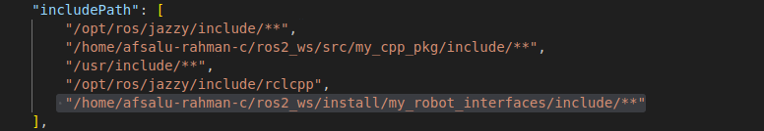

#### code

#include "rclcpp/rclcpp.hpp"

#include "my_robot_interfaces/msg/hardware_status.hpp"

using namespace std::chrono_literals;

class HardwareStatusPublisherNode : public rclcpp::Node

{

public:

HardwareStatusPublisherNode() : Node("hardware_status_publisher")

{

publisher_ = this->create_publisher<my_robot_interfaces::msg::HardwareStatus>("hardware_status", 10);

timer_ = this->create_wall_timer(

1s,

std::bind(&HardwareStatusPublisherNode::publishHardwareStatus, this));

RCLCPP_INFO(this->get_logger(),"Hardware status publisher has been started");

}

private:

void publishHardwareStatus()

{

auto msg = my_robot_interfaces::msg::HardwareStatus();

msg.temperature = 98.6;

msg.are_motors_ready = false;

msg.debug_message = "Motors are too hot!";

publisher_->publish(msg);

}

rclcpp::Publisher<my_robot_interfaces::msg::HardwareStatus>::SharedPtr publisher_;

rclcpp::TimerBase::SharedPtr timer_;

};

int main(int argc, char **argv)

{

rclcpp::init(argc, argv);

auto node = std::make_shared<HardwareStatusPublisherNode>();

rclcpp::spin(node);

rclcpp::shutdown();

return 0;

}

add executable, dependencies and install in CMakeLIsts.txt also dependency in package.xml file

ros2 run my_cpp_pkg hw_status_publisher

afsalu-rahman-c@tuf:~$ ros2 topic echo /hardware_status

temperature: 98.6

are_motors_ready: false

debug_message: Motors are too hot!

---

temperature: 98.6

are_motors_ready: false

### 7.6 Create and Build Your First Custom Srv

create new directory named srv and in that file ComputeRectangleArea.srv file

***Note:***Must follow the naming conventions, start with uppercase for each word ,no underscore or space separation between two words

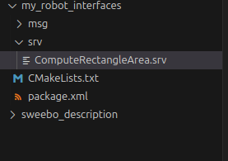

below one is a valid definition

---

***Note:***

“---” needed for any service definition

below one also a valid srv (with no response)

float64 lenght

float64 width

---

***Note:***make sure to add in cMakeLists.txt WITHOUT a comma

rosidl_generate_interfaces(${PROJECT_NAME}

"msg/HardwareStatus.msg"

"srv/ComputeRectangleArea.srv"

)

#### code

float64 lenght

float64 width

---

float64 area

after build and source

afsalu-rahman-c@tuf:~/ros2_ws$ ros2 interface show my_robot_interfaces/

my_robot_interfaces/msg/HardwareStatus my_robot_interfaces/srv/ComputeRectangleArea

afsalu-rahman-c@tuf:~/ros2_ws$ ros2 interface show my_robot_interfaces/srv/ComputeRectangleArea

float64 lenght

float64 width

---

float64 area

### 7.7 Introspect Interfaces with the ros2 Command Line

afsalu-rahman-c@tuf:~$ ros2 interface show example_interfaces/msg/Int64

# This is an example message of using a primitive datatype, int64.

# If you want to test with this that's fine, but if you are deploying

# it into a system you should create a semantically meaningful message type.

# If you want to embed it in another message, use the primitive data type instead.

int64 data

afsalu-rahman-c@tuf:~$ ros2 interface show my_robot_interfaces/msg/HardwareStatus

float64 temperature

bool are_motors_ready

string debug_message

ros2 interface list

*list all installed interface this include messages, actions and services*

afsalu-rahman-c@tuf:~$ ros2 interface package my_robot_interfaces (*list out all interface in my_robot_interface package)*

my_robot_interfaces/srv/ComputeRectangleArea

my_robot_interfaces/msg/HardwareStatus

afsalu-rahman-c@tuf:~$ ros2 interface package sensor_msgs

sensor_msgs/msg/Illuminance

sensor_msgs/msg/Imu

sensor_msgs/msg/Joy

sensor_msgs/msg/MultiEchoLaserScan

sensor_msgs/msg/RelativeHumidity

sensor_msgs/msg/JoyFeedbackArray

sensor_msgs/msg/RegionOfInterest

sensor_msgs/msg/Temperature

sensor_msgs/msg/CompressedImage

sensor_msgs/msg/PointField

sensor_msgs/msg/LaserEcho

sensor_msgs/msg/JointState

sensor_msgs/msg/NavSatFix

sensor_msgs/msg/PointCloud

sensor_msgs/msg/BatteryState

sensor_msgs/msg/MultiDOFJointState

sensor_msgs/msg/LaserScan

sensor_msgs/msg/TimeReference

sensor_msgs/msg/CameraInfo

sensor_msgs/srv/SetCameraInfo

sensor_msgs/msg/NavSatStatus

sensor_msgs/msg/MagneticField

sensor_msgs/msg/ChannelFloat32

sensor_msgs/msg/JoyFeedback

sensor_msgs/msg/PointCloud2

sensor_msgs/msg/Range

sensor_msgs/msg/Image

sensor_msgs/msg/FluidPressure

*If have a running node (eg: hw_status_publisher)*

ros2 node info /hardware_status_pubisher

/hardware_status_pubisher

Subscribers:

Publishers:

/hardware_status: my_robot_interfaces/msg/HardwareStatus

/parameter_events: rcl_interfaces/msg/ParameterEvent

/rosout: rcl_interfaces/msg/Log

Service Servers:

/hardware_status_pubisher/describe_parameters: rcl_interfaces/srv/DescribeParameters

/hardware_status_pubisher/get_parameter_types: rcl_interfaces/srv/GetParameterTypes

/hardware_status_pubisher/get_parameters: rcl_interfaces/srv/GetParameters

/hardware_status_pubisher/get_type_description: type_description_interfaces/srv/GetTypeDescription

/hardware_status_pubisher/list_parameters: rcl_interfaces/srv/ListParameters

/hardware_status_pubisher/set_parameters: rcl_interfaces/srv/SetParameters

/hardware_status_pubisher/set_parameters_atomically: rcl_interfaces/srv/SetParametersAtomically

Service Clients:

Action Servers:

Action Clients:

afsalu-rahman-c@tuf:~$ ros2 topic info /hardware_status

Type: my_robot_interfaces/msg/HardwareStatus

Publisher count: 1

Subscription count: 0

*with running add_two_ints_server service*

afsalu-rahman-c@tuf:~$ ros2 node list

/add_two_ints_server

afsalu-rahman-c@tuf:~$ ros2 node info /add_two_ints_server

/add_two_ints_server

Subscribers:

Publishers:

/parameter_events: rcl_interfaces/msg/ParameterEvent

/rosout: rcl_interfaces/msg/Log

Service Servers:

/add_two_ints: example_interfaces/srv/AddTwoInts

/add_two_ints_server/describe_parameters: rcl_interfaces/srv/DescribeParameters

/add_two_ints_server/get_parameter_types: rcl_interfaces/srv/GetParameterTypes

/add_two_ints_server/get_parameters: rcl_interfaces/srv/GetParameters

/add_two_ints_server/get_type_description: type_description_interfaces/srv/GetTypeDescription

/add_two_ints_server/list_parameters: rcl_interfaces/srv/ListParameters

/add_two_ints_server/set_parameters: rcl_interfaces/srv/SetParameters

/add_two_ints_server/set_parameters_atomically: rcl_interfaces/srv/SetParametersAtomically

Service Clients:

Action Servers:

Action Clients:

ros2 service list

/add_two_ints

/add_two_ints_server/describe_parameters

/add_two_ints_server/get_parameter_types

/add_two_ints_server/get_parameters

/add_two_ints_server/get_type_description

/add_two_ints_server/list_parameters

/add_two_ints_server/set_parameters

/add_two_ints_server/set_parameters_atomically

afsalu-rahman-c@tuf:~$ ros2 service type /add_two_ints

example_interfaces/srv/AddTwoInts

***Note***: Topic and service are the communication layers, actual contents are within the interface shared through topic or interface

### 7.8 Activity 04 - ROS 2 Custom Interfaces

In this activity you will implement the battery + led panel example that we used to understand Services in the previous section. When the battery is empty we power on a LED, and when the battery is full we power it off.

So, here’s the initial state:

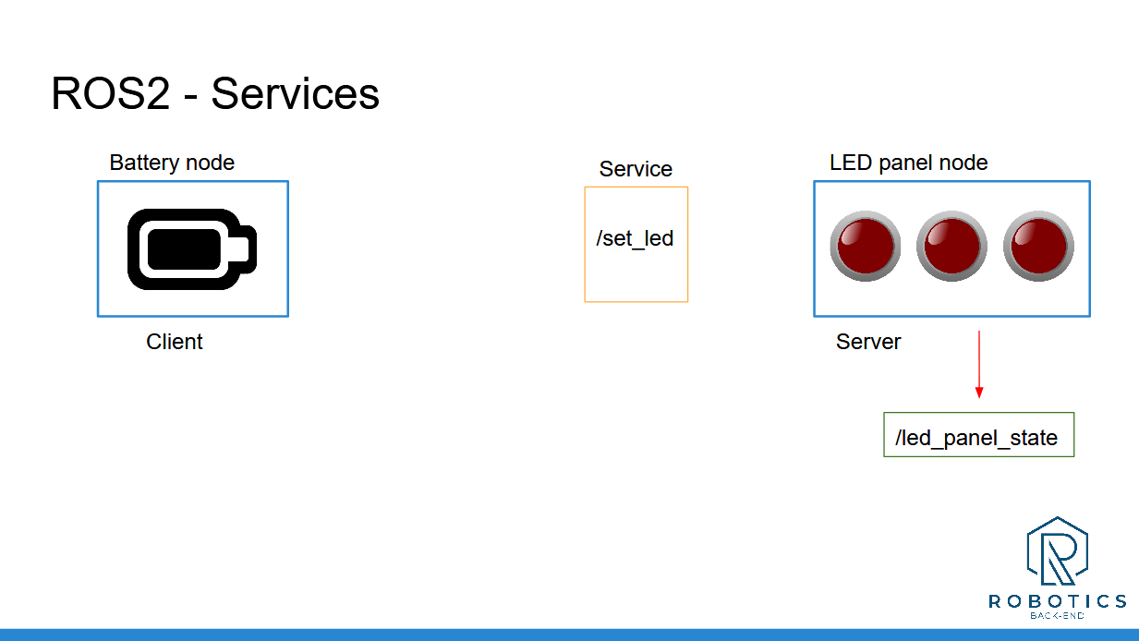

Blue boxes are for nodes, orange for services, and green for topics.

You can simply represent the state of the battery by a “battery_state” variable inside the battery node, and the LED panel by an integer array, inside the LED panel node.

At first, the battery is full, and all the LEDs are powered off ([0, 0, 0]).

Now, you will fake the battery state evolution. Let’s say that the battery is empty after 4 seconds, and then after 6 more seconds it’s full again. And so on.

When the battery is empty, the battery node will send a request to the LED panel, to power on one LED.

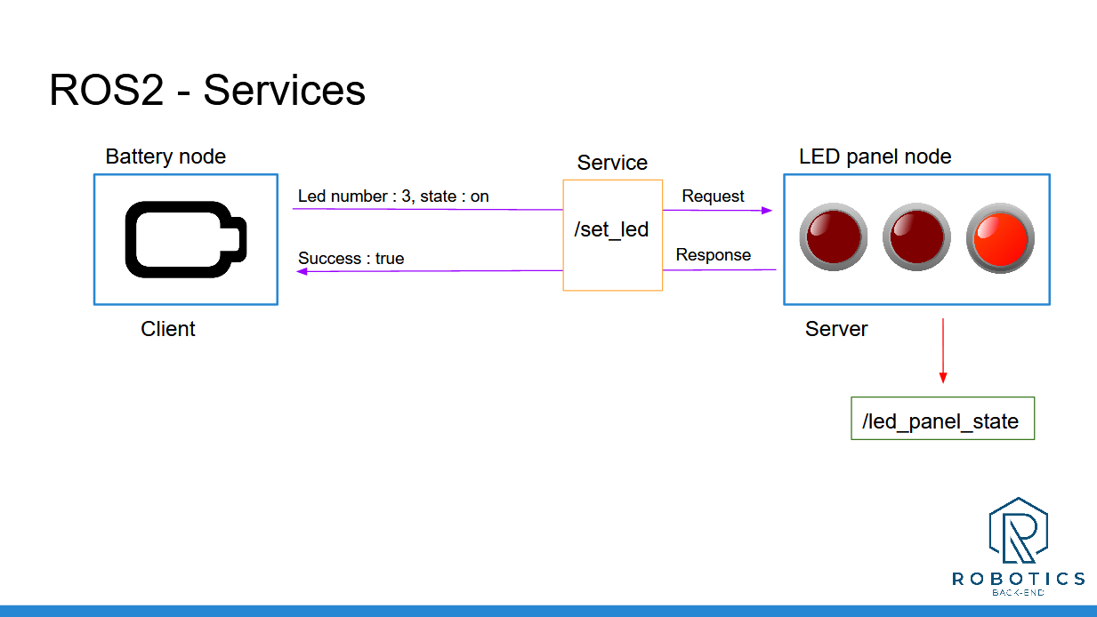

And, 6 seconds later, when the battery is full again, it will send another request to power off the LED.

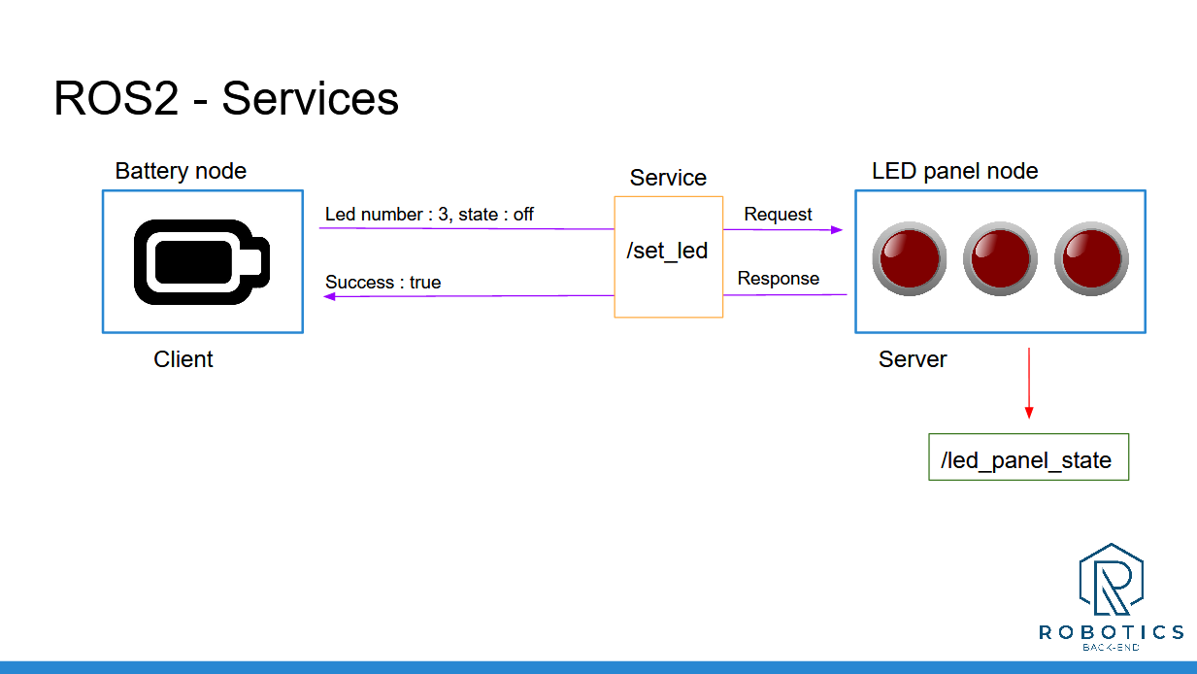

And you can continue looping between those 2 states indefinitely (until you press CTRL+C).

You will have to create:

* 1 node for the battery
* 1 node for the LED panel
* A custom msg definition for the “led_panel_state” topic
* A custom srv definition for the “set_led” service

This activity really sums up everything you’ve seen before. If you skipped some of the previous activities, don’t skip that one!

Of course there is not only one solution. You may succeed with a different code that the one I will provide.

And, as usual, I’ll see you in the next lecture for the solution. For more clarity and to help you navigate easily between the steps, I will separate the solution in 3 videos:

* Step 1: create LED panel node and publish the LED panel state (with a custom message)
* Step 2: add a service server inside the LED panel node (with a custom service definition)
* Step 3: create the battery node, simulate the battery life, and call the “set_led” service with a service client

#### py solution

##### LedPanelState.msg

int64[] led_states

#### HardwareStatus.msg

float64 temperature

bool are_motors_ready

string debug_message

##### led_panel.py

#!/usr/bin/env python3

import rclpy

from rclpy.node import Node

from my_robot_interfaces.msg import LedPanelState

from my_robot_interfaces.srv import SetLed

class LedPanelNode(Node):

def __init__(self):

super().__init__("led_panel")

self.led_state_pub = self.create_publisher(LedPanelState, 'led_panel_state',10)

self.timer_ = self.create_timer(5.0,self.pub_panel_state)

self.server_ = self.create_service(SetLed,"set_led",self.callback_set_led)

self.led_state_= [0, 0, 0]

self.get_logger().info("Led panel node has been started.")

def pub_panel_state(self):

msg = LedPanelState()

msg.led_states = self.led_state_

self.led_state_pub.publish(msg)

def callback_set_led(self, request: SetLed.Request, response: SetLed.Response):

LED_number = request.led_number

LED_state = request.state

if LED_number < 0 or LED_number > 2:

response.success = False

return response

if LED_state not in range(0, 2):

response.success = False

return response

self.led_state_[LED_number] = LED_state

response.success = True

self.pub_panel_state() # WE CAN PUBLISH FROM ANY WHERE, by calling function immediately after updating

return response

def main(args=None):

rclpy.init(args=args)

node = LedPanelNode()

rclpy.spin(node)

rclpy.shutdown()

if __name__ == "__main__":

main()

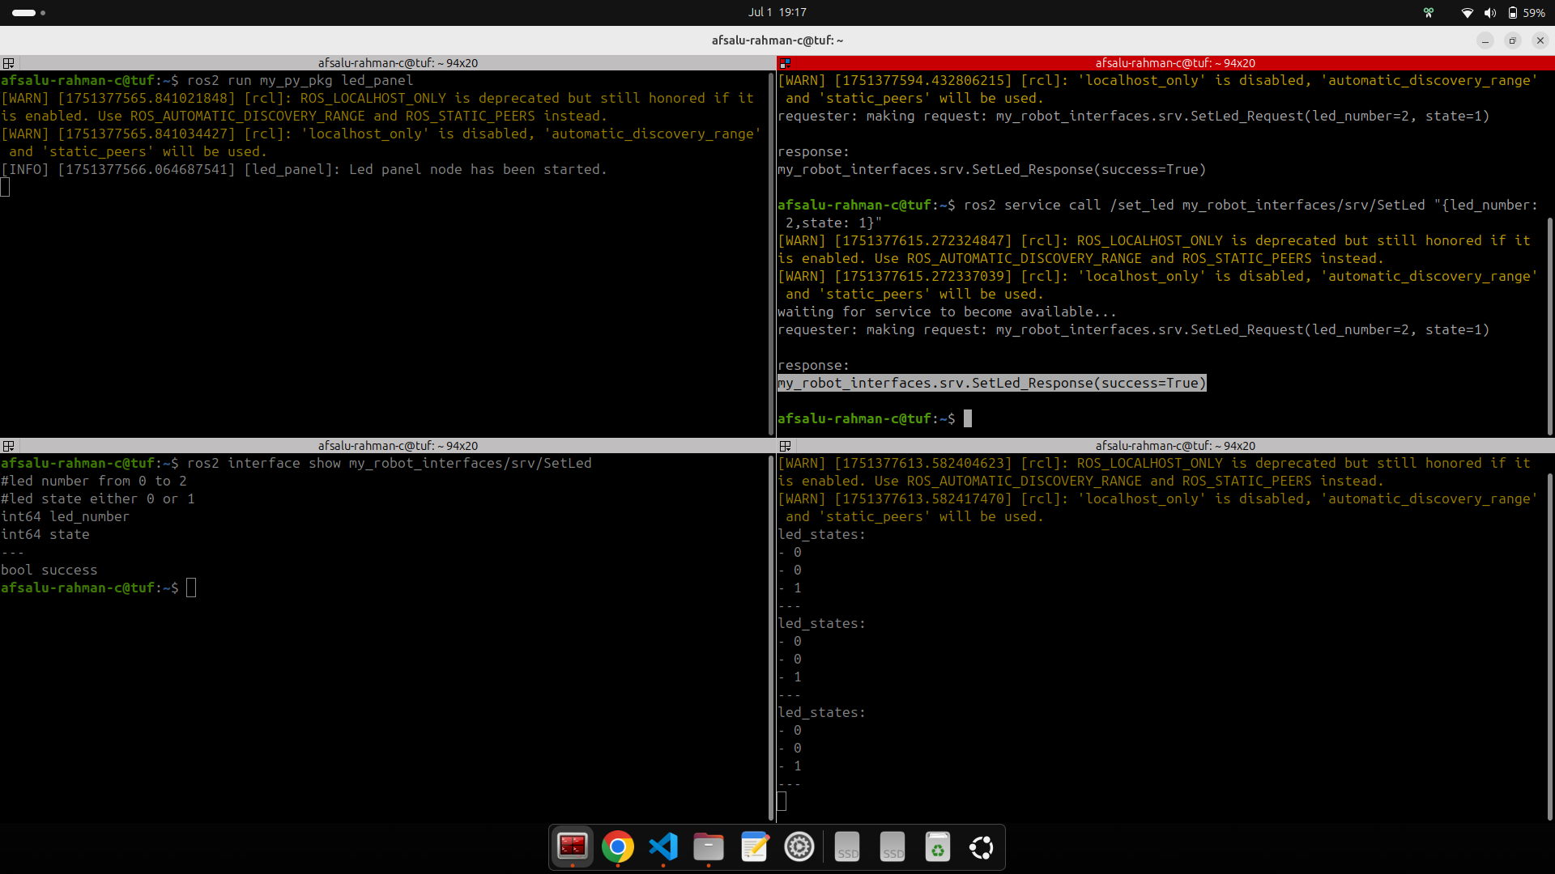

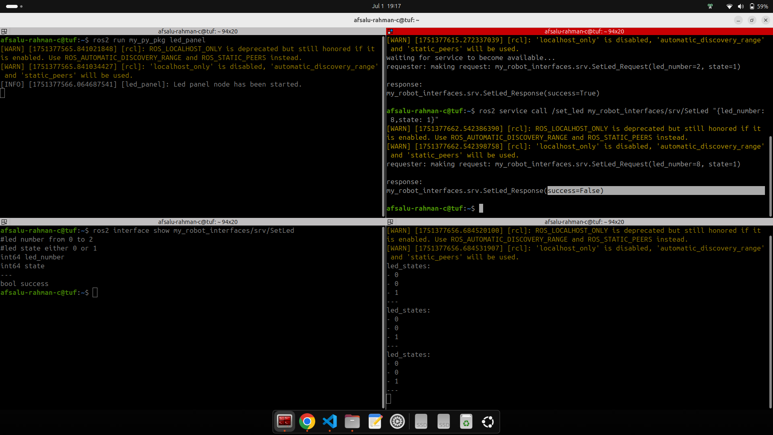

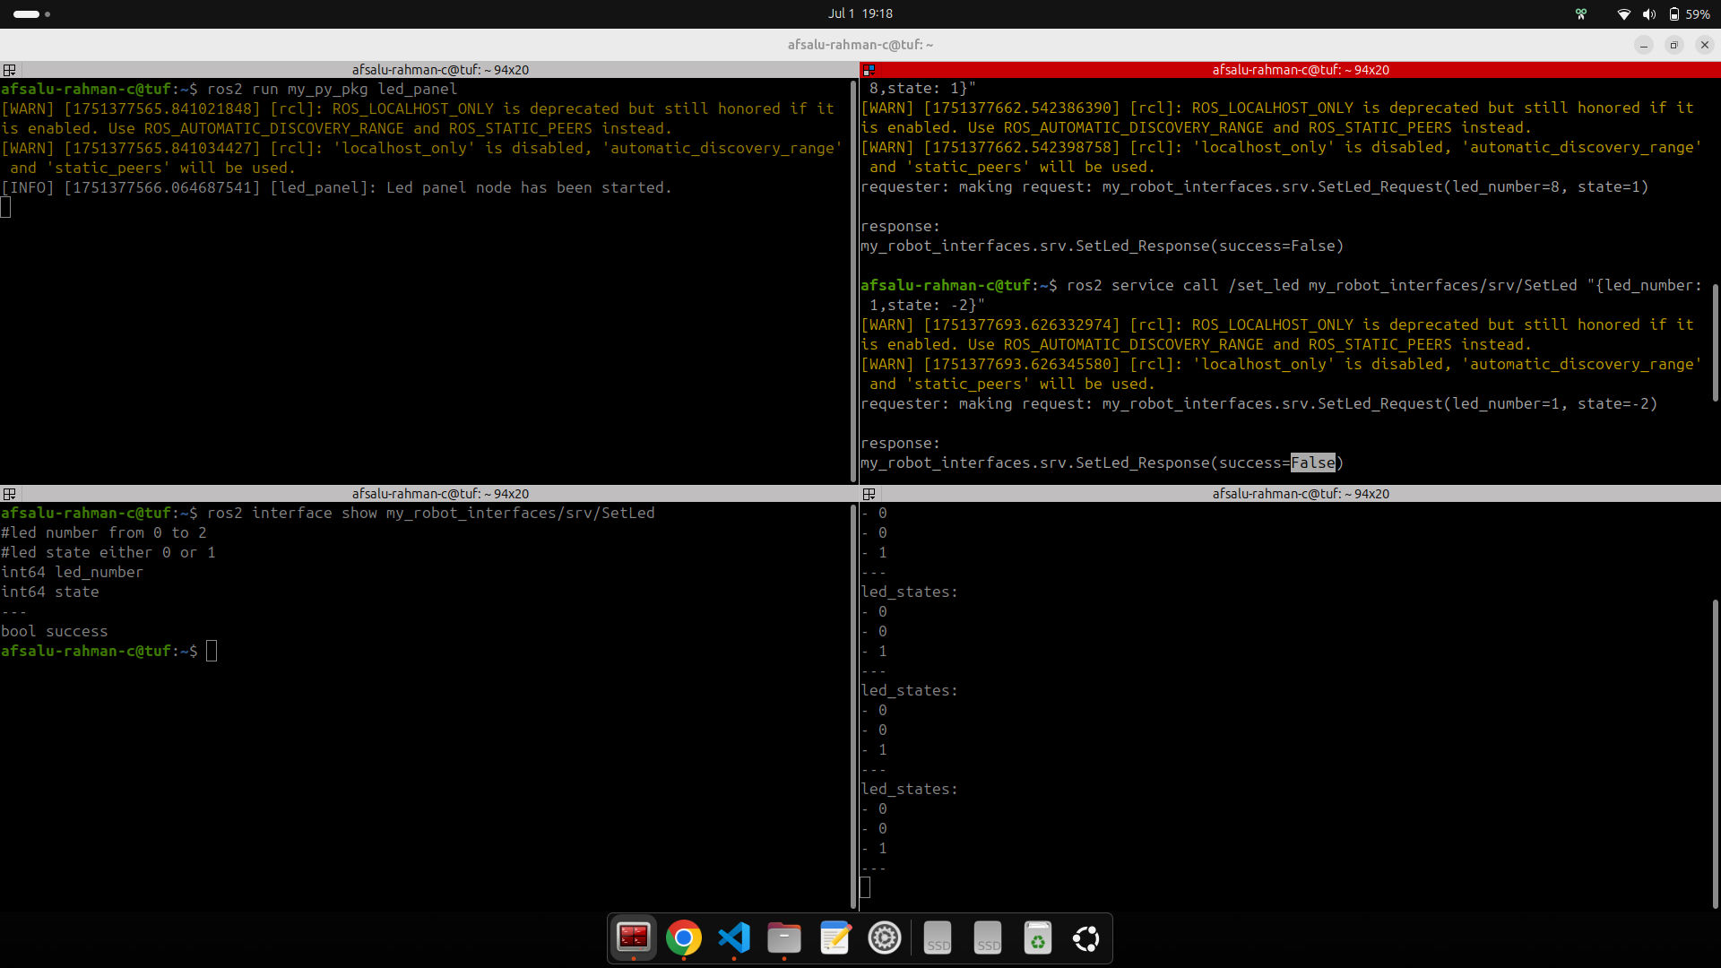

##### battery_node

#!/usr/bin/env python3

import rclpy

from rclpy.node import Node

from my_robot_interfaces.srv import SetLed

from functools import partial

class BatteryNode(Node):

def __init__(self):

super().__init__("battery_node")

self.service_client_ = self.create_client(SetLed,"set_led")

self.get_logger().info("Battery node has been staeted.")

self.create_timer(1.0,self.check_battery_state)

self.battery_state_ = 'full'

self.last_time_battery_state_changed_ = self.get_current_time_seconds()

def get_current_time_seconds(self):

seconds, nanoseconds = self.get_clock().now().seconds_nanoseconds()

return seconds + nanoseconds / 1e9 #or 1000000000.0

def check_battery_state(self):

time_now = self.get_current_time_seconds()

if self.battery_state_ == 'full':

if time_now - self.last_time_battery_state_changed_ > 4.0:

self.battery_state_ = 'empty'

self.get_logger().info("Battery is empty !, Charging.....")

self.callback_battery_node(2,1)

self.last_time_battery_state_changed_ = time_now

else:

if time_now - self.last_time_battery_state_changed_ > 6.0:

self.battery_state_ = 'full'

self.get_logger().info("Battery is now full.")

self.callback_battery_node(2,0)

self.last_time_battery_state_changed_ = time_now

def callback_battery_node(self, led_number, state):

while not self.service_client_.wait_for_service(1.0): #wait for 1 seconds

self.get_logger().warn("waiting for set led service...")

request = SetLed.Request()

request.led_number = led_number

request.state = state

future = self.service_client_.call_async(request)

future.add_done_callback(partial(self.callback_set_led,request=request))

def callback_set_led(self, future, request):

response = future.result()

if response.success:

self.get_logger().info('LED turned on')

else:

self.get_logger().info('LED not changed')

#self.get_logger().info("led number = " + str(request.led_number) + " , " + ", state = " +

#str(request.state) + "Response = " + str(response.success))

def main(args=None):

rclpy.init(args=args)

node = BatteryNode()

rclpy.spin(node)

rclpy.shutdown()

if __name__ == "__main__":

main()

***Note:***

Below template is useful for many real application based on time

self.create_timer(1.0,self.check_battery_state)

self.battery_state_ = 'full'

self.last_time_battery_state_changed_ = self.get_current_time_seconds()

def get_current_time_seconds(self):

seconds, nanoseconds = self.get_clock().now().seconds_nanoseconds()

return seconds + nanoseconds / 1e9 #or 1000000000.0

def check_battery_state(self):

time_now = self.get_current_time_seconds()

if self.battery_state_ == 'full':

if time_now - self.last_time_battery_state_changed_ > 4.0:

self.battery_state_ = 'empty'

self.get_logger().info("Battery is empty !, Charging.....")

self.callback_battery_node(2,1)

self.last_time_battery_state_changed_ = time_now

else:

if time_now - self.last_time_battery_state_changed_ > 6.0:

self.battery_state_ = 'full'

self.get_logger().info("Battery is now full.")

self.callback_battery_node(2,0)

self.last_time_battery_state_changed_ = time_now

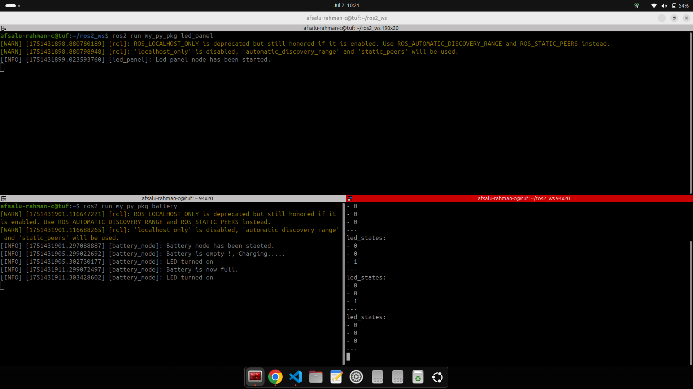

#### CPP solution

##### led_panel.cpp

#include "rclcpp/rclcpp.hpp"

#include "my_robot_interfaces/msg/led_panel_state.hpp"

#include "my_robot_interfaces/srv/set_led.hpp"

using namespace std::chrono_literals;

using namespace std::placeholders;

class LedPanelNode : public rclcpp::Node

{

public:

LedPanelNode() : Node("led_panel")

{

this->declare_parameter("led_states", std::vector<int64_t>{0, 0, 0});

led_states_ = this->get_parameter("led_states").as_integer_array();

led_states_publisher_ =

this->create_publisher<my_robot_interfaces::msg::LedPanelState>("led_panel_state", 10);

led_states_timer_ =

this->create_wall_timer(5s, std::bind(&LedPanelNode::publishLedStates, this));

set_led_service_ = this->create_service<my_robot_interfaces::srv::SetLed>(

"set_led",

std::bind(&LedPanelNode::callbackSetLed, this, _1, _2));

RCLCPP_INFO(this->get_logger(), "Led panel node has been started");

}

private:

void publishLedStates()

{

auto msg = my_robot_interfaces::msg::LedPanelState();

msg.led_states = led_states_;

led_states_publisher_->publish(msg);

}

void callbackSetLed(const my_robot_interfaces::srv::SetLed::Request::SharedPtr request,

const my_robot_interfaces::srv::SetLed::Response::SharedPtr response)

{

int64_t led_number = request->led_number;

int64_t state = request->state;

if (led_number >= (int64_t)led_states_.size() || led_number < 0)

{

response->success = false;

return;

}

if (state != 0 && state != 1)

{

response->success = false;

return;

}

led_states_.at(led_number) = state;

response->success = true;

publishLedStates();

}

std::vector<int64_t> led_states_;

rclcpp::Publisher<my_robot_interfaces::msg::LedPanelState>::SharedPtr led_states_publisher_;

rclcpp::TimerBase::SharedPtr led_states_timer_;

rclcpp::Service<my_robot_interfaces::srv::SetLed>::SharedPtr set_led_service_;

};

int main(int argc, char **argv)

{

rclcpp::init(argc, argv);

auto node = std::make_shared<LedPanelNode>();

rclcpp::spin(node);

rclcpp::shutdown();

return 0;

}

##### battery.cpp

#include "rclcpp/rclcpp.hpp"

#include "my_robot_interfaces/srv/set_led.hpp"

using namespace std::chrono_literals;

using namespace std::placeholders;

class BatteryNode : public rclcpp::Node

{

public:

BatteryNode() : Node("battery"), battery_state_("full")

{

last_time_battery_state_changed_ = this->get_clock()->now().seconds();

battery_timer_ = this->create_wall_timer(

0.1s,

std::bind(&BatteryNode::checkBatteryState, this));

set_led_client_ = this->create_client<my_robot_interfaces::srv::SetLed>("set_led");

while (!set_led_client_->wait_for_service(1s))

{

RCLCPP_WARN(this->get_logger(), "Waiting for Service Server to be up...");

}

RCLCPP_INFO(this->get_logger(), "Battery node has been started.");

}

private:

void checkBatteryState()

{

double time_now = this->get_clock()->now().seconds();

if (battery_state_ == "full")

{

if (time_now - last_time_battery_state_changed_ > 4.0)

{

RCLCPP_INFO(this->get_logger(), "Battery is empty! Charging battery...");

battery_state_ = "empty";

last_time_battery_state_changed_ = time_now;

callSetLed(2, 1);

}

}

else

{

if (time_now - last_time_battery_state_changed_ > 6.0)

{

RCLCPP_INFO(this->get_logger(), "Battery is now full again.");

battery_state_ = "full";

last_time_battery_state_changed_ = time_now;

callSetLed(2, 0);

}

}

}

void callSetLed(int led_number, int state)

{

auto request = std::make_shared<my_robot_interfaces::srv::SetLed::Request>();

request->led_number = led_number;

request->state = state;

auto future = set_led_client_->async_send_request(

request, std::bind(&BatteryNode::callbackCallSetLed, this, _1));

}

void callbackCallSetLed(rclcpp::Client<my_robot_interfaces::srv::SetLed>::SharedFuture future)

{

auto response = future.get();

if (response->success) {

RCLCPP_INFO(this->get_logger(), "LED state was changed");

}

else {

RCLCPP_INFO(this->get_logger(), "LED not changed");

}

}

std::string battery_state_;

double last_time_battery_state_changed_;

rclcpp::TimerBase::SharedPtr battery_timer_;

rclcpp::Client<my_robot_interfaces::srv::SetLed>::SharedPtr set_led_client_;

};

int main(int argc, char **argv)

{

rclcpp::init(argc, argv);

auto node = std::make_shared<BatteryNode>();

rclcpp::spin(node);

rclcpp::shutdown();

return 0;

}

### 7.9 Section Conclusion

In this section you have seen how to create your own ROS 2 interfaces, for Topics and Services.

Topics and Services are the communication layer. Interfaces are the actual content that you send.

To recap, here’s how to create a custom interface:

* Create a new package only for your msg and srv definitions.
* Setup the package (CMakeLists.txt and package.xml)
* Create a msg/ and srv/ folders, place your custom msg definitions and srv definitions here.

Once you’ve setup your package, adding a new interface is really simple:

* Add a new file in the right folder: msg/ or srv/
* Add one line into CMakeLists.txt
* Compile with “colcon build”
* And don’t forget to source your ROS 2 workspace when you want to use those messages!

Here’s what you can use inside a msg or srv definition:

* Any primitive type defined by ROS 2 (most common ones: int64, float64, bool, string, and array of those)
* Any message you’ve already created in this package.
* Any message from another package. In this case don’t forget to add a dependency for the other package in both package.xml and CMakeLists.txt.

And now, when you compile the definitions, new interfaces will be created, along with headers/modules ready to be included in your C++ or Python nodes.

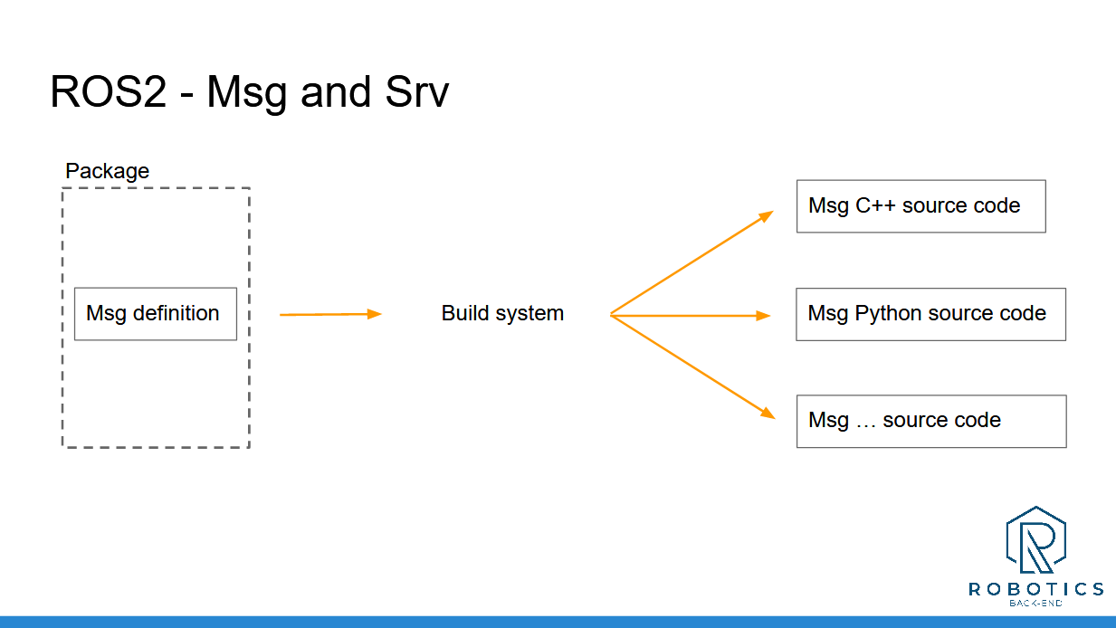

You’re almost ready to start your own ROS 2 application! In the next section you’ll see how to add settings to your nodes at run time with ROS 2 parameters.

___________________________________

Download the complete code for this section (this is the code from all previous sections + the current one).

Resources for this lecture

# Section 8 - (parameter) Change node settings at runtime with ROS2 parameters

### 8.1 Intro

If you read this, well, you’ve already made huge progress! The hardest is behind, now just a few more things and you’ll be ready to write your own complete ROS 2 application.

In this quick section we’ll focus on ROS 2 parameters.

Parameters will allow you to provide run-time settings for your nodes.

At the end of this section you will know:

* What ROS2 parameters are and when to use them.
* How to declare and get parameters for your nodes.
* How to store your parameters inside a YAML file
* Bonus: parameter callbacks

### 8.2 What is ROS2 parameter?

By the use of ROS2 parameter it is no needed to change or code again in accordance to the parameters

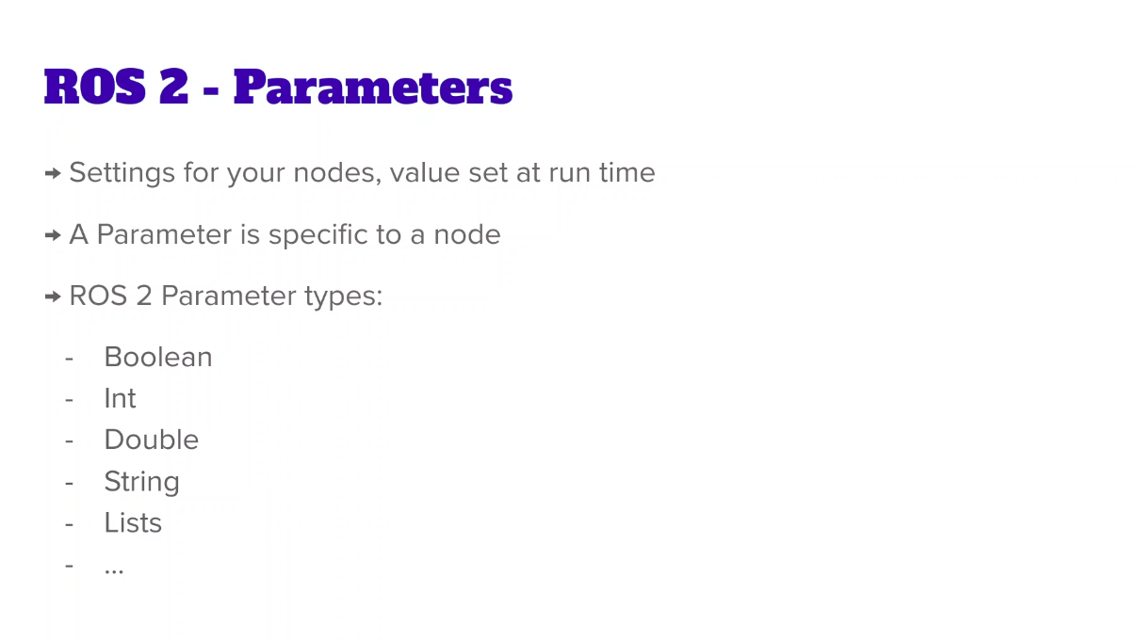

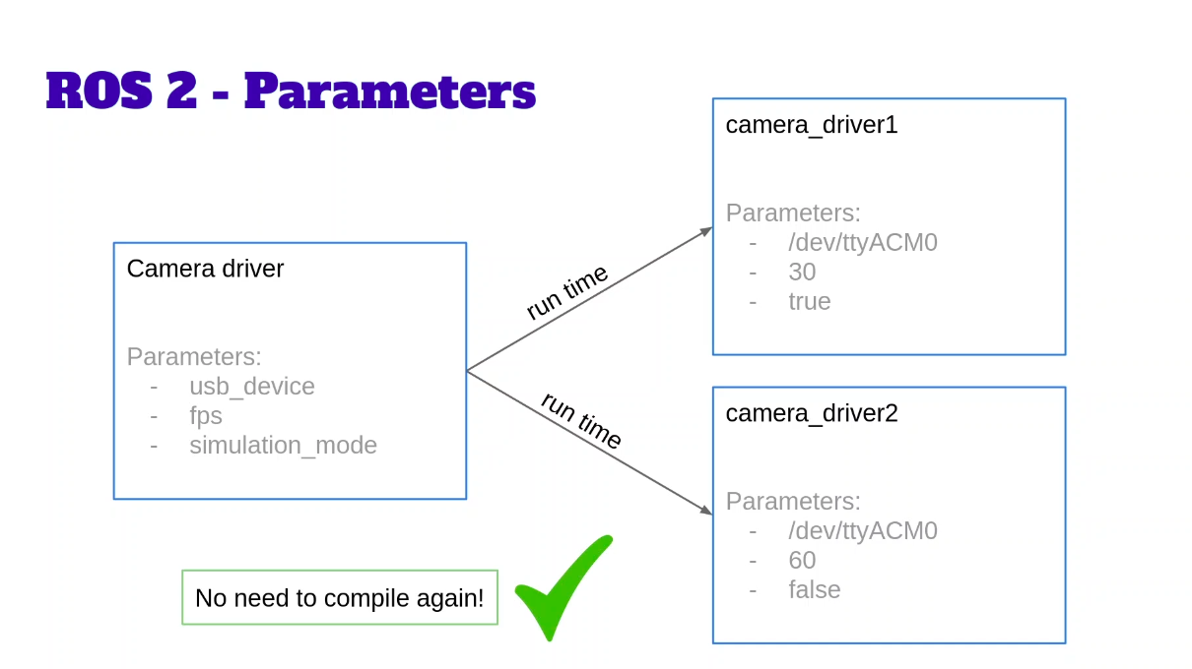

### 8.3 Use parameter in python node

**Declaration**

self.declare_parameter("number", 2)

self.declare_parameter("timer_period", 1.0)

**Get parameter**

self.number_ = self.get_parameter("number").value #get parameter is an object, NOTE There is no '()' parenthesis for value

self.timer_period_ = self.get_parameter("timer_period").value

ros2 param list (to list out all the parameters)

**During run time**

ros2 run my_py_pkg number_publisher --ros-args -p number:=50

**Chane two parameter during run time simultaneously**

ros2 run my_py_pkg number_publisher --ros-args -p number:=50 -p timer_period:=5.0

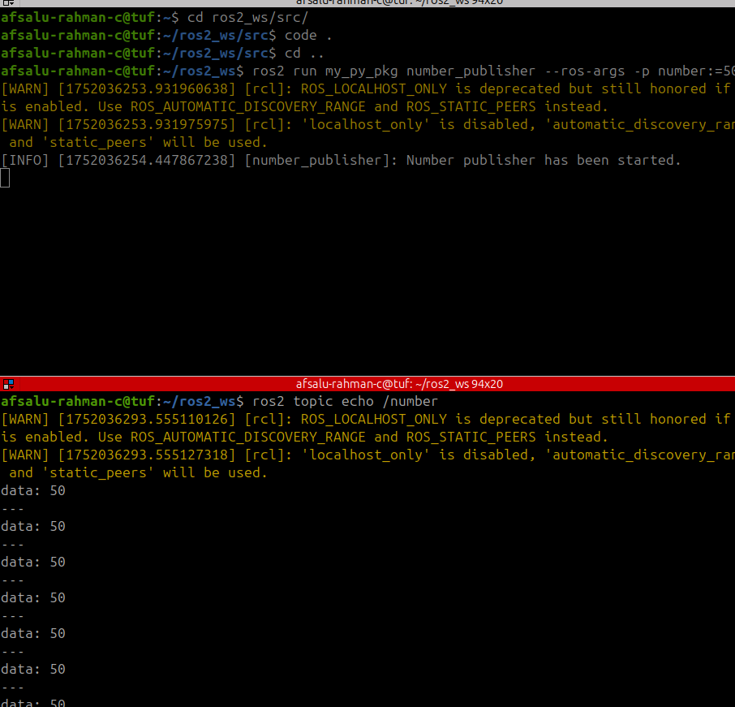

### 8.4 Use parameter in C++ node

this->declare_parameter("number", 2);

this->declare_parameter("timer_period", 1.0); //'this' keyword is not mandatory but it is used to say it is from 'Node' class

number_ = this->get_parameter("number").as_int();

double timer_period = this->get_parameter("timer_period").as_double();

updater timer like below

timer_ = this->create_wall_timer(std::chrono::duration<double>(timer_period),

std::bind(&NumberPublisherNode::PublishNumber,this));

ros2 run my_cpp_pkg number_publisher --ros-args -p number:=10 -p timer_period:=2.0

If I pass undeclared parameter in runtime it will work, ex:

ros2 run my_cpp_pkg number_publisher --ros-args -p number:=100 -p timer_period:=3.5 -p name:=sweebo

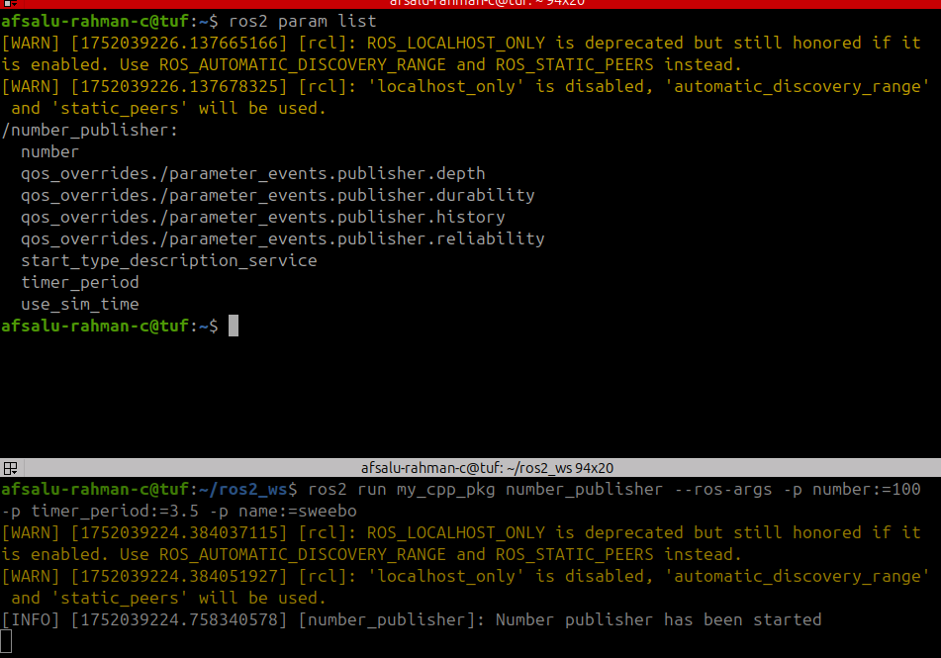

### 8.5 Experiment on Parameters with Turtlesim

ros2 run turtlesim turtlesim_node

ros2 param list

/turtlesim:

background_b

background_g

background_r

holonomic

qos_overrides./parameter_events.publisher.depth

qos_overrides./parameter_events.publisher.durability

qos_overrides./parameter_events.publisher.history

qos_overrides./parameter_events.publisher.reliability

start_type_description_service

use_sim_time

ros2 param get /turtlesim background_r

Integer value is: 69

ros2 param get /turtlesim background_g

Integer value is: 86

ros2 param get /turtlesim background_b

Integer value is: 255

ros2 run turtlesim turtlesim_node --ros-args -p background_b:=0

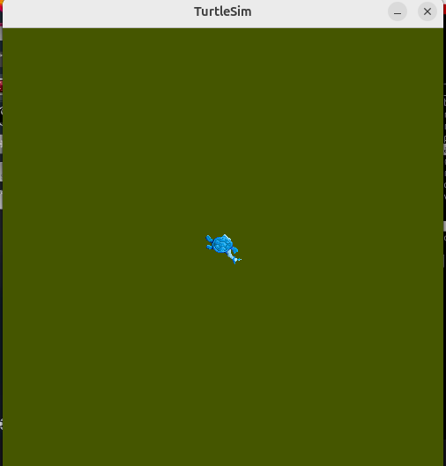

ros2 service list

/clear

/kill

/reset

/spawn

/turtle1/set_pen

/turtle1/teleport_absolute

/turtle1/teleport_relative

/turtlesim/describe_parameters

/turtlesim/get_parameter_types

/turtlesim/get_parameters

/turtlesim/get_type_description

/turtlesim/list_parameters

/turtlesim/set_parameters

/turtlesim/set_parameters_atomically

ros2 service type /turtlesim/list_parameters

rcl_interfaces/srv/ListParameters

ros2 interface show rcl_interfaces/srv/ListParameters

# Recursively get parameters with unlimited depth.

uint64 DEPTH_RECURSIVE=0

# The list of parameter prefixes to query.

string[] prefixes

# Relative depth from given prefixes to return.

#

# Use DEPTH_RECURSIVE to get the recursive parameters and prefixes for each prefix.

uint64 depth

---

# The list of parameter names and their prefixes.

ListParametersResult result

string[] names

string[] prefixes

ros2 service call /turtlesim/list_parameters rcl_interfaces/srv/ListParameters

requester: making request: rcl_interfaces.srv.ListParameters_Request(prefixes=[], depth=0)

response:

rcl_interfaces.srv.ListParameters_Response(result=rcl_interfaces.msg.ListParametersResult(names=['background_b', 'background_g', 'background_r', 'holonomic', 'qos_overrides./parameter_events.publisher.depth', 'qos_overrides./parameter_events.publisher.durability', 'qos_overrides./parameter_events.publisher.history', 'qos_overrides./parameter_events.publisher.reliability', 'start_type_description_service', 'use_sim_time'], prefixes=['qos_overrides./parameter_events.publisher']))

***Note:*** Above is equivalent to ros2 param list from terminal

this kind of service useful want to access / list out parameters from code another node etc.

### 8.6 YAML parameters from file

By the use of this will be able to create parameters file and load that

in home directory

mkdir yaml_params

touch number_params.yaml

gedit number_params.yaml

#### TEMPLATE

/number_publisher1:

ros__parameters:

number: 5

timer_period: 0.7

/number_publisher2:

ros__parameters:

number: 3

timer_period: 1.0

you can run like below

/number_publisher:

ros__parameters:

number: 5

timer_period: 0.7

ros2 run my_py_pkg number_publisher --ros-args --params-file ~/yaml_params/number_params.yaml

you can verify

ros2 topic hz /number

/number_publisher1:

ros__parameters:

number: 5

timer_period: 0.7

/number_publisher2:

ros__parameters:

number: 3

timer_period: 1.0

ros2 run my_py_pkg number_publisher --ros-args -r __node:=number_publisher2 --params-file ~/yaml_params/number_params.yaml

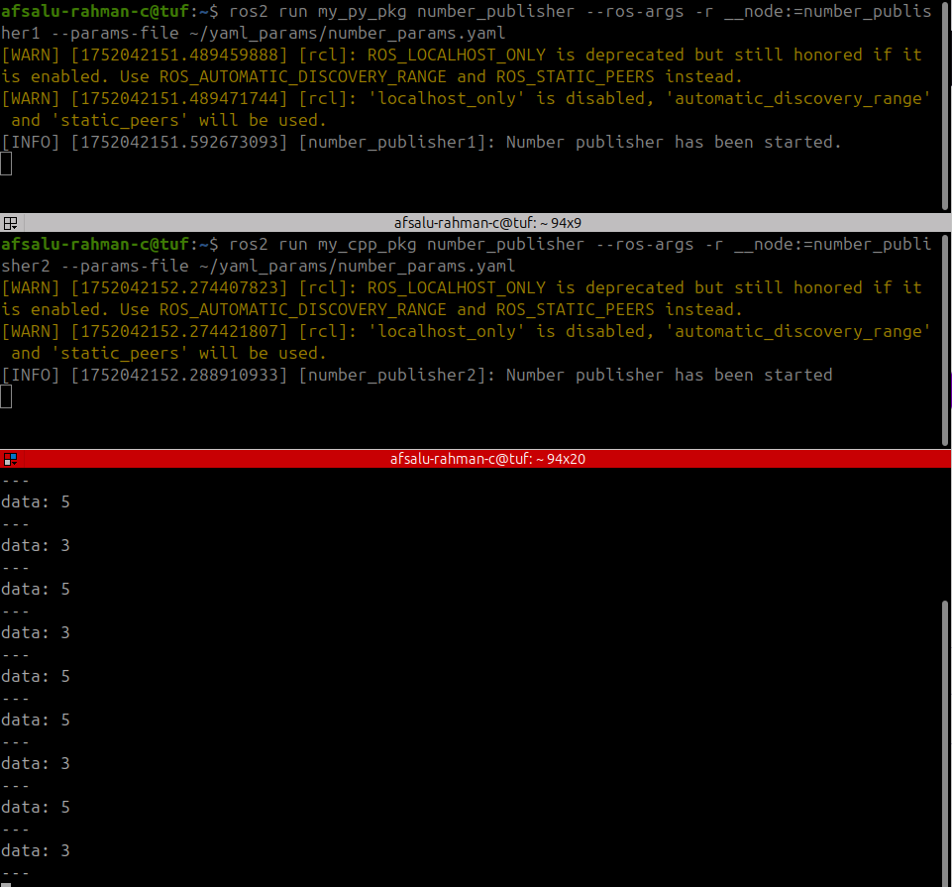

### 8.7 Activity 5

**Activity 05 - ROS 2 Parameters**

Let’s practice a little bit more with Parameters.

Here are 2 quick activities:

1.

Do you remember one of the first nodes we created in the Topic section, with the robot news radio? This node publishes a string on a topic, similar to this “Hi, this is R2D2 from the Robot News Station!”.

Now, it would be better if we could set the robot’s name at run time, so we can launch the node multiple times with different robot names.

Add a “robot_name” parameter, and use the value to publish the string on the “robot_news” topic. Your string template (“Hi, this is <robot_name> from the Robot News Station!”) will now use the name you set at runtime.

2.

Go back to the “led_panel_node”. Here you have an int array representing the states of your Leds (0 for powered off, 1 for powered on). Set this array with a parameter named “led_states”.

Then, create a YAML file to store this parameter and load it at runtime, when you start the node.

-----

This will make you practice on string and array parameters. Of course you can apply those changes in both the Python and Cpp nodes.

I’ll see you in the next lecture for the solution (2 parts).

### 8.8 Actv. 5.1 Solution (my)

py

self.declare_parameter("robot_name","C3P0")

self.robot_name_ = self.get_parameter("robot_name").value

cpp

this->declare_parameter("robot_name","R2D2");

robot_name_ = this->get_parameter("robot_name").as_string();

publisher_ = this->create_publisher<example_interfaces::msg::String>("robot_news",10);

ros2 run my_py_pkg robot_news_station --ros-args -p robot_name:=sweebo

ros2 run my_cpp_pkg robot_news_station --ros-args -p robot_name:=xyz

ros2 topic echo /robot_news

***Note:***

if I want provide name with space need to use double/single quotes

ex:

ros2 run my_py_pkg robot_news_station --ros-args -p robot_name:="The Robot"

### 8.9 Actv. 5.2 Solution (my)

self.led_state_= [0, 0, 0]

self.declare_parameter("led_state",[0, 0, 0])

self.led_state_ = self.get_parameter("led_state").value

ros2 run my_py_pkg led_panel --ros-args -p led_state:=[1,0,0]

ros2 topic echo /led_panel_state

#### led_config.yaml file

/led_panel:

ros__parameters:

led_states: [0, 0, 0, 0]

ros2 run my_py_pkg led_panel --ros-args --params-file ~/yaml_params/led_config.yaml

ros2 param get /led_panel led_state

Integer values are: [0, 0, 0]

ros2 run my_py_pkg led_panel --ros-args -p led_state:=[0,0,0,1]

ros2 param get /led_panel led_state

Integer values are: [0, 0, 0, 1]

### 8.10 Extra: Parameter Callbacks

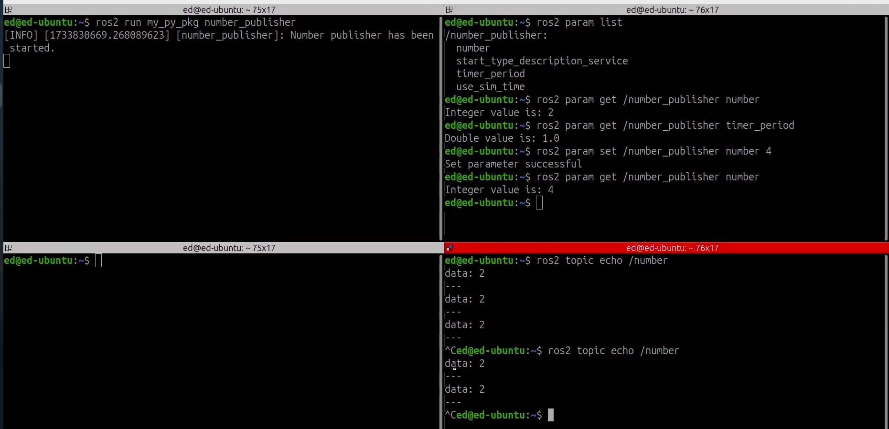

***Note:***

Even if parameter is changed by the command ros2 param set /number_publisher number 4, not reflecting in echo command because there is nothing in the code to do so, we need a parameter callback function for that

py

from rclpy.parameter import Parameter

self.add_post_set_parameters_callback(self.parameters_callback)

def parameters_callback(self, params: list[Parameter]):

for param in params:

if param.name == "number":

self.number_ = param.value

***Note:***

1. You can repeat for other parameters as like above
2. It is also possible to do operations using param.-----

cpp

param_callback_handle_ = this->add_post_set_parameters_callback(

std::bind(&NumberPublisherNode::parametersCallback, this, _1));

void parametersCallback(const std::vector<rclcpp::Parameter> & parameters)

{

for (const auto &param: parameters) {

if (param.get_name() == "number") {

number_ = param.as_int();

}

}

}

### 8.11 Conclusion

In this section you have discovered ROS 2 parameters.

With parameters you don’t need to modify + re-compile your code for each different set of configuration. Just write your code once, and choose your settings at run-time.

Using parameters is one of the first steps to make your application more scalable.

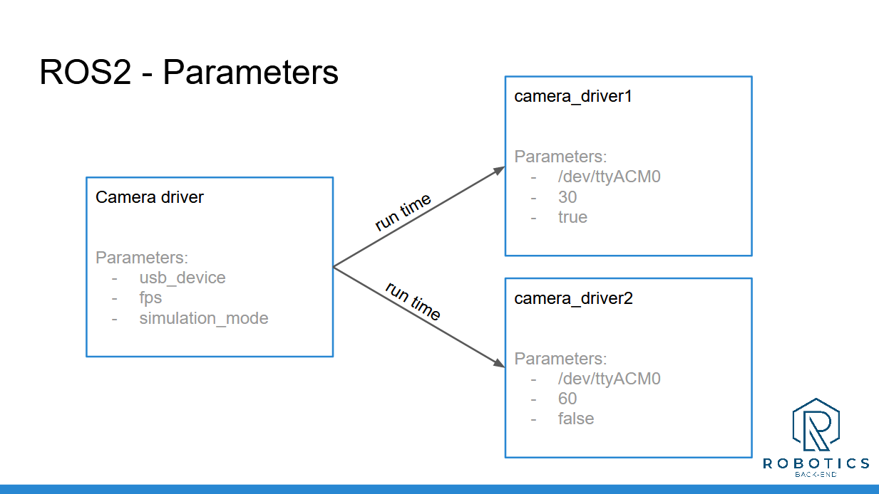

To handle parameters:

* Don’t forget to declare any parameter before you even try to use it.
* The default value’s data type will be the data type for the parameter.
* When you start your node, set values for your parameters (if you don’t, default values will be used).
* In your node’s code, get the parameters’ values and use them.

You can also store many parameters for one or several nodes, inside a YAML param file. Then, all you need to do is load the YAML file when you start the nodes.

---

Download the complete code for this section (this is the code from all previous sections + the current one).

Now that you can set parameters for your nodes, you might wonder: what if I have to run multiple nodes, each with multiple parameters? It would quickly become really long (and error prone) to always start everything from the terminal. YAML files already help, but there’s more.

In the next section we’ll see how to solve that problem with launch files.

# Section 9 - Launch file

### 9.1 Intro

**Intro**

So, you now have many nodes in your packages. When you start them, you can rename them, rename the topics, services, and set parameters.

That’s a lot of things! Now, imagine you have to start 10 nodes, each with a different configuration. Using the terminal is not something that scales well.

In this section we’ll see how to solve that problem with launch files.

At the end of this section you will be able to start all your nodes and parameters from one single ROS 2 Launch File.

What you’ll do in this section:

* Understand what launch files are and when to use them.
* How to create, install, and start a launch file.
* Install YAML files and load them inside your launch files.
* Discover how to start your nodes inside namespaces.
* And practice more on your one with another activity.

### 9.2 What is a ROS 2 Launch File?

### 

### 9.3 Create and Install Launch File (xml)

ros2 pkg create my_robot_bringup (ament_cmake by default)

afsalu-rahman-c@tuf:~/ros2_ws/src/my_robot_bringup$ rm -r include/ src/

*remove*

# uncomment the following section in order to fill in

# further dependencies manually.

# find_package(<dependency> REQUIRED)

if(BUILD_TESTING)

find_package(ament_lint_auto REQUIRED)

# the following line skips the linter which checks for copyrights

# comment the line when a copyright and license is added to all source files

set(ament_cmake_copyright_FOUND TRUE)

# the following line skips cpplint (only works in a git repo)

# comment the line when this package is in a git repo and when

# a copyright and license is added to all source files

set(ament_cmake_cpplint_FOUND TRUE)

ament_lint_auto_find_test_dependencies()

endif()

*add*

install(DIRECTORY

launch

DESTINATION share/${PROJECT_NAME}/

)

install(TARGETS ...) is used to install **compiled executables** (i.e., binary files).

These are installed into:  
lib/${PROJECT_NAME}

launch and config installed into share/${PROJECT_NAME}?

* These are **non-executable resources** (YAML config files, .launch.py, .rviz, URDFs, etc.).
* ROS 2 packages use:  
  share/${PROJECT_NAME}

#### exec_depend (in package.xml)

But for large files you could also use the exec depend tag because well, exec depend is a bit less stricter than depend.- - only for execution

*add in package.xml*

<exec_depend>my_py_pkg</exec_depend>

<exec_depend>my_cpp_pkg</exec_depend>

#### Minimal xml launch file

<launch>

<node pkg = "my_py_pkg" exec = "number_publisher"/>

<node pkg = "my_cpp_pkg" exec = "number_counter"/>

</launch>

ros2 launch my_robot_bringup number_app.launch.xml

process started with pid [7744]

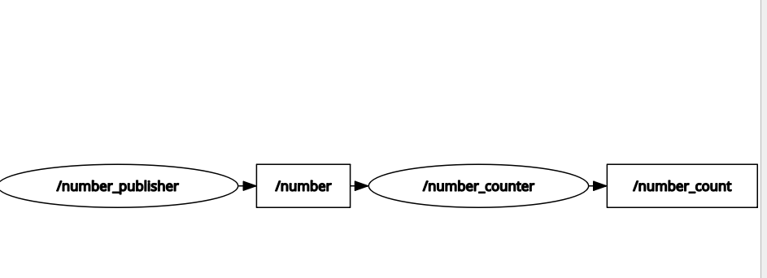

afsalu-rahman-c@tuf:~/ros2_ws$ ros2 topic list

/number

/number_count

/parameter_events

/rosout

afsalu-rahman-c@tuf:~/ros2_ws$ ros2 topic echo /number

data: 50

---

data: 50

---

data: 50

[Reference](https://roboticsbackend.com/ros2-xml-launch-file/)

### 9.4 Python launch file (Python vs xml)

Launch file write with 3 languages

* xml - much clearer and less prone to errors
* python - easy, common one
* yaml - not used

Begin with python switch slowly to xml, python uses complicates syntax and import for just provide description   
  
***Note*** *; Bit some functionalities only written in python*

***Good News****: Easily import python launch file inside xml launch file*

#### way of adding py file to xml

<launch>

<include file="$(find-pkg-share my_robot_bringup)/launch/number_app.launch.py" /> <!-- importing python file in to xml -->

</launch>

afsalu-rahman-c@tuf:~$ ros2 launch my_robot_bringup number_app_from_python.launch.xml

[INFO] [launch]: All log files can be found below /home/afsalu-rahman-c/.ros/log/2025-06-05-13-25-16-521956-tuf-9448

[INFO] [launch]: Default logging verbosity is set to INFO

[INFO] [number_publisher-1]: process started with pid [9451]

[INFO] [number_counter-2]: process started with pid [9452]

[number_counter-2] [INFO] [1749110117.978102856] [number_counter]: Number of messages recived = 1

[number_counter-2] [INFO] [1749110118.978418751] [number_counter]: Number of messages recived = 2

[number_counter-2] [INFO] [1749110119.978428714] [number_counter]: Number of messages recived = 3

[number_counter-2] [INFO] [1749110120.978364345] [number_counter]: Number of messages recived = 4

#### 

#### Minimal python code (number_app[.launch.py](http://.launch.py))

***Note*** : Must try to follow this template syntax

from launch import LaunchDescription

def generate_launch_description():

ld = LaunchDescription()

return ld #don’t forget the return statement (as like “return response”) in python service server

#### OR

**from** **launch** **import** LaunchDescription

**from** **launch_ros.actions** **import** Node

**def** generate_launch_description():

**return** LaunchDescription([

])

#### code

from launch import LaunchDescription

from launch_ros.actions import Node

def generate_launch_description():

ld = LaunchDescription()

number_publisher=Node(

package="my_py_pkg",

executable="number_publisher"

)

number_counter=Node(

package="my_cpp_pkg",

executable="number_counter"

)

ld.add_action(number_publisher)

ld.add_action(number_counter)

return ld

#### OR

**from** **launch** **import** LaunchDescription

**from** **launch_ros.actions** **import** Node

**def** generate_launch_description():

**return** LaunchDescription([

Node(

package='turtlesim',

namespace='turtlesim1',

executable='turtlesim_node',

name='sim'

),

Node(

package='turtlesim',

namespace='turtlesim2',

executable='turtlesim_node',

name='sim'

),

Node(

package='turtlesim',

executable='mimic',

name='mimic',

remappings=[

('/input/pose', '/turtlesim1/turtle1/pose'),

('/output/cmd_vel', '/turtlesim2/turtle1/cmd_vel'),

]

)

])

afsalu-rahman-c@tuf:~$ ros2 launch my_robot_bringup number_app.launch.py

[INFO] [launch]: All log files can be found below /home/afsalu-rahman-c/.ros/log/2025-06-05-13-22-54-652730-tuf-9197

[INFO] [launch]: Default logging verbosity is set to INFO

[INFO] [number_publisher-1]: process started with pid [9200]

[INFO] [number_counter-2]: process started with pid [9201]

[number_counter-2] [INFO] [1749109976.459640010] [number_counter]: Number of messages recived = 1

[number_counter-2] [INFO] [1749109977.458965548] [number_counter]: Number of messages recived = 2

[number_counter-2] [INFO] [1749109978.458830613] [number_counter]: Number of messages recived = 3

### 9.4 Remappings in launch file

#### xml - Remap EXECUTABLE name

<launch>

<node pkg = "my_py_pkg" exec = "number_publisher" name="my_number_publisher"/>

<node pkg = "my_cpp_pkg" exec = "number_counter" name="my_number_counter"/>

</launch>

***Note****:* ***exec*** *in ROS2 in* ***type*** *in ROS1*

afsalu-rahman-c@tuf:~/ros2_ws$ ros2 launch my_robot_bringup number_app.launch.xml

[INFO] [launch]: All log files can be found below /home/afsalu-rahman-c/.ros/log/2025-06-05-13-37-10-703646-tuf-10028

[INFO] [launch]: Default logging verbosity is set to INFO

[INFO] [number_publisher-1]: process started with pid [10031]

[INFO] [number_counter-2]: process started with pid [10032]

[number_counter-2] [INFO] [1749110831.367220527] [my_number_counter]: Counter Reciver started

[number_counter-2] [INFO] [1749110832.340679717] [my_number_counter]: Number of messages recived = 1

[number_counter-2] [INFO] [1749110833.343067622] [my_number_counter]: Number of messages recived = 2

[number_counter-2] [INFO] [1749110834.342419766] [my_number_counter]: Number of messages recived = 3

[number_counter-2] [INFO] [1749110835.340413848] [my_number_counter]: Number of messages recived = 4

[number_counter-2] [INFO] [1749110836.341061144] [my_number_counter]: Number of messages recived = 5

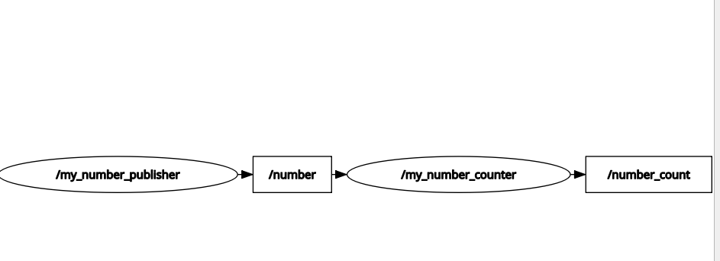

#### xml - Remap TOPIC

<launch>

<node pkg = "my_py_pkg" exec = "number_publisher" name="my_number_publisher">

<remap from="/number" to="/my_number"/>

</node>

<node pkg = "my_py_pkg" exec = "number_counter" name="my_number_counter">

<remap from="/number" to ="/my_number"/>

</node>

</launch>

***Note:*** For topic remap specifically use ‘remap’ keyword, but for executable remap by ‘name’ keyword

afsalu-rahman-c@tuf:~$ ros2 topic list

**/my_number**

/number_count

/parameter_events

/rosout

afsalu-rahman-

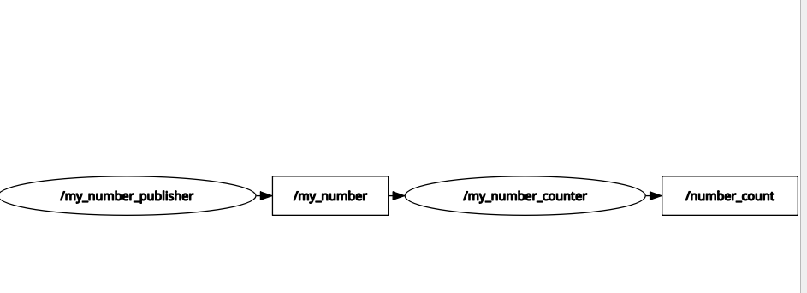

#### python remap EXECUTABLE and TOPIC

from launch import LaunchDescription

from launch_ros.actions import Node

def generate_launch_description():

ld = LaunchDescription()

number_publisher = Node(

package="my_py_pkg",

executable="number_publisher",

name="my_number_publisher",

remappings=[("/number", "/my_number")]

)

number_counter = Node(

package="my_cpp_pkg",

executable="number_counter",

name="my_number_counter",

remappings=[("/number", "/my_number")] #listed tuple

)

ld.add_action(number_publisher)

ld.add_action(number_counter)

return ld

***Note:*** For topic remap specifically use ‘remappings’ keyword, but for executable remap by ‘name’ keyword

afsalu-rahman-c@tuf:~/ros2_ws$ ros2 launch my_robot_bringup number_app.launch.py

[INFO] [launch]: All log files can be found below /home/afsalu-rahman-c/.ros/log/2025-06-05-13-52-12-838670-tuf-11574

[INFO] [launch]: Default logging verbosity is set to INFO

[INFO] [number_publisher-1]: process started with pid [11577]

[INFO] [number_counter-2]: process started with pid [11578]

[number_counter-2] [INFO] [1749111734.217213515] [my_number_counter]: Number of messages recived = 1

[number_counter-2] [INFO] [1749111735.215373737] [my_number_counter]: Number of messages recived = 2

[number_counter-2] [INFO] [1749111736.215370755] [my_number_counter]: Number of messages recived = 3

[number_counter-2]

### 9.5 Load parameters in launch file

--ros-args -p param_name:=value

***Note:*** Instead of ‘-r’ used ‘-p’ rest all are like topic run time change.

ros2 param list

/my_number_counter:

qos_overrides./parameter_events.publisher.depth

qos_overrides./parameter_events.publisher.durability

qos_overrides./parameter_events.publisher.history

qos_overrides./parameter_events.publisher.reliability

start_type_description_service

use_sim_time

/my_number_publisher:

number

start_type_description_service

timer_period

use_sim_time

afsalu-rahman-c@tuf:~/ros2_ws$ ros2 param get /my_number_publisher number

Integer value is: 50

syntax

ros2 param get /node_name parameter_name

afsalu-rahman-c@tuf:~$ ros2 param get /my_number_publisher timer_period

Double value is: 1.5

#### 

#### code

<launch>

<node pkg = "my_py_pkg" exec = "number_publisher" name="my_number_publisher">

<remap from="/number" to="/my_number"/>

<param name="number" value="50"/>

<param name="timer_period" value="1.5"/>

</node>

<node pkg = "my_cpp_pkg" exec = "number_counter" name="my_number_counter">

<remap from="/number" to ="/my_number"/>

</node>

</launch>

#### Loading parameter from already created yaml file

afsalu-rahman-c@tuf:~$ cd yaml_params/

afsalu-rahman-c@tuf:~/yaml_params$ ls

led_config.yaml number_params.yaml

above file going to move to config folder, 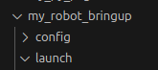

before that adding config in Cmakelists.txt

***Note****: any new f*older is created should add to the install section of Cmakelist.txt

install(DIRECTORY

launch

config

DESTINATION share/${PROJECT_NAME}/

)

ament_package()

#### 

#### trying to create a yaml file manually

/my_number_publisher: #executable node name, #forward slash is recommended

ros__parameters: #note ddouble underscore

number: 50

timer_period: 1.5

#### adding yaml file in xml

<launch>

<node pkg = "my_py_pkg" exec = "number_publisher" name="my_number_publisher" namespace="/abc">

<remap from="number" to="my_number"/>

<!-- <param name="number" value="50"/>

<param name="timer_period" value="1.5"/> -->

<param from="$(find-pkg-share my_robot_bringup)/config/number_app.yaml" />

</node>

<node pkg = "my_cpp_pkg" exec = "number_counter" name="my_number_counter" namespace="/abc">

<remap from="number" to ="my_number"/>

</node>

</launch>

#### parameters included in python launch file

from launch import LaunchDescription

from launch_ros.actions import Node

def generate_launch_description():

ld = LaunchDescription()

number_publisher = Node(

package="my_py_pkg",

executable="number_publisher",

name="my_number_publisher",

remappings=[("/number", "/my_number")], #listed tuple

parameters=[ #listed dictionary

{"number": 50},

{"timer_period": 1.3}

]

)

number_counter = Node(

package="my_cpp_pkg",

executable="number_counter",

name="my_number_counter",

remappings=[("/number", "/my_number")]

)

ld.add_action(number_publisher)

ld.add_action(number_counter)

return ld

***Note:***

1. Remappings = Listed Tuple
2. Parameters = Listed Dictionary

#### Added “number_app.yaml” in python code

from launch import LaunchDescription

from launch_ros.actions import Node

**from ament_index_python.packages import get_package_share_directory**

**import os**

def generate_launch_description():

ld = LaunchDescription()

**param_config = os.path.join(get_package_share_directory("my_robot_bringup"),**

**"config","number_app.yaml")**

number_publisher = Node(

package="my_py_pkg",

executable="number_publisher",

name="my_number_publisher",

remappings=[("/number", "/my_number")], #listed tuple

# parameters=[ #listed dictionary

# {"number": 50},

# {"timer_period": 1.3}

# ]

**parameters=[param_config]**

)

number_counter = Node(

package="my_cpp_pkg",

executable="number_counter",

name="my_number_counter",

remappings=[("/number", "/my_number")]

)

ld.add_action(number_publisher)

ld.add_action(number_counter)

return ld

### 9.6 Adding namespace to your nodes

A **namespace** is a prefix to names of ROS entities. For example, if your namespace is /robot1, and your node publishes to a topic cmd_vel, the fully-qualified topic name becomes:

### **Namespaces Apply To 🧾:**

* Nodes
* Topics
* Services
* Actions
* Parameters

#### Namespace during run time

***Note***: syntax similar to remapping **node name**

ros2 run my_cpp_pkg number_publisher --ros-args -r __ns:=/test

[INFO] [1749133662.431596654] [test.number_publisher]: Number publisher has been started

ros2 node list

/test/number_publisher

ros2 topic list

/parameter_events

/rosout

/test/number

#### Adding leading ‘ / '

leading “/” **will NOT ADD** the namespace to your code

self.number_publisher_ = self.create_publisher(Int64, "/number", 10)

ros2 topic list

/number >> namespace NOT reflected

if I remove leading ‘ / ‘ in topic number and run it

ros2 node list

/test/number_publisher >> namespace GET reflected

Note: So we can use it for, without changing in future

#### Application

/robot1/number_publisher

/robot2/number_publisher

/robot3/number_publisher

We can scale to multiple robot without changing the code, by changing namespace

#### namespace in xml launch file

**with leading ‘ / ‘ slash**

<node pkg = "my_py_pkg" exec = "number_publisher" name="my_number_publisher" namespace="/abc">

<remap from="/number" to="/my_number"/>

this will not make communication possible because leading slash in number and my_number topic

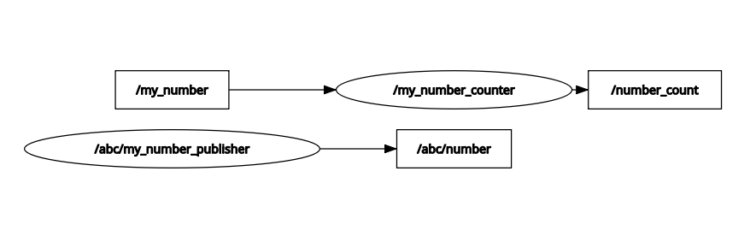

**without leading ‘ / ‘**

**Group 0**

**Group 1**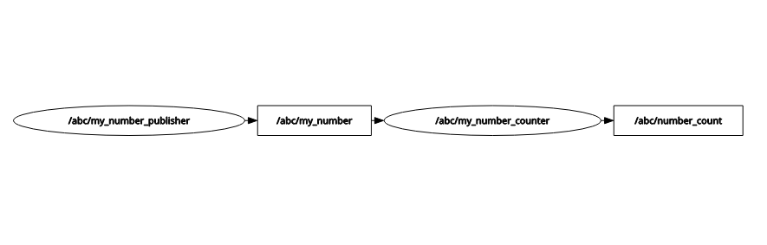

**Group 1**

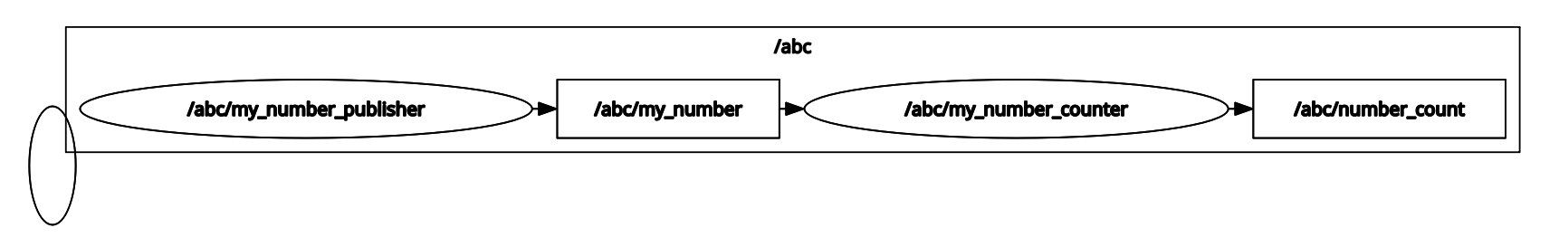

**<launch>**

**<node pkg = "my_py_pkg" exec = "number_publisher" name="my_number_publisher" namespace="/abc">**

**<remap from="number" to="my_number"/>**

**<!-- <param name="number" value="50"/>**

**<param name="timer_period" value="1.5"/> -->**

**<param from="$(find-pkg-share my_robot_bringup)/config/number_app.yaml" />**

**</node>**

**<node pkg = "my_cpp_pkg" exec = "number_counter" name="my_number_counter" namespace="/abc">**

**<remap from="number" to ="my_number"/>**

**</node>**

**</launch>**

afsalu-rahman-c@tuf:~/ros2_ws$ ros2 launch my_robot_bringup number_app.launch.xml

[INFO] [launch]: All log files can be found below /home/afsalu-rahman-c/.ros/log/2025-06-05-22-19-00-630231-tuf-13191

[INFO] [launch]: Default logging verbosity is set to INFO

[INFO] [number_publisher-1]: process started with pid [13194]

[INFO] [number_counter-2]: process started with pid [13195]

[number_publisher-1] [INFO] [1749142141.107355472] [**abc.my_number_publisher]**: Number publisher has been started.

[number_counter-2] [INFO] [1749142142.097058913] [abc.my_number_counter]: Number of messages recived = 2

[number_counter-2] [INFO] [1749142143.097552868] [**abc.my_number_counter**]: Number of messages recived = 4

#### namespace in py launch file

code

from launch import LaunchDescription

from launch_ros.actions import Node

from ament_index_python.packages import get_package_share_directory

import os

def generate_launch_description():

ld = LaunchDescription()

param_config = os.path.join(get_package_share_directory("my_robot_bringup"),

"config","number_app.yaml")

number_publisher = Node(

package="my_py_pkg",

executable="number_publisher",

namespace="/abc"

, name="my_number_publisher",

remappings=[("number", "my_number")], #listed tuple

# parameters=[ #listed dictionary

# {"number": 50},

# {"timer_period": 1.3}

# ]

parameters=[param_config]

)

number_counter = Node(

package="my_cpp_pkg",

executable="number_counter",

namespace="/abc",

name="my_number_counter",

remappings=[("number", "my_number")]

)

ld.add_action(number_publisher)

ld.add_action(number_counter)

return ld

### 

### 9.7 Activity 6

In this activity you will practice by creating a new launch file, with the nodes that you’ve already created during this course.

Goal:

Start 5 “robot_news_station” nodes and 1 smartphone node.

Each “robot_news_station” will need a different name, and will publish "Hi, this is <robot_name> from the Robot News Station!"

The “smartphone” node gets all the messages from all other nodes.

Here’s the graph you should get:

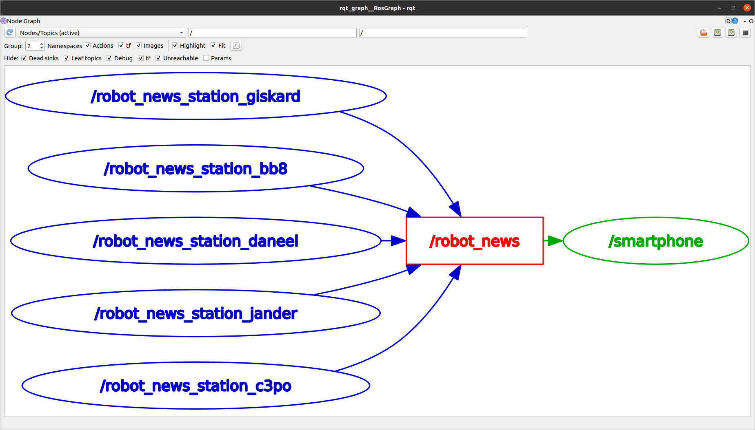

So, no need to create or modify any node here. You just need to create a single launch file.

You can start by providing the parameters one by one in the launch file, and then load them from a YAML file.

I’ll see you in the next lecture for the solution.

Bonus point if you find the book/movie reference for all robot names! (shouldn’t be too hard).

### 

### My solution - xml with yaml file

#### xml file(news-station.xml)

<launch>

<node pkg="my_py_pkg" exec="robot_news_station" name="robot_news_station_glskard" >

<param from="$(find-pkg-share my_robot_bringup)/config/robots.yaml" />

</node>

<node pkg="my_py_pkg" exec="robot_news_station" name="robot_news_station_bb8" >

<param from="$(find-pkg-share my_robot_bringup)/config/robots.yaml" />

</node>

<node pkg="my_py_pkg" exec="robot_news_station" name="robot_news_station_daneel" >

<param from="$(find-pkg-share my_robot_bringup)/config/robots.yaml" />

</node>

<node pkg="my_py_pkg" exec="robot_news_station" name="robot_news_station_lander" >

<param from="$(find-pkg-share my_robot_bringup)/config/robots.yaml" />

</node>

<node pkg="my_py_pkg" exec="robot_news_station" name="robot_news_station_c3po" >

<param name="robot_name" value="daneel" />

</node>

<node pkg="my_py_pkg" exec="smartphone" />

</launch>

#### robots.yaml

/robot_news_station_glskard:

ros__parameters:

robot_name: "glskard"

/robot_news_station_bb8:

ros__parameters:

robot_name: "bb8"

/robot_news_station_c3po:

ros__parameters:

robot_name: "c3po"

/robot_news_station_lander:

ros__parameters:

robot_name: "lander"

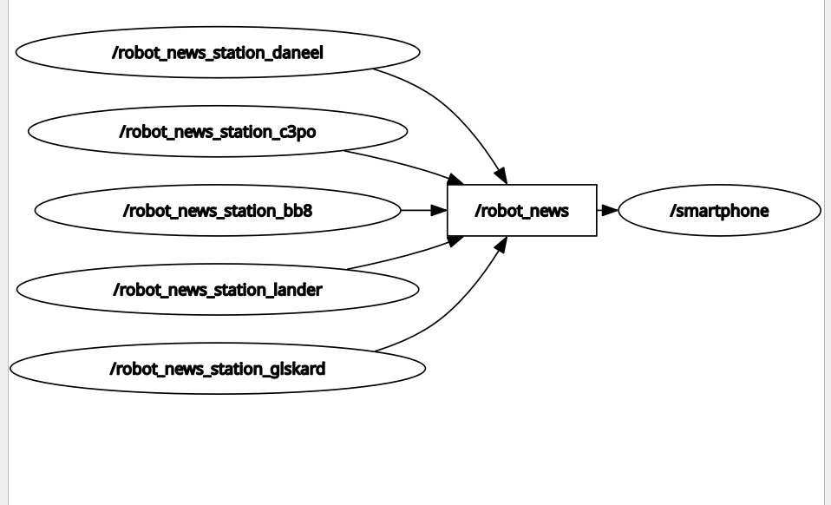

#### Changing parameter name from terminal

ros2 run my_py_pkg robot_news_station --ros-args __node:=robot_news_station_gliskard -p robot_name:=”Gliksard”

afsalu-rahman-c@tuf:~$ ros2 param list

/robot_news_station_bb8:

robot_name

start_type_description_service

use_sim_time

/robot_news_station_c3po:

robot_name

start_type_description_service

use_sim_time

/robot_news_station_daneel:

robot_name

start_type_description_service

use_sim_time

/robot_news_station_glskard:

robot_name

start_type_description_service

use_sim_time

/robot_news_station_lander:

robot_name

start_type_description_service

use_sim_time

/smartphone:

start_type_description_service

use_sim_time

# Section 10

### 10.1 Turtlesim Project - Final Result Overview - Video

### 10.2 Your challenge

Turtlesim “Catch Them All” project

Time to start your first complete project with ROS 2!

For this project you will use the Turtlesim package as a simulation tool, so you can visualize what the robot is doing.

Before going further, make sure you’ve watched the video with the final result you should get (“Turtlesim Project - Final Result Overview” video).

If this sounds hard, well, yes, it’s certainly harder than what we previously did in this course. But it’s totally doable if you’ve understood the concepts, how to apply them, and of course if you take enough time to work on the project.

At any time feel free to come back to previous lessons on the course. Solving problems when you work on a project is one of the best ways to learn, because the lessons you’ll watch again will be directly linked to a practical problem.

How is it organized

I have separated the solution into different parts, so that it will be easier for you to navigate. Also, if you really feel stuck at some point, you can watch only one part of the solution, and then go back to work on the next part by yourself.

So:

First try to design the application by yourself. Don’t write code! Just take a piece of paper and make the design. What nodes should you create? How do the nodes communicate between each other? Which functionality should you add, and where to put them? Etc.

Then, either you directly start on your own (let’s call this the hardcore mode), or read the next part where I give you some tips for the design.

Then, work step by step on each functionality/communication. You can decide to break the project as I did, and for each step, write the code, and then watch the solution. Or you can ignore the solution and challenge yourself to do everything by yourself.

Just do as you feel. The more independent you are on the project, the better. However, don’t stay stuck for days or weeks, if you have to watch parts of the solution, it’s fine too. In this case, a nice challenge would be to do the project again a few days later, without any help this time.

Note: the design + code I propose is ONLY one possible solution. You might end up with a totally different code, but still working. And that’s great too! The real goal here is to make what you saw on the demo video (and also keep in mind to make your code clean and scalable).

As an additional help, you can download the code for each step (contains both Python and Cpp code for the step)

### My py solution

#### Turtle controller

#!/usr/bin/env python3

import rclpy

from rclpy.node import Node

from turtlesim.msg import Pose

from geometry_msgs.msg import Twist

from my_robot_interfaces.msg import Turtle

from my_robot_interfaces.srv import CatchTurtle

import math

class TurtleController(Node):

def __init__(self):

super().__init__("turtle_controller")

self.master_pose_sub_ = self.create_subscription(

Pose, '/turtle1/pose', self.callback_master_pose_sub, 10

)

self.master_cmd_vel_pub_ = self.create_publisher(

Twist, '/turtle1/cmd_vel', 10

)

self.alive_turtle_sub_ = self.create_subscription(

Turtle, 'alive_turtle', self.callback_alive_turtle_sub, 10

)

self.catch_turtle_service_ = self.create_client(

CatchTurtle, '/catch_turtle'

)

self.timer_ = self.create_timer(0.01, self.control_loop)

self.current_x = 0.0

self.current_y = 0.0

self.current_theta = 0.0

self.goal_turtle = None

self.goal_x = None

self.goal_y = None

self.goal_theta = None

self.turtle_caught = False

def callback_master_pose_sub(self, msg: Pose):

self.current_x = msg.x

self.current_y = msg.y

self.current_theta = msg.theta

def callback_alive_turtle_sub(self, msg: Turtle):

if len(msg.turtle_name_list) > 0:

self.goal_turtle = msg.turtle_name_list[0]

self.goal_x = msg.turtle_x[0]

self.goal_y = msg.turtle_y[0]

self.goal_theta = msg.turtle_theta[0]

self.turtle_caught = False

def control_loop(self):

if ( #if any one is 'True' loop return immediately without nothing happen otherwise raise error like substraction between none type and float

self.goal_turtle is None

or self.goal_x is None

or self.goal_y is None

or self.turtle_caught

):

return

error_x = self.goal_x - self.current_x

error_y = self.goal_y - self.current_y

distance_error = math.sqrt(error_x ** 2 + error_y ** 2)

angle_to_goal = math.atan2(error_y, error_x)

angle_error = angle_to_goal - self.current_theta

# Normalize angle to [-pi, pi]

angle_error = math.atan2(math.sin(angle_error), math.cos(angle_error))

# Controller gains

Kp_linear = 2.0

Kp_angular = 6.0

max_linear_speed = 2.0

max_angular_speed = 2.0

linear_velocity = min(Kp_linear * distance_error, max_linear_speed)

angular_velocity = max(-max_angular_speed,

min(Kp_angular * angle_error, max_angular_speed))

cmd = Twist()

if distance_error > 0.5:

cmd.linear.x = linear_velocity

cmd.angular.z = angular_velocity

self.master_cmd_vel_pub_.publish(cmd)

else:

# Stop and request to catch

cmd.linear.x = 0.0

cmd.angular.z = 0.0

if self.catch_turtle_service_.service_is_ready():

request = CatchTurtle.Request()

request.name = self.goal_turtle

future = self.catch_turtle_service_.call_async(request)

future.add_done_callback(self.future_response_callback)

self.turtle_caught = True

self.master_cmd_vel_pub_.publish(cmd)

def future_response_callback(self, future):

try:

response = future.result()

if response.success:

self.get_logger().info(f"Turtle '{self.goal_turtle}' caught successfully.")

else:

self.get_logger().info(f"Failed to catch turtle '{self.goal_turtle}'.")

except Exception as e:

self.get_logger().error(f"Service call failed: {e}")

def main(args=None):

rclpy.init(args=args)

node = TurtleController()

rclpy.spin(node)

rclpy.shutdown()

if __name__ == "__main__":

main()

#### Turtle spawner

#!/usr/bin/env python3

import rclpy

from rclpy.node import Node

from turtlesim.srv import Spawn, Kill

from my_robot_interfaces.msg import Turtle

from my_robot_interfaces.srv import CatchTurtle

import random

from functools import partial

class TurtleSpawner(Node):

def __init__(self):

super().__init__("turtle_spawner")

self.spawn_service_client_ = self.create_client(Spawn,"spawn")

self.catch_turtle_service_server_ = self.create_service(CatchTurtle,"/catch_turtle",self.callback_catch_turtle_service_server)

self.kill_service_client_ = self.create_client(Kill,"kill")

self.get_logger().info("The turtle spawner node has been started.")

self.create_timer(random.uniform(1.0, 5.0),self.timer_callback)

self.alive_turtles_ = self.create_publisher(Turtle,"alive_turtle",10)

# self.coordinates_of_turtles_ = self.create_publisher(TurtleArray, "turtle_coordinates",10)

self.x_ = 0.0

self.y_ = 0.0

self.theta_ = 0.0

self.all_turtle_names = []

self.x_list_ = []

self.y_list_ = []

self.theta_list_ = []

def timer_callback(self):

while not self.spawn_service_client_.wait_for_service(1.0):

self.get_logger().warn("Waiting for spawn service server")

while not self.kill_service_client_.wait_for_service(1.0):

self.get_logger().warn("waiting for kill service server")

self.x_ = random.uniform(0.0, 11.0)

self.y_ = random.uniform(0.0, 11.0)

self.theta_ = random.uniform(0.0, 6.283)

request_1 = Spawn.Request()

request_1.x = self.x_

request_1.y = self.y_

request_1.theta = self.theta_

future_1 = self.spawn_service_client_.call_async(request_1)

future_1.add_done_callback(self.spawn_response_callback)

def spawn_response_callback(self, future_1):

respone_1 = future_1.result()

turtle_name = respone_1.name

self.all_turtle_names.append(turtle_name)

self.x_list_.append(self.x_)

self.y_list_.append(self.y_)

self.theta_list_.append(self.theta_)

self.publish_turtle_info()

def publish_turtle_info(self):

msg1 = Turtle()

msg1.turtle_name_list = self.all_turtle_names

msg1.turtle_x = self.x_list_

msg1.turtle_y = self.y_list_

msg1.turtle_theta = self.theta_list_

self.alive_turtles_.publish(msg1)

# msg2 = TurtleArray()

# msg2.turtle_coordinates.append([x_, y_, theta_])

# self.coordinates_of_turtles_.publish(msg2)

# request_2 = Kill.Request()

# request_2.name = turtle_name

# self.kill_service_client_.call_async(request_2)

#

# self.name_ = respone_1.name

# request_2 = Kill.Request()

# request_2.name = self.name_

# self.kill_service_client_.call_async(request_2)

def callback_catch_turtle_service_server(self, request_2: CatchTurtle.Request, response_2: CatchTurtle.Response):

turtle_to_catch = request_2.name

request_3 = Kill.Request()

request_3.name = turtle_to_catch

future_2 = self.kill_service_client_.call_async(request_3)

future_2.add_done_callback(partial(self.kill_response_callback,catched_turtle=turtle_to_catch))

return response_2

def kill_response_callback(self,future_2,catched_turtle):

index_to_remove = self.all_turtle_names.index(catched_turtle)

self.all_turtle_names.remove(catched_turtle)

self.x_list_.pop(index_to_remove)

self.y_list_.pop(index_to_remove)

self.theta_list_.pop(index_to_remove)

self.publish_turtle_info()

def main(args=None):

rclpy.init(args=args)

node = TurtleSpawner()

rclpy.spin(node)

rclpy.shutdown()

if __name__ == "__main__":

main()

Turtle.msg

string[] turtle_name_list

float64[] turtle_x

float64[] turtle_y

float64[] turtle_theta

CatchTurtle.srv

string name #name of the turtle which was cauhgt

---

bool success

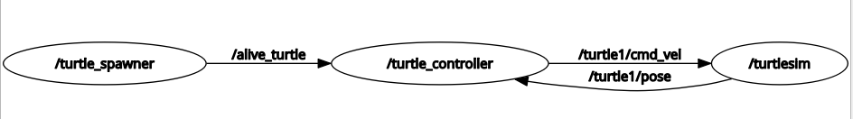

[Working](https://photos.app.goo.gl/rry4LQsrkGmrqnWf7)

[Error](https://photos.app.goo.gl/bhA9PNyw3ZR9Y19M6)

#### package.xml

### 

<?xml version="1.0"?>

<?xml-model href="http://download.ros.org/schema/package_format3.xsd" schematypens="http://www.w3.org/2001/XMLSchema"?>

<package format="3">

<name>turtlesim_catch_them_all</name>

<version>0.0.0</version>

<description>TODO: Package description</description>

<maintainer email="afsalu2002@gmail.com">afsalu-rahman-c</maintainer>

<license>TODO: License declaration</license>

<depend>rclpy</depend>

<exec_depend>turtlesim</exec_depend>

<exec_depend>my_robot_interfaces</exec_depend>

<exec_depend>geometry_msgs</exec_depend>

<test_depend>ament_copyright</test_depend>

<test_depend>ament_flake8</test_depend>

<test_depend>ament_pep257</test_depend>

<test_depend>python3-pytest</test_depend>

<export>

<build_type>ament_python</build_type>

</export>

</package>

### 10.3 Some Tips to get started

[PDF](https://drive.google.com/file/d/1VQOz3U1gCjC0ycUOoLLfWbzEM7if64pH/view?usp=sharing)

### 

### 10.4 Part ⅙

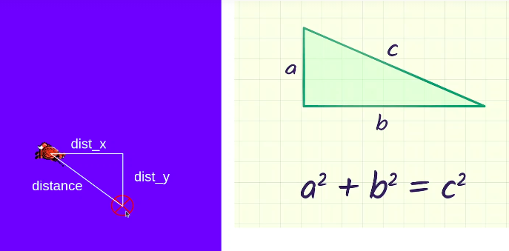

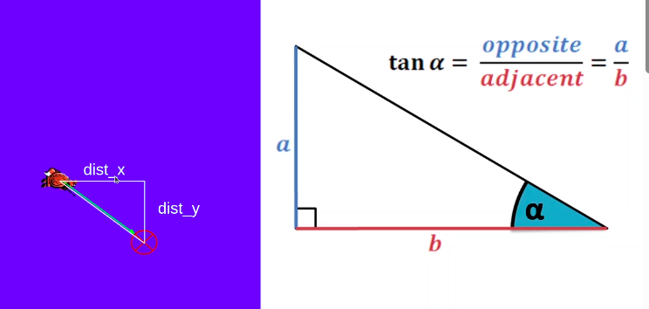

#### code end of part 1

#!/usr/bin/env python3

import rclpy

from rclpy.node import Node

from turtlesim.msg import Pose

from geometry_msgs.msg import Twist

from my_robot_interfaces.msg import Turtle

from my_robot_interfaces.srv import CatchTurtle

import math

class TurtleController(Node):

def __init__(self):

super().__init__("turtle_controller")

self.target_x = 2.0

self.target_y = 8.0

self.pose_: Pose = None

self.pose_sub_ = self.create_subscription(

Pose, '/turtle1/pose', self.callback_pose, 10)

self.cmd_vel_pub_ = self.create_publisher(

Twist, '/turtle1/cmd_vel', 10)

self.control_loop_timer_ = self.create_timer(

0.01,self.control_loop)

def callback_pose(self, pose: Pose):

self.pose_ = pose

def control_loop(self):

if self.pose_ == None:

return

dist_x = self.target_x - self.pose_.x

dist_y = self.target_y - self.pose_.y

distance = math.sqrt(dist_x **2 + dist_y ** 2)

cmd = Twist()

kp_linear = 2.0

kp_angular = 6.0

if distance > 0.5: #position

cmd.linear.x = kp_linear * distance

goal_theta = math.atan2(dist_y, dist_x)

diff = goal_theta - self.pose_.theta

cmd.angular.z = 0.0

if diff > math.pi:

diff -= 2*math.pi

elif diff < -math.pi:

diff += 2*math.pi

cmd.angular.z = kp_angular * diff

else: #target reached

cmd.linear.x = 0.0

cmd.angular.z = 0.0

self.cmd_vel_pub_.publish(cmd)

def main(args=None):

rclpy.init(args=args)

node = TurtleController()

rclpy.spin(node)

rclpy.shutdown()

if __name__ == "__main__":

main()

### 10.5 Part 2/6

#### code at end

#!/usr/bin/env python3

import rclpy

from rclpy.node import Node

from turtlesim.srv import Spawn, Kill

from my_robot_interfaces.msg import Turtle

from my_robot_interfaces.srv import CatchTurtle

import random

import math

from functools import partial

class TurtleSpawner(Node):

def __init__(self):

super().__init__("turtle_spawner")

self.turtle_name_prefix_ = "turtle"

self.turtle_counter_ = 1

self.spawn_client_ = self.create_client(Spawn, "/spawn")

self.call_spawn_service_timer_ = self.create_timer(2.0, self.spawn_new_turtle)

def spawn_new_turtle(self):

self.turtle_counter_ += 1

name = self.turtle_name_prefix_ + str(self.turtle_counter_)

x = random.uniform(0.0, 11.0)

y = random.uniform(0.0, 11.0)

theta = random.uniform(0.0, 2 * math.pi)

self.call_spawn_service(name, x, y, theta)

def call_spawn_service(self, turtle_name, x, y, theta):

while not self.spawn_client_.wait_for_service(1.0):

self.get_logger().warn("Waiting for spawn service ..")

request = Spawn.Request()

request.x = x

request.y = y

request.theta = theta

request.name = turtle_name

future = self.spawn_client_.call_async(request)

future.add_done_callback(partial(self.callback_call_spawn_service, request=request))

def callback_call_spawn_service(self, future, request):

response: Spawn.Response = future.result()

if response.name != "":

self.get_logger().info("New alive turtle: " + response.name)

def main(args=None):

rclpy.init(args=args)

node = TurtleSpawner()

rclpy.spin(node)

rclpy.shutdown()

if __name__ == "__main__":

main()

### 10.6 Part 3/6

#### Turtle.msg

string name

float64 x

float64 y

float64 theta

#### TurtleArray.msg

Turtle[] turtles

afsalu-rahman-c@tuf:~/ros2_ws$ ros2 interface show my_robot_interfaces/msg/Turtle

string name

float64 x

float64 y

float64 theta

afsalu-rahman-c@tuf:~/ros2_ws$ ros2 interface show my_robot_interfaces/msg/TurtleArray

Turtle[] turtles

string name

float64 x

float64 y

float64 theta

#### turtle_spawner.py

#!/usr/bin/env python3

import random

import math

from functools import partial

import rclpy

from rclpy.node import Node

from turtlesim.srv import Spawn, Kill

from my_robot_interfaces.msg import Turtle, TurtleArray

from my_robot_interfaces.srv import CatchTurtle

class TurtleSpawner(Node):

def __init__(self):

super().__init__("turtle_spawner")

self.turtle_name_prefix_ = "turtle"

self.turtle_counter_ = 1

self.alive_turtles_ = []

self.alive_turtles_pub_ = self.create_publisher(

TurtleArray,'alive_turtles', 10)

self.spawn_client_ = self.create_client(Spawn, "/spawn")

self.call_spawn_service_timer_ = self.create_timer(2.0, self.spawn_new_turtle)

def publish_alive_turtles(self):

msg = TurtleArray()

msg.turtles = self.alive_turtles_

self.alive_turtles_pub_.publish(msg)

def spawn_new_turtle(self):

self.turtle_counter_ += 1

name = self.turtle_name_prefix_ + str(self.turtle_counter_)

x = random.uniform(0.0, 11.0)

y = random.uniform(0.0, 11.0)

theta = random.uniform(0.0, 2 * math.pi)

self.call_spawn_service(name, x, y, theta)

def call_spawn_service(self, turtle_name, x, y, theta):

while not self.spawn_client_.wait_for_service(1.0):

self.get_logger().warn("Waiting for spawn service ..")

request = Spawn.Request()

request.x = x

request.y = y

request.theta = theta

request.name = turtle_name

future = self.spawn_client_.call_async(request)

future.add_done_callback(partial(self.callback_call_spawn_service, request=request))

def callback_call_spawn_service(self, future, request: Spawn.Request):

response: Spawn.Response = future.result()

if response.name != "":

self.get_logger().info("New alive turtle: " + response.name)

new_turtle = Turtle() #pass with turtle object

new_turtle.name = response.name

new_turtle.x = request.x

new_turtle.y = request.y

new_turtle.theta = request.theta

self.alive_turtles_.append(new_turtle)

self.publish_alive_turtles()

def main(args=None):

rclpy.init(args=args)

node = TurtleSpawner()

rclpy.spin(node)

rclpy.shutdown()

if __name__ == "__main__":

main()

#### turtle_controller.py

#!/usr/bin/env python3

import rclpy

from rclpy.node import Node

from turtlesim.msg import Pose

from geometry_msgs.msg import Twist

from my_robot_interfaces.msg import Turtle, TurtleArray

from my_robot_interfaces.srv import CatchTurtle

import math

class TurtleController(Node):

def __init__(self):

super().__init__("turtle_controller")

self.turtle_to_catch_: Turtle = None

self.pose_: Pose = None

self.cmd_vel_pub_ = self.create_publisher(

Twist, '/turtle1/cmd_vel', 10)

self.pose_sub_ = self.create_subscription(

Pose, '/turtle1/pose', self.callback_pose, 10)

self.alive_turtles_sub_ = self.create_subscription(

TurtleArray,"alive_turtles",self.callback_alive_turtles,10)

self.control_loop_timer_ = self.create_timer(

0.01,self.control_loop)

def callback_pose(self, pose: Pose):

self.pose_ = pose

def callback_alive_turtles(self, msg: TurtleArray):

if len(msg.turtles) > 0:

self.turtle_to_catch_ = msg.turtles[0]

def control_loop(self):

if self.pose_ == None or self.turtle_to_catch_ == None:

return

dist_x = self.turtle_to_catch_.x - self.pose_.x

dist_y = self.turtle_to_catch_.y - self.pose_.y

distance = math.sqrt(dist_x **2 + dist_y ** 2)

cmd = Twist()

kp_linear = 2.0

kp_angular = 6.0

if distance > 0.5: #position

cmd.linear.x = kp_linear * distance

goal_theta = math.atan2(dist_y, dist_x)

diff = goal_theta - self.pose_.theta

cmd.angular.z = 0.0

if diff > math.pi:

diff -= 2*math.pi

elif diff < -math.pi:

diff += 2*math.pi

cmd.angular.z = kp_angular * diff

else: #target reached

cmd.linear.x = 0.0

cmd.angular.z = 0.0

self.cmd_vel_pub_.publish(cmd)

def main(args=None):

rclpy.init(args=args)

node = TurtleController()

rclpy.spin(node)

rclpy.shutdown()

if __name__ == "__main__":

main()

### 10.7 Part 4/6

***Note:***

1. If you want you call kill turtle from the turtle_controlller itself but it is better to do from turtle_spawner because it have the list of turtle
2. For a service creation it is always better to create from server side

# 

#### turtle_spawner.py

#!/usr/bin/env python3

import random

import math

from functools import partial

import rclpy

from rclpy.node import Node

from turtlesim.srv import Spawn, Kill

from my_robot_interfaces.msg import Turtle, TurtleArray

from my_robot_interfaces.srv import CatchTurtle

class TurtleSpawner(Node):

def __init__(self):

super().__init__("turtle_spawner")

self.turtle_name_prefix_ = "turtle"

self.turtle_counter_ = 1

self.alive_turtles_ = []

self.alive_turtles_pub_ = self.create_publisher(

TurtleArray,'alive_turtles', 10)

self.spawn_client_ = self.create_client(Spawn, "/spawn")

self.catch_turtle_service_ = self.create_service(

CatchTurtle,"cath_turtle", self.callback_catch_turtle)

self.call_spawn_service_timer_ = self.create_timer(2.0, self.spawn_new_turtle)

self.kill_client_ = self.create_client(Kill,"/kill")

def callback_catch_turtle(self, request: CatchTurtle.Request, response: CatchTurtle.Response):

#call kill service

self.call_kill_service(request.name) # forwarding name from CatchTurtle service

response.success = True

return response

def publish_alive_turtles(self):

msg = TurtleArray()

msg.turtles = self.alive_turtles_

self.alive_turtles_pub_.publish(msg)

def spawn_new_turtle(self):

self.turtle_counter_ += 1

name = self.turtle_name_prefix_ + str(self.turtle_counter_)

x = random.uniform(0.0, 11.0)

y = random.uniform(0.0, 11.0)

theta = random.uniform(0.0, 2 * math.pi)

self.call_spawn_service(name, x, y, theta)

def call_spawn_service(self, turtle_name, x, y, theta):

while not self.spawn_client_.wait_for_service(1.0):

self.get_logger().warn("Waiting for spawn service ..")

request = Spawn.Request()

request.x = x

request.y = y

request.theta = theta

request.name = turtle_name

future = self.spawn_client_.call_async(request)

future.add_done_callback(partial(self.callback_call_spawn_service, request=request))

def callback_call_spawn_service(self, future, request: Spawn.Request):

response: Spawn.Response = future.result()

if response.name != "":

self.get_logger().info("New alive turtle: " + response.name)

new_turtle = Turtle() #pass with turtle object

new_turtle.name = response.name

new_turtle.x = request.x

new_turtle.y = request.y

new_turtle.theta = request.theta

self.alive_turtles_.append(new_turtle)

self.publish_alive_turtles()

def call_kill_service(self, turtle_name):

while not self.kill_client_.wait_for_service(1.0):

self.get_logger().warn("Waiting for kill service...")

request = Kill.Request()

request.name = turtle_name

future = self.kill_client_.call_async(request)

future.add_done_callback(partial(self.callback_call_kill_service, turtle_name=turtle_name))

def callback_call_kill_service(self, future, turtle_name):

for (i, turtle) in enumerate(self.alive_turtles_):

if turtle.name == turtle_name:

del self.alive_turtles_[i]

self.publish_alive_turtles()

break

def main(args=None):

rclpy.init(args=args)

node = TurtleSpawner()

rclpy.spin(node)

rclpy.shutdown()

if __name__ == "__main__":

main()

#### 

***Note:***

Please note the for loop

#### turtle_controller.py

#!/usr/bin/env python3

import math

from functools import partial

import rclpy

from rclpy.node import Node

from turtlesim.msg import Pose

from geometry_msgs.msg import Twist

from my_robot_interfaces.msg import Turtle, TurtleArray

from my_robot_interfaces.srv import CatchTurtle

class TurtleController(Node):

def __init__(self):

super().__init__("turtle_controller")

self.turtle_to_catch_: Turtle = None

self.pose_: Pose = None

self.cmd_vel_pub_ = self.create_publisher(

Twist, '/turtle1/cmd_vel', 10)

self.pose_sub_ = self.create_subscription(

Pose, '/turtle1/pose', self.callback_pose, 10)

self.alive_turtles_sub_ = self.create_subscription(

TurtleArray,"alive_turtles",self.callback_alive_turtles,10)

self.catch_turtle_client_ = self.create_client(

CatchTurtle,"cath_turtle")

self.control_loop_timer_ = self.create_timer(

0.01,self.control_loop)

def callback_pose(self, pose: Pose):

self.pose_ = pose

def callback_alive_turtles(self, msg: TurtleArray):

if len(msg.turtles) > 0:

self.turtle_to_catch_ = msg.turtles[0]

def control_loop(self):

if self.pose_ == None or self.turtle_to_catch_ == None:

return

dist_x = self.turtle_to_catch_.x - self.pose_.x

dist_y = self.turtle_to_catch_.y - self.pose_.y

distance = math.sqrt(dist_x **2 + dist_y ** 2)

cmd = Twist()

kp_linear = 2.0

kp_angular = 6.0

if distance > 0.5: #position

cmd.linear.x = kp_linear * distance

goal_theta = math.atan2(dist_y, dist_x)

diff = goal_theta - self.pose_.theta

cmd.angular.z = 0.0

if diff > math.pi:

diff -= 2*math.pi

elif diff < -math.pi:

diff += 2*math.pi

cmd.angular.z = kp_angular * diff

else: #target reached

cmd.linear.x = 0.0

cmd.angular.z = 0.0

self.call_catch_turtle_service(self.turtle_to_catch_.name)

self.turtle_to_catch_ = None

self.cmd_vel_pub_.publish(cmd)

def call_catch_turtle_service(self, turtle_name):

while not self.catch_turtle_client_.wait_for_service(1.0):

self.get_logger().warn("Waiting for kill service...")

request = CatchTurtle.Request()

request.name = turtle_name

future = self.catch_turtle_client_.call_async(request)

future.add_done_callback(partial(self.callback_call_catch_turtle_service, turtle_name=turtle_name))

def callback_call_catch_turtle_service(self, future, turtle_name):

response: CatchTurtle.Response = future.result()

if not response.success:

self.get_logger().error("Turtle " + turtle_name + " could not be removes")

def main(args=None):

rclpy.init(args=args)

node = TurtleController()

rclpy.spin(node)

rclpy.shutdown()

if __name__ == "__main__":

main()

***Note:***

Actually below part is not mandatory,

future.add_done_callback(partial(self.callback_call_catch_turtle_service, turtle_name=turtle_name))

def callback_call_catch_turtle_service(self, future, turtle_name):

response: CatchTurtle.Response = future.result()

if not response.success:

self.get_logger().error("Turtle " + turtle_name + " could not be removes")

***Note:Problem***

Master turtle is hitting the wall

### 10.8 part ⅚

In order to avoid always picking the turtle by order

self.turtle_to_catch_ = msg.turtles[0]

always better to catch the nearest one , to do so

#### edit in turtle_spawner.py

edi in turtle_controller.py

### 10.9 Part 6/6

Added parameters in both turtle spawner and turtle controller file and created launch file

#### turtle_controller.py

#!/usr/bin/env python3

import math

from functools import partial

import rclpy

from rclpy.node import Node

from turtlesim.msg import Pose

from geometry_msgs.msg import Twist

from my_robot_interfaces.msg import Turtle, TurtleArray

from my_robot_interfaces.srv import CatchTurtle

class TurtleController(Node):

def __init__(self):

super().__init__("turtle_controller")

self.declare_parameter("catch_closet_turtle_first", True)

self.catch_closet_turtle_first = self.get_parameter(

"catch_closet_turtle_first").value

self.turtle_to_catch_: Turtle = None

self.pose_: Pose = None

self.cmd_vel_pub_ = self.create_publisher(

Twist, '/turtle1/cmd_vel', 10)

self.pose_sub_ = self.create_subscription(

Pose, '/turtle1/pose', self.callback_pose, 10)

self.alive_turtles_sub_ = self.create_subscription(

TurtleArray,"alive_turtles",self.callback_alive_turtles,10)

self.catch_turtle_client_ = self.create_client(

CatchTurtle,"cath_turtle")

self.control_loop_timer_ = self.create_timer(

0.01,self.control_loop)

def callback_pose(self, pose: Pose):

self.pose_ = pose

def callback_alive_turtles(self, msg: TurtleArray):

if len(msg.turtles) > 0:

closet_turtle = None

closet_turtle_distance = None

for turtle in msg.turtles:

dist_x = turtle.x - self.pose_.x

dist_y = turtle.y - self.pose_.y

distance = math.sqrt(dist_x ** 2 + dist_y ** 2)

if closet_turtle == None or distance < closet_turtle_distance:

closet_turtle = turtle

closet_turtle_distance = distance

self.turtle_to_catch_ = closet_turtle

else:

self.turtle_to_catch_ = msg.turtles[0]

def control_loop(self):

if self.pose_ == None or self.turtle_to_catch_ == None:

return

dist_x = self.turtle_to_catch_.x - self.pose_.x

dist_y = self.turtle_to_catch_.y - self.pose_.y

distance = math.sqrt(dist_x **2 + dist_y ** 2)

cmd = Twist()

kp_linear = 2.0

kp_angular = 6.0

if distance > 0.5: #position

cmd.linear.x = kp_linear * distance

goal_theta = math.atan2(dist_y, dist_x)

diff = goal_theta - self.pose_.theta

cmd.angular.z = 0.0

if diff > math.pi:

diff -= 2*math.pi

elif diff < -math.pi:

diff += 2*math.pi

cmd.angular.z = kp_angular * diff

else: #target reached

cmd.linear.x = 0.0

cmd.angular.z = 0.0

self.call_catch_turtle_service(self.turtle_to_catch_.name)

self.turtle_to_catch_ = None

self.cmd_vel_pub_.publish(cmd)

def call_catch_turtle_service(self, turtle_name):

while not self.catch_turtle_client_.wait_for_service(1.0):

self.get_logger().warn("Waiting for kill service...")

request = CatchTurtle.Request()

request.name = turtle_name

future = self.catch_turtle_client_.call_async(request)

future.add_done_callback(partial(self.callback_call_catch_turtle_service, turtle_name=turtle_name))

def callback_call_catch_turtle_service(self, future, turtle_name):

response: CatchTurtle.Response = future.result()

if not response.success:

self.get_logger().error("Turtle " + turtle_name + " could not be removes")

def main(args=None):

rclpy.init(args=args)

node = TurtleController()

rclpy.spin(node)

rclpy.shutdown()

if __name__ == "__main__":

main()

#!/usr/bin/env python3

import math

from functools import partial

import rclpy

from rclpy.node import Node

from turtlesim.msg import Pose

from geometry_msgs.msg import Twist

from my_robot_interfaces.msg import Turtle, TurtleArray

from my_robot_interfaces.srv import CatchTurtle

class TurtleController(Node):

def __init__(self):

super().__init__("turtle_controller")

self.declare_parameter("catch_closet_turtle_first", True)

self.catch_closet_turtle_first = self.get_parameter(

"catch_closet_turtle_first").value

self.turtle_to_catch_: Turtle = None

self.pose_: Pose = None

self.cmd_vel_pub_ = self.create_publisher(

Twist, '/turtle1/cmd_vel', 10)

self.pose_sub_ = self.create_subscription(

Pose, '/turtle1/pose', self.callback_pose, 10)

self.alive_turtles_sub_ = self.create_subscription(

TurtleArray,"alive_turtles",self.callback_alive_turtles,10)

self.catch_turtle_client_ = self.create_client(

CatchTurtle,"cath_turtle")

self.control_loop_timer_ = self.create_timer(

0.01,self.control_loop)

def callback_pose(self, pose: Pose):

self.pose_ = pose

def callback_alive_turtles(self, msg: TurtleArray):

if len(msg.turtles) > 0:

closet_turtle = None

closet_turtle_distance = None

for turtle in msg.turtles:

dist_x = turtle.x - self.pose_.x

dist_y = turtle.y - self.pose_.y

distance = math.sqrt(dist_x ** 2 + dist_y ** 2)

if closet_turtle == None or distance < closet_turtle_distance:

closet_turtle = turtle

closet_turtle_distance = distance

self.turtle_to_catch_ = closet_turtle

else:

self.turtle_to_catch_ = msg.turtles[0]

def control_loop(self):

if self.pose_ == None or self.turtle_to_catch_ == None:

return

dist_x = self.turtle_to_catch_.x - self.pose_.x

dist_y = self.turtle_to_catch_.y - self.pose_.y

distance = math.sqrt(dist_x **2 + dist_y ** 2)

cmd = Twist()

kp_linear = 2.0

kp_angular = 6.0

if distance > 0.5: #position

cmd.linear.x = kp_linear * distance

goal_theta = math.atan2(dist_y, dist_x)

diff = goal_theta - self.pose_.theta

cmd.angular.z = 0.0

if diff > math.pi:

diff -= 2*math.pi

elif diff < -math.pi:

diff += 2*math.pi

cmd.angular.z = kp_angular * diff

else: #target reached

cmd.linear.x = 0.0

cmd.angular.z = 0.0

self.call_catch_turtle_service(self.turtle_to_catch_.name)

self.turtle_to_catch_ = None

self.cmd_vel_pub_.publish(cmd)

def call_catch_turtle_service(self, turtle_name):

while not self.catch_turtle_client_.wait_for_service(1.0):

self.get_logger().warn("Waiting for kill service...")

request = CatchTurtle.Request()

request.name = turtle_name

future = self.catch_turtle_client_.call_async(request)

future.add_done_callback(partial(self.callback_call_catch_turtle_service, turtle_name=turtle_name))

def callback_call_catch_turtle_service(self, future, turtle_name):

response: CatchTurtle.Response = future.result()

if not response.success:

self.get_logger().error("Turtle " + turtle_name + " could not be removes")

def main(args=None):

rclpy.init(args=args)

node = TurtleController()

rclpy.spin(node)

rclpy.shutdown()

if __name__ == "__main__":

main()

#### turtle_spawner.py

#!/usr/bin/env python3

import random

import math

from functools import partial

import rclpy

from rclpy.node import Node

from turtlesim.srv import Spawn, Kill

from my_robot_interfaces.msg import Turtle, TurtleArray

from my_robot_interfaces.srv import CatchTurtle

class TurtleSpawner(Node):

def __init__(self):

super().__init__("turtle_spawner")

self.declare_parameter("turtle_name_prefix", "turtle")

self.declare_parameter("spawn_frequency", 1.0)

self.turtle_name_prefix_ = self.get_parameter("turtle_name_prefix").value

self.spawn_frequncy_ = self.get_parameter("spawn_frequency").value

self.turtle_counter_ = 1

self.alive_turtles_ = []

self.alive_turtles_pub_ = self.create_publisher(

TurtleArray,'alive_turtles', 10)

self.spawn_client_ = self.create_client(Spawn, "/spawn")

self.catch_turtle_service_ = self.create_service(

CatchTurtle,"cath_turtle", self.callback_catch_turtle)

self.call_spawn_service_timer_ = self.create_timer(1.0 / self.spawn_frequncy_, self.spawn_new_turtle)

self.kill_client_ = self.create_client(Kill,"/kill")

def callback_catch_turtle(self, request: CatchTurtle.Request, response: CatchTurtle.Response):

#call kill service

self.call_kill_service(request.name) # forwarding name from CatchTurtle service

response.success = True

return response

def publish_alive_turtles(self):

msg = TurtleArray()

msg.turtles = self.alive_turtles_

self.alive_turtles_pub_.publish(msg)

def spawn_new_turtle(self):

self.turtle_counter_ += 1

name = self.turtle_name_prefix_ + str(self.turtle_counter_)

x = random.uniform(0.0, 11.0)

y = random.uniform(0.0, 11.0)

theta = random.uniform(0.0, 2 * math.pi)

self.call_spawn_service(name, x, y, theta)

def call_spawn_service(self, turtle_name, x, y, theta):

while not self.spawn_client_.wait_for_service(1.0):

self.get_logger().warn("Waiting for spawn service ..")

request = Spawn.Request()

request.x = x

request.y = y

request.theta = theta

request.name = turtle_name

future = self.spawn_client_.call_async(request)

future.add_done_callback(partial(self.callback_call_spawn_service, request=request))

def callback_call_spawn_service(self, future, request: Spawn.Request):

response: Spawn.Response = future.result()

if response.name != "":

self.get_logger().info("New alive turtle: " + response.name)

new_turtle = Turtle() #pass with turtle object

new_turtle.name = response.name

new_turtle.x = request.x

new_turtle.y = request.y

new_turtle.theta = request.theta

self.alive_turtles_.append(new_turtle)

self.publish_alive_turtles()

def call_kill_service(self, turtle_name):

while not self.kill_client_.wait_for_service(1.0):

self.get_logger().warn("Waiting for kill service...")

request = Kill.Request()

request.name = turtle_name

future = self.kill_client_.call_async(request)

future.add_done_callback(partial(self.callback_call_kill_service, turtle_name=turtle_name))

def callback_call_kill_service(self, future, turtle_name):

for (i, turtle) in enumerate(self.alive_turtles_):

if turtle.name == turtle_name:

del self.alive_turtles_[i]

self.publish_alive_turtles()

break

def main(args=None):

rclpy.init(args=args)

node = TurtleSpawner()

rclpy.spin(node)

rclpy.shutdown()

if __name__ == "__main__":

main()

#### initial_pen_color_set.py

#!/usr/bin/env python3

import rclpy

from rclpy.node import Node

from turtlesim.srv import SetPen

class SetPenColorGreen(Node):

def __init__(self):

super().__init__("set_pen_color_green")

self.set_pen_color_green_client_ = self.create_client(SetPen,"/turtle1/set_pen")

def set_pen_color_service(self):

while not self.set_pen_color_green_client_.wait_for_service(1.0):

self.get_logger().warn("Waiting for set pen service...")

request = SetPen.Request()

request.r = 0

request.g = 255

request.b = 0

request.width = 2

self.set_pen_color_green_client_.call_async(request)

def main(args=None):

rclpy.init(args=args)

node = SetPenColorGreen()

node.set_pen_color_service()

#rclpy.spin(node)

rclpy.shutdown()

if __name__ == "__main__":

main()

In bringup package

under config

#### catch_them_all_config.yaml

/turtle_controller: #NOTE it is node name

ros__parameters:

catch_closet_turtle_first: turtle_controller

/turtle_spawner:

ros__parameters:

turtle_name_prefix: "my_turtle"

spawn_frequency: 1.5

under launch

#### turtlesim_cath_them_all.launch.xml

<launch>

<node pkg="turtlesim" exec="turtlesim_node"/>

<node pkg="turtlesim_catch_them_all" exec="set_pen_color_green" />

<node pkg="turtlesim_catch_them_all" exec="turtle_controller">

<param from="$(find-pkg-share my_robot_bringup)config/catch_them_all_config.yaml"/>

</node>

<node pkg="turtlesim_catch_them_all" exec="turtle_spawner">

<param from="$(find-pkg-share my_robot_bringup)config/catch_them_all_config.yaml"/>

</node>

</launch>

in

#### package.xml

added below lines

<exec_depend>my_cpp_pkg</exec_depend>

<exec_depend>turtlesim</exec_depend>

<exec_depend>turtlesim_catch_them_all</exec_depend

***Note***:

1. If you want to modify the code just only need to modify the catch_them_all_config.yaml

### 10.8 Project conclusion

**Project Conclusion**

**Congratulations!**

The Turtlesim project is now finished. But… is it really? Well you can always improve a project.

If you want to go further you can, for example:

* Make the new turtles move randomly. You will then need to be able to keep an eye on each turtle, and thus dynamically create a subscription for each alive turtle’s pose! For that you can create a “middle” node whose goal is to monitor the playground, and tell the turtle controller where to go at any given time.
* Change the pen color each time the “master turtle” has caught another turtle.
* Add another “master turtle” node to catch turtles even faster!
* ...

With this project under your belt you should now be able to apply all the knowledge you got here on any of your robot projects using ROS 2.

Some of the functionalities you saw in this section are in fact pretty similar to what you can find on existing robots.

### CPP Solution instructor

#### part 1

##### turtle_controller.cpp

#include "rclcpp/rclcpp.hpp"

#include <cmath>

#include "turtlesim/msg/pose.hpp"

#include "geometry_msgs/msg/twist.hpp"

using namespace std::chrono_literals;

using namespace std::placeholders;

class TurtleControllerNode : public rclcpp::Node

{

public:

TurtleControllerNode() : Node("turtle_controller"), name_("turtle1"), turtlesim_up_(false)

{

target_x_ = 8.0;

target_y_ = 4.0;

cmd_vel_publisher_ = this->create_publisher<geometry_msgs::msg::Twist>(

name_ + "/cmd_vel", 10);

pose_subscriber_ = this->create_subscription<turtlesim::msg::Pose>(

name_ + "/pose", 10, std::bind(&TurtleControllerNode::callbackPose, this, _1));

control_loop_timer_ = this->create_wall_timer(

0.01s, std::bind(&TurtleControllerNode::controlLoop, this));

}

private:

void callbackPose(const turtlesim::msg::Pose::SharedPtr pose)

{

pose_ = *pose.get();

turtlesim_up_ = true;

}

void publishCmdVel(double x, double theta)

{

auto msg = geometry_msgs::msg::Twist();

msg.linear.x = x;

msg.angular.z = theta;

cmd_vel_publisher_->publish(msg);

}

void controlLoop()

{

if (!turtlesim_up_)

{

return;

}

double dist_x = target_x_ - pose_.x;

double dist_y = target_y_ - pose_.y;

double distance = std::sqrt(dist_x * dist_x + dist_y * dist_y);

auto msg = geometry_msgs::msg::Twist();

if (distance > 0.5)

{

// position

msg.linear.x = 2 * distance;

// orientation

double steering_angle = std::atan2(dist_y, dist_x);

double angle_diff = steering_angle - pose_.theta;

if (angle_diff > M_PI)

{

angle_diff -= 2 * M_PI;

}

else if (angle_diff < -M_PI)

{

angle_diff += 2 * M_PI;

}

msg.angular.z = 6 * angle_diff;

}

else

{

// target reached!

msg.linear.x = 0.0;

msg.angular.z = 0.0;

}

cmd_vel_publisher_->publish(msg);

}

double target_x_;

double target_y_;

std::string name_;

turtlesim::msg::Pose pose_;

bool turtlesim_up_;

rclcpp::Publisher<geometry_msgs::msg::Twist>::SharedPtr cmd_vel_publisher_;

rclcpp::Subscription<turtlesim::msg::Pose>::SharedPtr pose_subscriber_;

rclcpp::TimerBase::SharedPtr control_loop_timer_;

};

int main(int argc, char **argv)

{

rclcpp::init(argc, argv);

auto node = std::make_shared<TurtleControllerNode>();

rclcpp::spin(node);

rclcpp::shutdown();

return 0;

}

##### CMakeLists.txt

find_package(ament_cmake REQUIRED)

find_package(rclcpp REQUIRED)

find_package(turtlesim REQUIRED)

find_package(geometry_msgs REQUIRED)

add_executable(controller src/turtle_controller.cpp)

ament_target_dependencies(controller rclcpp turtlesim geometry_msgs)

install(TARGETS

controller

DESTINATION lib/${PROJECT_NAME}

)

##### package.xml

<depend>rclcpp</depend>

<depend>turtlesim</depend>

<depend>geometry_msgs</depend>

#### Part 2

turtle_spawner.cpp

#include "rclcpp/rclcpp.hpp"

#include <cmath>

#include "turtlesim/srv/spawn.hpp"

using namespace std::placeholders;

using namespace std::chrono_literals;

class TurtleSpawnerNode : public rclcpp::Node

{

public:

TurtleSpawnerNode() : Node("turtle_spawner"), turtle_counter_(0)

{

turtle_name_prefix_ = "turtle";

spawn_client_ = this->create_client<turtlesim::srv::Spawn>("spawn");

spawn_turtle_timer_ = this->create_wall_timer(

2s, std::bind(&TurtleSpawnerNode::spawnNewTurtle, this));

}

private:

// returns random double number in range [0.0, 1.0)

double randomDouble()

{

return double(std::rand()) / (double(RAND_MAX) + 1.0);

}

void spawnNewTurtle()

{

turtle_counter_++;

auto name = turtle_name_prefix_ + std::to_string(turtle_counter_);

double x = randomDouble() * 10.0;

double y = randomDouble() * 10.0;

double theta = randomDouble() * 2 * M_PI;

callSpawnTurtleService(name, x, y, theta);

}

void callSpawnTurtleService(std::string turtle_name, double x, double y, double theta)

{

while (!spawn_client_->wait_for_service(1s))

{

RCLCPP_WARN(this->get_logger(), "Waiting for Service Server to be up...");

}

auto request = std::make_shared<turtlesim::srv::Spawn::Request>();

request->name = turtle_name;

request->x = x;

request->y = y;

request->theta = theta;

spawn_client_->async_send_request(

request, std::bind(&TurtleSpawnerNode::callbackCallSpawnTurtleService, this, _1));

}

void callbackCallSpawnTurtleService(rclcpp::Client<turtlesim::srv::Spawn>::SharedFuture future)

{

auto response = future.get();

if (response->name != "")

{

RCLCPP_INFO(this->get_logger(), "Turtle %s is now alive.", response->name.c_str());

}

}

std::string turtle_name_prefix_;

int turtle_counter_;

rclcpp::Client<turtlesim::srv::Spawn>::SharedPtr spawn_client_;

rclcpp::TimerBase::SharedPtr spawn_turtle_timer_;

};

int main(int argc, char **argv)

{

rclcpp::init(argc, argv);

auto node = std::make_shared<TurtleSpawnerNode>();

rclcpp::spin(node);

rclcpp::shutdown();

return 0;

}

add executable in **CMakeLists.txt**

#### Part 3

turtle_spawner.cpp#include "rclcpp/rclcpp.hpp"

#include <cmath>

#include "turtlesim/srv/spawn.hpp"

using namespace std::placeholders;

using namespace std::chrono_literals;

class TurtleSpawnerNode : public rclcpp::Node

{

public:

TurtleSpawnerNode() : Node("turtle_spawner"), turtle_counter_(0)

{

turtle_name_prefix_ = "turtle";

spawn_client_ = this->create_client<turtlesim::srv::Spawn>("spawn");

spawn_turtle_timer_ = this->create_wall_timer(

2s, std::bind(&TurtleSpawnerNode::spawnNewTurtle, this));

}

private:

// returns random double number in range [0.0, 1.0)

double randomDouble()

{

return double(std::rand()) / (double(RAND_MAX) + 1.0);

}

void spawnNewTurtle()

{

turtle_counter_++;

auto name = turtle_name_prefix_ + std::to_string(turtle_counter_);

double x = randomDouble() * 10.0;

double y = randomDouble() * 10.0;

double theta = randomDouble() * 2 * M_PI;

callSpawnTurtleService(name, x, y, theta);

}

void callSpawnTurtleService(std::string turtle_name, double x, double y, double theta)

{

while (!spawn_client_->wait_for_service(1s))

{

RCLCPP_WARN(this->get_logger(), "Waiting for Service Server to be up...");

}

auto request = std::make_shared<turtlesim::srv::Spawn::Request>();

request->name = turtle_name;

request->x = x;

request->y = y;

request->theta = theta;

spawn_client_->async_send_request(

request, std::bind(&TurtleSpawnerNode::callbackCallSpawnTurtleService, this, _1));

}

void callbackCallSpawnTurtleService(rclcpp::Client<turtlesim::srv::Spawn>::SharedFuture future)

{

auto response = future.get();

if (response->name != "")

{

RCLCPP_INFO(this->get_logger(), "Turtle %s is now alive.", response->name.c_str());

}

}

std::string turtle_name_prefix_;

int turtle_counter_;

rclcpp::Client<turtlesim::srv::Spawn>::SharedPtr spawn_client_;

rclcpp::TimerBase::SharedPtr spawn_turtle_timer_;

};

int main(int argc, char **argv)

{

rclcpp::init(argc, argv);

auto node = std::make_shared<TurtleSpawnerNode>();

rclcpp::spin(node);

rclcpp::shutdown();

return 0;

}

turtle_controller.cpp

#include "rclcpp/rclcpp.hpp"

#include <cmath>

#include "turtlesim/msg/pose.hpp"

#include "geometry_msgs/msg/twist.hpp"

using namespace std::chrono_literals;

using namespace std::placeholders;

class TurtleControllerNode : public rclcpp::Node

{

public:

TurtleControllerNode() : Node("turtle_controller"), name_("turtle1"), turtlesim_up_(false)

{

target_x_ = 8.0;

target_y_ = 4.0;

cmd_vel_publisher_ = this->create_publisher<geometry_msgs::msg::Twist>(

name_ + "/cmd_vel", 10);

pose_subscriber_ = this->create_subscription<turtlesim::msg::Pose>(

name_ + "/pose", 10, std::bind(&TurtleControllerNode::callbackPose, this, _1));

control_loop_timer_ = this->create_wall_timer(

0.01s, std::bind(&TurtleControllerNode::controlLoop, this));

}

private:

void callbackPose(const turtlesim::msg::Pose::SharedPtr pose)

{

pose_ = *pose.get();

turtlesim_up_ = true;

}

void publishCmdVel(double x, double theta)

{

auto msg = geometry_msgs::msg::Twist();

msg.linear.x = x;

msg.angular.z = theta;

cmd_vel_publisher_->publish(msg);

}

void controlLoop()

{

if (!turtlesim_up_)

{

return;

}

double dist_x = target_x_ - pose_.x;

double dist_y = target_y_ - pose_.y;

double distance = std::sqrt(dist_x * dist_x + dist_y * dist_y);

auto msg = geometry_msgs::msg::Twist();

if (distance > 0.5)

{

// position

msg.linear.x = 2 * distance;

// orientation

double steering_angle = std::atan2(dist_y, dist_x);

double angle_diff = steering_angle - pose_.theta;

if (angle_diff > M_PI)

{

angle_diff -= 2 * M_PI;

}

else if (angle_diff < -M_PI)

{

angle_diff += 2 * M_PI;

}

msg.angular.z = 6 * angle_diff;

}

else

{

// target reached!

msg.linear.x = 0.0;

msg.angular.z = 0.0;

}

cmd_vel_publisher_->publish(msg);

}

double target_x_;

double target_y_;

std::string name_;

turtlesim::msg::Pose pose_;

bool turtlesim_up_;

rclcpp::Publisher<geometry_msgs::msg::Twist>::SharedPtr cmd_vel_publisher_;

rclcpp::Subscription<turtlesim::msg::Pose>::SharedPtr pose_subscriber_;

rclcpp::TimerBase::SharedPtr control_loop_timer_;

};

int main(int argc, char **argv)

{

rclcpp::init(argc, argv);

auto node = std::make_shared<TurtleControllerNode>();

rclcpp::spin(node);

rclcpp::shutdown();

return 0;

}

#### Part 4

turtle_controller.cpp

#include "rclcpp/rclcpp.hpp"

#include <cmath>

#include "turtlesim/msg/pose.hpp"

#include "geometry_msgs/msg/twist.hpp"

#include "my_robot_interfaces/msg/turtle.hpp"

#include "my_robot_interfaces/msg/turtle_array.hpp"

#include "my_robot_interfaces/srv/catch_turtle.hpp"

using namespace std::chrono_literals;

using namespace std::placeholders;

class TurtleControllerNode : public rclcpp::Node

{

public:

TurtleControllerNode() : Node("turtle_controller"), name_("turtle1"), turtlesim_up_(false)

{

cmd_vel_publisher_ = this->create_publisher<geometry_msgs::msg::Twist>(

name_ + "/cmd_vel", 10);

pose_subscriber_ = this->create_subscription<turtlesim::msg::Pose>(

name_ + "/pose", 10, std::bind(&TurtleControllerNode::callbackPose, this, _1));

alive_turtles_subscriber_ = this->create_subscription<my_robot_interfaces::msg::TurtleArray>(

"alive_turtles", 10, std::bind(&TurtleControllerNode::callbackAliveTurtles, this, _1));

catch_turtle_client_ = this->create_client<my_robot_interfaces::srv::CatchTurtle>("catch_turtle");

control_loop_timer_ = this->create_wall_timer(

0.01s, std::bind(&TurtleControllerNode::controlLoop, this));

}

private:

void callbackPose(const turtlesim::msg::Pose::SharedPtr pose)

{

pose_ = *pose.get();

turtlesim_up_ = true;

}

void callbackAliveTurtles(const my_robot_interfaces::msg::TurtleArray::SharedPtr msg)

{

if (!msg->turtles.empty())

{

turtle_to_catch_ = msg->turtles.at(0);

}

}

void publishCmdVel(double x, double theta)

{

auto msg = geometry_msgs::msg::Twist();

msg.linear.x = x;

msg.angular.z = theta;

cmd_vel_publisher_->publish(msg);

}

void controlLoop()

{

if (!turtlesim_up_ || turtle_to_catch_.name == "")

{

return;

}

double dist_x = turtle_to_catch_.x - pose_.x;

double dist_y = turtle_to_catch_.y - pose_.y;

double distance = std::sqrt(dist_x * dist_x + dist_y * dist_y);

auto msg = geometry_msgs::msg::Twist();

if (distance > 0.5)

{

// position

msg.linear.x = 2 * distance;

// orientation

double steering_angle = std::atan2(dist_y, dist_x);

double angle_diff = steering_angle - pose_.theta;

if (angle_diff > M_PI)

{

angle_diff -= 2 * M_PI;

}

else if (angle_diff < -M_PI)

{

angle_diff += 2 * M_PI;

}

msg.angular.z = 6 * angle_diff;

}

else

{

// target reached!

msg.linear.x = 0.0;

msg.angular.z = 0.0;

callCatchTurtleService(turtle_to_catch_.name);

turtle_to_catch_.name = "";

}

cmd_vel_publisher_->publish(msg);

}

void callCatchTurtleService(std::string turtle_name)

{

while (!catch_turtle_client_->wait_for_service(1s))

{

RCLCPP_WARN(this->get_logger(), "Waiting for Service Server to be up...");

}

auto request = std::make_shared<my_robot_interfaces::srv::CatchTurtle::Request>();

request->name = turtle_name;

catch_turtle_client_->async_send_request(

request, std::bind(&TurtleControllerNode::callbackCallCatchTurtleService, this, _1));

}

void callbackCallCatchTurtleService(rclcpp::Client<my_robot_interfaces::srv::CatchTurtle>::SharedFuture future)

{

auto response = future.get();

if (!response->success)

{

RCLCPP_ERROR(this->get_logger(), "Failed to remove turtle");

}

}

std::string name_;

turtlesim::msg::Pose pose_;

bool turtlesim_up_;

my_robot_interfaces::msg::Turtle turtle_to_catch_;

rclcpp::Publisher<geometry_msgs::msg::Twist>::SharedPtr cmd_vel_publisher_;

rclcpp::Subscription<turtlesim::msg::Pose>::SharedPtr pose_subscriber_;

rclcpp::Subscription<my_robot_interfaces::msg::TurtleArray>::SharedPtr alive_turtles_subscriber_;

rclcpp::Client<my_robot_interfaces::srv::CatchTurtle>::SharedPtr catch_turtle_client_;

rclcpp::TimerBase::SharedPtr control_loop_timer_;

};

int main(int argc, char **argv)

{

rclcpp::init(argc, argv);

auto node = std::make_shared<TurtleControllerNode>();

rclcpp::spin(node);

rclcpp::shutdown();

return 0;

}

turtle_spawner.cpp

#include "rclcpp/rclcpp.hpp"

#include <cmath>

#include "turtlesim/srv/spawn.hpp"

#include "turtlesim/srv/kill.hpp"

#include "my_robot_interfaces/msg/turtle.hpp"

#include "my_robot_interfaces/msg/turtle_array.hpp"

#include "my_robot_interfaces/srv/catch_turtle.hpp"

using namespace std::placeholders;

using namespace std::chrono_literals;

class TurtleSpawnerNode : public rclcpp::Node

{

public:

TurtleSpawnerNode() : Node("turtle_spawner"), turtle_counter_(0)

{

turtle_name_prefix_ = "turtle";

alive_turtles_publisher_ =

this->create_publisher<my_robot_interfaces::msg::TurtleArray>("alive_turtles", 10);

spawn_client_ = this->create_client<turtlesim::srv::Spawn>("spawn");

kill_client_= this->create_client<turtlesim::srv::Kill>("kill");

catch_turtle_service_ = this->create_service<my_robot_interfaces::srv::CatchTurtle>(

"catch_turtle", std::bind(&TurtleSpawnerNode::callbackCatchTurtle, this, _1, _2));

spawn_turtle_timer_ = this->create_wall_timer(

1s, std::bind(&TurtleSpawnerNode::spawnNewTurtle, this));

}

private:

void publishAliveTurtles()

{

auto msg = my_robot_interfaces::msg::TurtleArray();

msg.turtles = alive_turtles_;

alive_turtles_publisher_->publish(msg);

}

void callbackCatchTurtle(const my_robot_interfaces::srv::CatchTurtle::Request::SharedPtr request,

const my_robot_interfaces::srv::CatchTurtle::Response::SharedPtr response)

{

callKillTurtleService(request->name);

response->success = true;

}

// returns random double number in range [0.0, 1.0)

double randomDouble()

{

return double(std::rand()) / (double(RAND_MAX) + 1.0);

}

void spawnNewTurtle()

{

turtle_counter_++;

auto name = turtle_name_prefix_ + std::to_string(turtle_counter_);

double x = randomDouble() * 10.0;

double y = randomDouble() * 10.0;

double theta = randomDouble() * 2 * M_PI;

callSpawnTurtleService(name, x, y, theta);

}

void callSpawnTurtleService(std::string turtle_name, double x, double y, double theta)

{

while (!spawn_client_->wait_for_service(1s))

{

RCLCPP_WARN(this->get_logger(), "Waiting for Service Server to be up...");

}

auto request = std::make_shared<turtlesim::srv::Spawn::Request>();

request->name = turtle_name;

request->x = x;

request->y = y;

request->theta = theta;

turtle_to_save_ = my_robot_interfaces::msg::Turtle();

turtle_to_save_.name = turtle_name;

turtle_to_save_.x = x;

turtle_to_save_.y = y;

turtle_to_save_.theta = theta;

spawn_client_->async_send_request(

request, std::bind(&TurtleSpawnerNode::callbackCallSpawnTurtleService, this, _1));

}

void callbackCallSpawnTurtleService(rclcpp::Client<turtlesim::srv::Spawn>::SharedFuture future)

{

auto response = future.get();

if (response->name != "")

{

RCLCPP_INFO(this->get_logger(), "Turtle %s is now alive.", response->name.c_str());

auto new_turtle = my_robot_interfaces::msg::Turtle();

new_turtle.name = turtle_to_save_.name;

new_turtle.x = turtle_to_save_.x;

new_turtle.y = turtle_to_save_.y;

new_turtle.theta = turtle_to_save_.theta;

alive_turtles_.push_back(new_turtle);

publishAliveTurtles();

}

}

void callKillTurtleService(std::string turtle_name)

{

while (!kill_client_->wait_for_service(std::chrono::seconds(1)))

{

RCLCPP_WARN(this->get_logger(), "Waiting for Service Server to be up...");

}

auto request = std::make_shared<turtlesim::srv::Kill::Request>();

request->name = turtle_name;

turtle_to_remove_ = turtle_name;

kill_client_->async_send_request(

request, std::bind(&TurtleSpawnerNode::callbackCallKillTurtleService, this, _1));

}

void callbackCallKillTurtleService(rclcpp::Client<turtlesim::srv::Kill>::SharedFuture future)

{

(void)future;

for (int i = 0; i < (int)alive_turtles_.size(); i++)

{

if (alive_turtles_.at(i).name == turtle_to_remove_)

{

alive_turtles_.erase(alive_turtles_.begin() + i);

publishAliveTurtles();

break;

}

}

}

std::string turtle_name_prefix_;

int turtle_counter_;

my_robot_interfaces::msg::Turtle turtle_to_save_;

std::vector<my_robot_interfaces::msg::Turtle> alive_turtles_;

std::string turtle_to_remove_;

rclcpp::Publisher<my_robot_interfaces::msg::TurtleArray>::SharedPtr alive_turtles_publisher_;

rclcpp::Client<turtlesim::srv::Spawn>::SharedPtr spawn_client_;

rclcpp::Client<turtlesim::srv::Kill>::SharedPtr kill_client_;

rclcpp::Service<my_robot_interfaces::srv::CatchTurtle>::SharedPtr catch_turtle_service_;

rclcpp::TimerBase::SharedPtr spawn_turtle_timer_;

};

int main(int argc, char **argv)

{

rclcpp::init(argc, argv);

auto node = std::make_shared<TurtleSpawnerNode>();

rclcpp::spin(node);

rclcpp::shutdown();

return 0;

}

#### Part 6

turtle_controller.cpp

#include "rclcpp/rclcpp.hpp"

#include <cmath>

#include "turtlesim/msg/pose.hpp"

#include "geometry_msgs/msg/twist.hpp"

#include "my_robot_interfaces/msg/turtle.hpp"

#include "my_robot_interfaces/msg/turtle_array.hpp"

#include "my_robot_interfaces/srv/catch_turtle.hpp"

using namespace std::chrono_literals;

using namespace std::placeholders;

class TurtleControllerNode : public rclcpp::Node

{

public:

TurtleControllerNode() : Node("turtle_controller"), name_("turtle1"), turtlesim_up_(false)

{

this->declare_parameter("catch_closest_turtle_first", true);

catch_closest_turtle_first_ = this->get_parameter("catch_closest_turtle_first").as_bool();

cmd_vel_publisher_ = this->create_publisher<geometry_msgs::msg::Twist>(

name_ + "/cmd_vel", 10);

pose_subscriber_ = this->create_subscription<turtlesim::msg::Pose>(

name_ + "/pose", 10, std::bind(&TurtleControllerNode::callbackPose, this, _1));

alive_turtles_subscriber_ = this->create_subscription<my_robot_interfaces::msg::TurtleArray>(

"alive_turtles", 10, std::bind(&TurtleControllerNode::callbackAliveTurtles, this, _1));

catch_turtle_client_ = this->create_client<my_robot_interfaces::srv::CatchTurtle>("catch_turtle");

control_loop_timer_ = this->create_wall_timer(

0.01s, std::bind(&TurtleControllerNode::controlLoop, this));

}

private:

void callbackPose(const turtlesim::msg::Pose::SharedPtr pose)

{

pose_ = *pose.get();

turtlesim_up_ = true;

}

double getDistanceFromCurrentPose(my_robot_interfaces::msg::Turtle turtle)

{

double dist_x = turtle.x - pose_.x;

double dist_y = turtle.y - pose_.y;

return std::sqrt(dist_x * dist_x + dist_y * dist_y);

}

void callbackAliveTurtles(const my_robot_interfaces::msg::TurtleArray::SharedPtr msg)

{

if (!msg->turtles.empty())

{

if (catch_closest_turtle_first_)

{

my_robot_interfaces::msg::Turtle closest_turtle = msg->turtles.at(0);

double closest_turtle_distance = getDistanceFromCurrentPose(closest_turtle);

for (int i = 1; i < (int)msg->turtles.size(); i++)

{

double distance = getDistanceFromCurrentPose(msg->turtles.at(i));

if (distance < closest_turtle_distance)

{

closest_turtle = msg->turtles.at(i);

closest_turtle_distance = distance;

}

}

turtle_to_catch_ = closest_turtle;

}

else

{

turtle_to_catch_ = msg->turtles.at(0);

}

}

}

void publishCmdVel(double x, double theta)

{

auto msg = geometry_msgs::msg::Twist();

msg.linear.x = x;

msg.angular.z = theta;

cmd_vel_publisher_->publish(msg);

}

void controlLoop()

{

if (!turtlesim_up_ || turtle_to_catch_.name == "")

{

return;

}

double dist_x = turtle_to_catch_.x - pose_.x;

double dist_y = turtle_to_catch_.y - pose_.y;

double distance = std::sqrt(dist_x * dist_x + dist_y * dist_y);

auto msg = geometry_msgs::msg::Twist();

if (distance > 0.5)

{

// position

msg.linear.x = 2 * distance;

// orientation

double steering_angle = std::atan2(dist_y, dist_x);

double angle_diff = steering_angle - pose_.theta;

if (angle_diff > M_PI)

{

angle_diff -= 2 * M_PI;

}

else if (angle_diff < -M_PI)

{

angle_diff += 2 * M_PI;

}

msg.angular.z = 6 * angle_diff;

}

else

{

// target reached!

msg.linear.x = 0.0;

msg.angular.z = 0.0;

callCatchTurtleService(turtle_to_catch_.name);

turtle_to_catch_.name = "";

}

cmd_vel_publisher_->publish(msg);

}

void callCatchTurtleService(std::string turtle_name)

{

while (!catch_turtle_client_->wait_for_service(1s))

{

RCLCPP_WARN(this->get_logger(), "Waiting for Service Server to be up...");

}

auto request = std::make_shared<my_robot_interfaces::srv::CatchTurtle::Request>();

request->name = turtle_name;

catch_turtle_client_->async_send_request(

request, std::bind(&TurtleControllerNode::callbackCallCatchTurtleService, this, _1));

}

void callbackCallCatchTurtleService(rclcpp::Client<my_robot_interfaces::srv::CatchTurtle>::SharedFuture future)

{

auto response = future.get();

if (!response->success)

{

RCLCPP_ERROR(this->get_logger(), "Failed to remove turtle");

}

}

std::string name_;

turtlesim::msg::Pose pose_;

bool turtlesim_up_;

bool catch_closest_turtle_first_;

my_robot_interfaces::msg::Turtle turtle_to_catch_;

rclcpp::Publisher<geometry_msgs::msg::Twist>::SharedPtr cmd_vel_publisher_;

rclcpp::Subscription<turtlesim::msg::Pose>::SharedPtr pose_subscriber_;

rclcpp::Subscription<my_robot_interfaces::msg::TurtleArray>::SharedPtr alive_turtles_subscriber_;

rclcpp::Client<my_robot_interfaces::srv::CatchTurtle>::SharedPtr catch_turtle_client_;

rclcpp::TimerBase::SharedPtr control_loop_timer_;

};

int main(int argc, char **argv)

{

rclcpp::init(argc, argv);

auto node = std::make_shared<TurtleControllerNode>();

rclcpp::spin(node);

rclcpp::shutdown();

return 0;

}

turtle_spawner.cpp

#include "rclcpp/rclcpp.hpp"

#include <cmath>

#include "turtlesim/srv/spawn.hpp"

#include "turtlesim/srv/kill.hpp"

#include "my_robot_interfaces/msg/turtle.hpp"

#include "my_robot_interfaces/msg/turtle_array.hpp"

#include "my_robot_interfaces/srv/catch_turtle.hpp"

using namespace std::placeholders;

using namespace std::chrono_literals;

class TurtleSpawnerNode : public rclcpp::Node

{

public:

TurtleSpawnerNode() : Node("turtle_spawner"), turtle_counter_(0)

{

this->declare_parameter("turtle_name_prefix", "turtle");

this->declare_parameter("spawn_frequency", 0.5);

turtle_name_prefix_ = this->get_parameter("turtle_name_prefix").as_string();

spawn_frequency_ = this->get_parameter("spawn_frequency").as_double();

alive_turtles_publisher_ =

this->create_publisher<my_robot_interfaces::msg::TurtleArray>("alive_turtles", 10);

spawn_client_ = this->create_client<turtlesim::srv::Spawn>("spawn");

kill_client_= this->create_client<turtlesim::srv::Kill>("kill");

catch_turtle_service_ = this->create_service<my_robot_interfaces::srv::CatchTurtle>(

"catch_turtle", std::bind(&TurtleSpawnerNode::callbackCatchTurtle, this, _1, _2));

spawn_turtle_timer_ = this->create_wall_timer(

std::chrono::milliseconds((int)(1000.0 / spawn_frequency_)),

std::bind(&TurtleSpawnerNode::spawnNewTurtle, this));

}

private:

void publishAliveTurtles()

{

auto msg = my_robot_interfaces::msg::TurtleArray();

msg.turtles = alive_turtles_;

alive_turtles_publisher_->publish(msg);

}

void callbackCatchTurtle(const my_robot_interfaces::srv::CatchTurtle::Request::SharedPtr request,

const my_robot_interfaces::srv::CatchTurtle::Response::SharedPtr response)

{

callKillTurtleService(request->name);

response->success = true;

}

// returns random double number in range [0.0, 1.0)

double randomDouble()

{

return double(std::rand()) / (double(RAND_MAX) + 1.0);

}

void spawnNewTurtle()

{

turtle_counter_++;

auto name = turtle_name_prefix_ + std::to_string(turtle_counter_);

double x = randomDouble() * 10.0;

double y = randomDouble() * 10.0;

double theta = randomDouble() * 2 * M_PI;

callSpawnTurtleService(name, x, y, theta);

}

void callSpawnTurtleService(std::string turtle_name, double x, double y, double theta)

{

while (!spawn_client_->wait_for_service(1s))

{

RCLCPP_WARN(this->get_logger(), "Waiting for Service Server to be up...");

}

auto request = std::make_shared<turtlesim::srv::Spawn::Request>();

request->name = turtle_name;

request->x = x;

request->y = y;

request->theta = theta;

turtle_to_save_ = my_robot_interfaces::msg::Turtle();

turtle_to_save_.name = turtle_name;

turtle_to_save_.x = x;

turtle_to_save_.y = y;

turtle_to_save_.theta = theta;

spawn_client_->async_send_request(

request, std::bind(&TurtleSpawnerNode::callbackCallSpawnTurtleService, this, _1));

}

void callbackCallSpawnTurtleService(rclcpp::Client<turtlesim::srv::Spawn>::SharedFuture future)

{

auto response = future.get();

if (response->name != "")

{

RCLCPP_INFO(this->get_logger(), "Turtle %s is now alive.", response->name.c_str());

auto new_turtle = my_robot_interfaces::msg::Turtle();

new_turtle.name = turtle_to_save_.name;

new_turtle.x = turtle_to_save_.x;

new_turtle.y = turtle_to_save_.y;

new_turtle.theta = turtle_to_save_.theta;

alive_turtles_.push_back(new_turtle);

publishAliveTurtles();

}

}

void callKillTurtleService(std::string turtle_name)

{

while (!kill_client_->wait_for_service(std::chrono::seconds(1)))

{

RCLCPP_WARN(this->get_logger(), "Waiting for Service Server to be up...");

}

auto request = std::make_shared<turtlesim::srv::Kill::Request>();

request->name = turtle_name;

turtle_to_remove_ = turtle_name;

kill_client_->async_send_request(

request, std::bind(&TurtleSpawnerNode::callbackCallKillTurtleService, this, _1));

}

void callbackCallKillTurtleService(rclcpp::Client<turtlesim::srv::Kill>::SharedFuture future)

{

(void)future;

for (int i = 0; i < (int)alive_turtles_.size(); i++)

{

if (alive_turtles_.at(i).name == turtle_to_remove_)

{

alive_turtles_.erase(alive_turtles_.begin() + i);

publishAliveTurtles();

break;

}

}

}

std::string turtle_name_prefix_;

int turtle_counter_;

double spawn_frequency_;

my_robot_interfaces::msg::Turtle turtle_to_save_;

std::vector<my_robot_interfaces::msg::Turtle> alive_turtles_;

std::string turtle_to_remove_;

rclcpp::Publisher<my_robot_interfaces::msg::TurtleArray>::SharedPtr alive_turtles_publisher_;

rclcpp::Client<turtlesim::srv::Spawn>::SharedPtr spawn_client_;

rclcpp::Client<turtlesim::srv::Kill>::SharedPtr kill_client_;

rclcpp::Service<my_robot_interfaces::srv::CatchTurtle>::SharedPtr catch_turtle_service_;

rclcpp::TimerBase::SharedPtr spawn_turtle_timer_;

};

int main(int argc, char **argv)

{

rclcpp::init(argc, argv);

auto node = std::make_shared<TurtleSpawnerNode>();

rclcpp::spin(node);

rclcpp::shutdown();

return 0;

}

##### CMakeLists.txt

add below

**find_package(ament_cmake REQUIRED)**

**find_package(rclcpp REQUIRED)**

**find_package(turtlesim REQUIRED)**

**find_package(geometry_msgs REQUIRED)**

**find_package(my_robot_interfaces REQUIRED)**

**add_executable(controller src/turtle_controller.cpp)**

**ament_target_dependencies(controller rclcpp turtlesim geometry_msgs my_robot_interfaces)**

**add_executable(spawner src/turtle_spawner.cpp)**

**ament_target_dependencies(spawner rclcpp turtlesim my_robot_interfaces)**

**install(TARGETS**

**controller**

**spawner**

**DESTINATION lib/${PROJECT_NAME}**

**)**

##### package.xml

<depend>rclcpp</depend>

<depend>turtlesim</depend>

<depend>geometry_msgs</depend>

<depend>my_robot_interfaces</depend>

### My CPP solution) (from instructor) -last

#### turtle_controller.cpp

#include "rclcpp/rclcpp.hpp"

#include <cmath> //This is a header file that includes the C standard math library.

#include "turtlesim/msg/pose.hpp"

#include "geometry_msgs/msg/twist.hpp"

#include "my_robot_interfaces/msg/turtle.hpp"

#include "my_robot_interfaces/msg/turtle_array.hpp"

#include "my_robot_interfaces/srv/catch_turtle.hpp"

using namespace std::chrono_literals;

using namespace std::placeholders;

class TurtleControllerNode : public rclcpp::Node

{

public:

TurtleControllerNode() : Node("turtle_controller"), name_("turtle1"),

turtlesim_up_(false)

{

this->declare_parameter("catch_closest_turtle_first", true);

catch_closest_turtle_first_ = this->get_parameter("catch_closest_turtle_first").as_bool();

control_loop_timer_ = this->create_wall_timer(

0.01s,std::bind(&TurtleControllerNode::control_loop,this));

cmd_vel_publisher_ = this->create_publisher<geometry_msgs::msg::Twist>(name_ + "/cmd_vel", 10);

pose_subscriber_ = this->create_subscription<turtlesim::msg::Pose>(name_ + "/pose", 10, std::bind(&TurtleControllerNode::callback_pose,this, _1));

alive_turtles_subscriber_ = this->create_subscription<my_robot_interfaces::msg::TurtleArray>("alive_turtles",10, std::bind(&TurtleControllerNode::callbackAliveTurtles,this, _1));

catch_turtle_client_ = this->create_client<my_robot_interfaces::srv::CatchTurtle>("catch_turtle");

}

private:

void callback_pose(const turtlesim::msg::Pose::SharedPtr pose)

{

pose_ = *pose.get();

turtlesim_up_ = true; //the variable turtlesim_up_ is a boolean flag used to ensure that control commands are only sent after the first pose message has been received from the turtlesim node.

}

double getDistanceFromCurrentPose(my_robot_interfaces::msg::Turtle turtle)

{

double dist_x = turtle.x - pose_.x;

double dist_y = turtle.y - pose_.y;

return std::sqrt(dist_x * dist_x + dist_y * dist_y);

}

void callbackAliveTurtles(const my_robot_interfaces::msg::TurtleArray::SharedPtr msg)

{

if (!msg->turtles.empty())

{

if (catch_closest_turtle_first_)

{

my_robot_interfaces::msg::Turtle closet_turtle = msg->turtles.at(0);

double closest_turtle_distance = getDistanceFromCurrentPose(closet_turtle);

for (int i = 1; i < (int)msg->turtles.size(); i++)

{

double distance = getDistanceFromCurrentPose(msg->turtles.at(i));

if (distance < closest_turtle_distance)

{

closet_turtle = msg->turtles.at(i);

closest_turtle_distance = distance;

}

}

turtle_to_catch_ = closet_turtle;

}

else

{

turtle_to_catch_ = msg->turtles.at(0);

}

}

}

void publishCmdVel(double x, double theta)

{

auto msg = geometry_msgs::msg::Twist();

msg.linear.x = x;

msg.angular.z = theta;

cmd_vel_publisher_->publish(msg);

}

void control_loop()

{

if (!turtlesim_up_ || turtle_to_catch_.name == "") {

return;

}

double dist_x = turtle_to_catch_.x - pose_.x;

double dist_y = turtle_to_catch_.y - pose_.y;

double distance = std::sqrt(dist_x * dist_x + dist_y * dist_y);

auto cmd = geometry_msgs::msg::Twist();

if (distance > 0.5) {

cmd.linear.x = 2 * distance;

double steering_angle = std::atan2(dist_y, dist_x);

double angle_diff = steering_angle - pose_.theta;

if (angle_diff > M_PI) {

angle_diff -= 2 * M_PI;

} else if (angle_diff < -M_PI) {

angle_diff += 2 * M_PI;

}

cmd.angular.z = 6 * angle_diff;

} else {

cmd.linear.x = 0.0;

cmd.angular.z = 0.0;

callCatchTurtleService(turtle_to_catch_.name);

turtle_to_catch_.name = "";

}

cmd_vel_publisher_->publish(cmd);

}

void callCatchTurtleService(std::string turtle_name)

{

while(!catch_turtle_client_->wait_for_service(1s))

{

RCLCPP_WARN(this->get_logger(), "Waiting for Service Server to be up...");

}

auto request = std::make_shared<my_robot_interfaces::srv::CatchTurtle::Request>();

request->name = turtle_name;

catch_turtle_client_->async_send_request(

request, std::bind(&TurtleControllerNode::callbackCallCatchTurtleService, this, _1));

}

void callbackCallCatchTurtleService(rclcpp::Client<my_robot_interfaces::srv::CatchTurtle>::SharedFuture future)

{

auto response = future.get();

if(!response->success)

{

RCLCPP_ERROR(this->get_logger(), "Failed to remove turtle");

}

}

// double target_x_;

// double target_y_;

std::string name_;

turtlesim::msg::Pose pose_;

bool turtlesim_up_;

bool catch_closest_turtle_first_;

my_robot_interfaces::msg::Turtle turtle_to_catch_;

rclcpp::Publisher<geometry_msgs::msg::Twist>::SharedPtr cmd_vel_publisher_;

rclcpp::Subscription<turtlesim::msg::Pose>::SharedPtr pose_subscriber_;

rclcpp::TimerBase::SharedPtr control_loop_timer_;

rclcpp::Subscription<my_robot_interfaces::msg::TurtleArray>::SharedPtr alive_turtles_subscriber_;

rclcpp::Client<my_robot_interfaces::srv::CatchTurtle>::SharedPtr catch_turtle_client_;

};

int main(int argc, char **argv)

{

rclcpp::init(argc, argv);

auto node = std::make_shared<TurtleControllerNode>();

rclcpp::spin(node);

rclcpp::shutdown();

return 0;

}

#### 

#### turtle_spawner.cpp

#include "rclcpp/rclcpp.hpp"

#include <cmath> //This is a header file that includes the C standard math library.

#include "turtlesim/srv/spawn.hpp"

#include "my_robot_interfaces/msg/turtle.hpp"

#include "my_robot_interfaces/msg/turtle_array.hpp"

#include "my_robot_interfaces/srv/catch_turtle.hpp"

#include "turtlesim/srv/kill.hpp"

using namespace std::chrono_literals;

using namespace std::placeholders;

class TurtleSpawnerNode : public rclcpp::Node

{

public:

TurtleSpawnerNode() : Node("turtle_spawner"), turtle_counter_(1)

{

this->declare_parameter("turtle_name_prefix","turtle");

this->declare_parameter("spawn_frequency", 0.5);

turtle_name_prefix_ = this->get_parameter("turtle_name_prefix").as_string();

spawn_frequncy_ = this->get_parameter("spawn_frequency").as_double();

spawn_client_ = this->create_client<turtlesim::srv::Spawn>("spawn");

alive_turtles_publisher_ = this->create_publisher<my_robot_interfaces::msg::TurtleArray>("alive_turtles",10);

catch_turtle_service_ = this->create_service<my_robot_interfaces::srv::CatchTurtle>("catch_turtle",std::bind(&TurtleSpawnerNode::callbackCatchTurtle, this, _1, _2));

kill_client_ = this->create_client<turtlesim::srv::Kill>("kill");

spawn_turtle_timer_ = this->create_wall_timer(

std::chrono::milliseconds((int)(1000.0 / spawn_frequncy_)),std::bind(&TurtleSpawnerNode::spawnNewTurtle, this));

}

private:

void publishAliveTurtles()

{

auto msg = my_robot_interfaces::msg::TurtleArray();

msg.turtles = alive_turtles_;

alive_turtles_publisher_->publish(msg);

}

void callbackCatchTurtle(const my_robot_interfaces::srv::CatchTurtle::Request::SharedPtr request,

const my_robot_interfaces::srv::CatchTurtle::Response::SharedPtr response)

{

callKillTurtleService(request->name);

response->success = true;

}

// returns random double number in range [0.0, 1.0)

double randomDouble()

{

return double(std::rand()) / (double(RAND_MAX) + 1.0);

}

void spawnNewTurtle()

{

turtle_counter_ ++;

auto name = turtle_name_prefix_ + std::to_string(turtle_counter_);

double x = randomDouble() * 10.0;

double y = randomDouble() * 10.0;

double theta = randomDouble() * 2 * M_PI;

callSpawnTurtleService(name, x, y, theta);

}

void callSpawnTurtleService(std::string turtle_name, double x, double y, double theta)

{

while (!spawn_client_->wait_for_service(1s))

{

RCLCPP_WARN(this->get_logger(),"Waiting for the server ...");

}

auto request = std::make_shared<turtlesim::srv::Spawn::Request>();

request->name = turtle_name;

request->x = x;

request->y = y;

request->theta = theta;

turtle_to_save_ = my_robot_interfaces::msg::Turtle();

turtle_to_save_.name = turtle_name;

turtle_to_save_.x = x;

turtle_to_save_.y = y;

turtle_to_save_.theta = theta;

spawn_client_->async_send_request(request, std::bind(&TurtleSpawnerNode::callbackCallSpawnTurtleService, this, _1));

}

void callbackCallSpawnTurtleService(rclcpp::Client<turtlesim::srv::Spawn>::SharedFuture future)

{

auto response = future.get();

if (response->name != "")

{

RCLCPP_INFO(this->get_logger(),"New alive turtle: %s",response->name.c_str());

}

auto new_turtle = my_robot_interfaces::msg::Turtle();

new_turtle.name = turtle_to_save_.name;

new_turtle.x = turtle_to_save_.x;

new_turtle.y = turtle_to_save_.y;

new_turtle.theta = turtle_to_save_.theta;

alive_turtles_.push_back(new_turtle);

publishAliveTurtles();

}

void callKillTurtleService(std::string turtle_name)

{

while (!kill_client_->wait_for_service(std::chrono::seconds(1)))

{

RCLCPP_WARN(this->get_logger(), "Waiting for Service Server to be up...");

}

auto request = std::make_shared<turtlesim::srv::Kill::Request>();

request->name = turtle_name;

turtle_to_remove_ = turtle_name;

kill_client_->async_send_request(

request, std::bind(&TurtleSpawnerNode::callbackCallKillTurtleService, this, _1));

}

void callbackCallKillTurtleService(rclcpp::Client<turtlesim::srv::Kill>::SharedFuture future)

{

(void)future;//is a common technique in C and C++ used to explicitly mark a variable as intentionally unused,

for (int i = 0; i < (int)alive_turtles_.size(); i++)

{

if (alive_turtles_.at(i).name == turtle_to_remove_)

{

alive_turtles_.erase(alive_turtles_.begin() + i);

publishAliveTurtles();

break;

}

}

}

int turtle_counter_; //int is a built-in type

double spawn_frequncy_;

std::string turtle_name_prefix_; //std::string is a class in the C++ Standard Library

std::string turtle_to_remove_;

my_robot_interfaces::msg::Turtle turtle_to_save_;

std::vector<my_robot_interfaces::msg::Turtle> alive_turtles_;

rclcpp::TimerBase::SharedPtr spawn_turtle_timer_;

rclcpp::Client<turtlesim::srv::Spawn>::SharedPtr spawn_client_;

rclcpp::Publisher<my_robot_interfaces::msg::TurtleArray>::SharedPtr alive_turtles_publisher_;

rclcpp::Service<my_robot_interfaces::srv::CatchTurtle>::SharedPtr catch_turtle_service_;

rclcpp::Client<turtlesim::srv::Kill>::SharedPtr kill_client_;

};

int main(int argc, char **argv)

{

rclcpp::init(argc, argv);

auto node = std::make_shared<TurtleSpawnerNode>();

rclcpp::spin(node);

rclcpp::shutdown();

return 0;

}

#### CMakeLists.txt

add below

add_executable(controller src/turtle_controller.cpp)

ament_target_dependencies(controller rclcpp turtlesim geometry_msgs my_robot_interfaces)

add_executable(spawner src/turtle_spawner.cpp)

ament_target_dependencies(spawner rclcpp turtlesim my_robot_interfaces)

install(TARGETS

controller

spawner

DESTINATION lib/${PROJECT_NAME}

)

#### Package.xml

add below

<depend>rclcpp</depend>

<depend>turtlesim</depend>

<depend>geometry_msgs</depend>

<depend>my_robot_interfaces</depend>

#### turtlesim_project_cpp.launch.xml

<launch>

<node pkg="turtlesim" exec="turtlesim_node"/>

<!-- <node pkg="turtlesim_catch_them_all" exec="set_pen_color_green" /> in python -->

<node pkg="turtlesim_project_cpp" exec="controller"/>

<node pkg="turtlesim_project_cpp" exec="spawner"/>

</launch>

#### 

# Section 11

### 11.1 What you have learned

### 

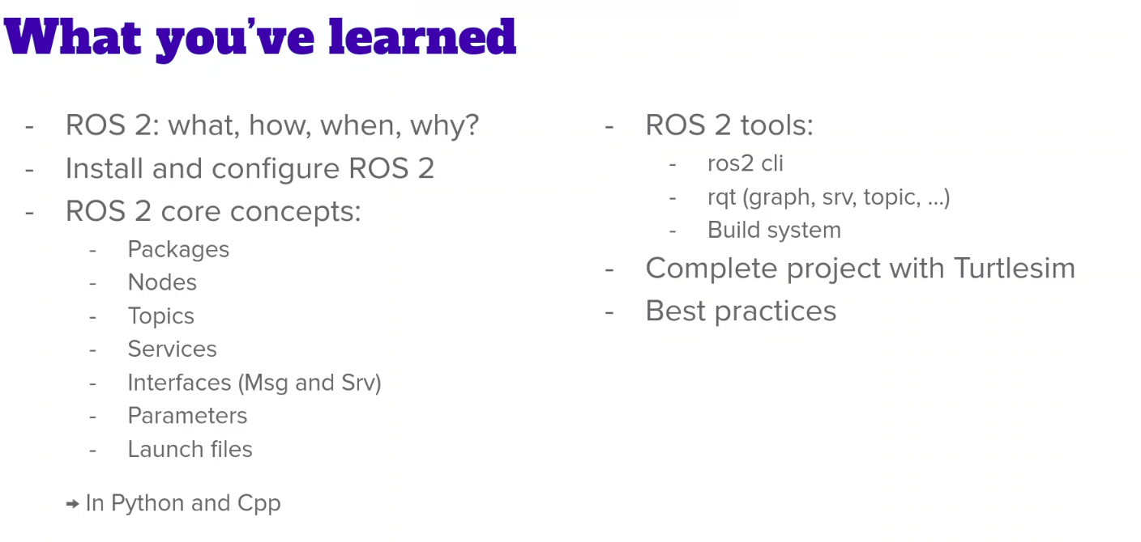

### 11.2 What to do next? How to learn more about ROS 2?

**What to do next? How to learn more about ROS 2?**

Your ROS 2 journey is only beginning.

You now have strong basics to start almost any project, but there’s still so much to learn!

**So, what to do next?**

The number 1 thing I recommend is to find yourself a project to work on. Either at work, at school, or at home, your goal should be to develop your own robot application.

Of course, developing a complex robot could be expensive when you think about all the hardware and mechanical stuff you need to buy and assemble (and also the time it would take to design and assemble!).

What’s great with ROS 2 is that you also get many simulation tools. You can leverage those tools to develop a complete robot application, without having to work with a real robot.

**Official ROS 2 websites**

This set of resources will help you go further, and help you when you’re stuck with a problem.

* [**ROS 2 Docs**](https://docs.ros.org/): the official ROS 2 documentation.
* [**Robotics StackExchange**](https://robotics.stackexchange.com/): if something is not working, or you don’t know how to solve a specific problem: ask your question on the Robotics StackExchange, which is a Q&A website. Also, you’ll see that when you google some questions you’ll often find the response on this website.
* [**ROS Discourse**](https://discourse.ros.org/): this forums website is useful to keep you updated about the latest developments and discussions about ROS 2. Over time it may help you get an even bigger picture, taking the community aspect into the equation. This is also a place where you can interact with others and introduce your own ROS 2 project!

### 11.3 Bonus Lecture

**Bonus Lecture**

One more time, congratulations for finishing the course! I really hope you could learn something valuable for your future personal or professional projects.

**ROS 2 Book**

* [**ROS 2 from Scratch**](https://rbcknd.com/ros2-book): almost 400 pages on ROS 2. If you want to learn both from video courses and written tutorials, this is the perfect combo for you. This book contains additional insights, examples, and practical exercises that are not included in the video courses.

**Free Resources**

For more free tutorials, check out my online resources:

* [**Robotics Back-End tutorials website**](https://roboticsbackend.com/)
* [**Robotics Back-End Youtube channel**](https://www.youtube.com/c/RoboticsBackEnd)

**More Courses From Me**

If you want to continue to learn with me on Udemy, here is a list of my other courses.

Right after this ROS2 course, I would suggest:

* [**ROS2 For Beginners Level 2**](https://www.udemy.com/course/ros2-tf-urdf-rviz-gazebo/?referralCode=295EEB9799E3BE2D6AA0): the direct following, where you go further and learn how to design a custom robot with ROS2 (with TF, URDF, RViz), as well as a robotics simulation (Gazebo).
* [**ROS2 For Beginners Level 3**](https://www.udemy.com/course/ros2-advanced-core-concepts/?referralCode=3CF87D49B86684822960): to complete the course series, you will learn more advanced ROS2 concepts to take your robotics applications to the next level. Actions, Lifecycle Nodes, Executors, Components, and more.
* [**ROS2 Nav2 Stack**](https://www.udemy.com/course/ros2-nav2-stack/?referralCode=58EC3A074CC7C64A9046): after you’ve learned ROS2, the Navigation stack is a great next step, to know how to make mobile robots navigate autonomously.
* [**ros2_control**](https://www.udemy.com/course/ros2_control/?referralCode=119D1ACB38100D41DA8A): to learn how to bridge the gap between ROS 2 and real hardware.

Other ROS courses:

* [**ROS For Beginners**](https://www.udemy.com/course/ros-for-beginners/?referralCode=F41DAF6F3EA18F324DD7): if you are starting your ROS journey with ROS2, then you might also want to learn the version 1 of ROS. This can be useful if you need to interact with existing ROS applications. Currently most of the existing ROS code out there is based on ROS1. This is slowly evolving to ROS2, but you can still expect to see ROS1 code for a few more years from now.
* [**ROS Actions**](https://www.udemy.com/course/ros-actions/?referralCode=54D4AACE23FE2F5684FE): The following of the ROS beginner course. This will teach you a more advanced but super powerful communication: actions. Note that this course is focused on ROS1, not ROS2, but the concept applies to both versions - just the syntax and a few details are different.
* [**ROS2 For ROS1 Developers**](https://www.udemy.com/course/learn-ros2-as-a-ros1-developer-and-migrate-your-ros-projects/?referralCode=C4B12EA75756456A7D2B): You already know ROS2 after this course, but if you need to interact with both ROS1 and ROS2 code, this course is for you. Before you take this course, it’s better that you first learn the ROS1 basics, and then you will be able to compare ROS1 and ROS2 easily. You will also learn how to migrate a ROS1 code base into ROS2.

And other courses from me that you might like - depending on your interests:

* [**Raspberry Pi For Beginners**](https://www.udemy.com/course/raspberry-pi-for-beginners-step-by-step/?referralCode=9B81E4A156B54799FF16): this beginner course will teach you how to get started with a Raspberry Pi, through different projects. Raspberry Pi can also run ROS (not included in the course), so taking the course is a first great step if you want to develop robotics applications with embedded computers.
* [**Arduino For Beginners**](https://www.udemy.com/course/arduino-for-beginners-complete-course/?referralCode=43AB5E5AF5437D4A19B3): complete beginner course with many projects, to learn Arduino from scratch (programming, circuits, components, optimization, tools, projects, etc.)
* [**Getting Started with Arduino Programming**](https://www.udemy.com/course/arduino-programming-for-beginners/?referralCode=4E47D8F2D89017F83F7F): a beginner course centered on the programming side of Arduino (and thus shorter), if you just want to focus on programming.
* [**Arduino OOP**](https://www.udemy.com/course/arduino-oop/?referralCode=ED285E42FCC22C8DB36A): a great addition to your Arduino skill set. You will learn how to turn any Arduino code into OOP (Object Oriented Programming) code. Best to take if you already have a solid Arduino foundation, or after one of the Arduino beginner courses.
* [**Raspberry Pi and Arduino**](https://www.udemy.com/course/raspberry-pi-and-arduino/?referralCode=EFCF4EB5945B7D17F9FB): After you get the basics in Arduino and Raspberry Pi, this course is your next step. You will learn how to combine the 2 boards to create even more complete and complex projects.

If you feel the need of some more programming basics (small courses taught with a practical mindset):

* [**Python For Beginners**](https://www.udemy.com/course/practical-python-3/?referralCode=7F5E58FE89A78513B542)
* [**C++ For Beginners**](https://www.udemy.com/course/practical-cpp/?referralCode=3CE0E789F8D891A045D0)
* [**Linux Terminal For Beginners**](https://www.udemy.com/course/practical-linux-command-line/?referralCode=2FBF1DBB8B92A23103AD)

And if you feel you’re lacking programming fundamentals:

* [**Coding For Beginners**](https://www.udemy.com/course/the-complete-coding-for-beginners-course/?referralCode=304027A02474941D40AA): complete 16h course where you learn how to code from scratch. All the coding concepts are covered in a simplified way and you finish the course really understanding what you’re doing when you code.

See you in one (or more!) of my courses :)

Best wishes,

Edouard

# Certificate

Certificate no: UC-84e812a5-af5a-47a8-ab87-8e624e215557

Certificate url: [ude.my/UC-84e812a5-af5a-47a8-ab87-8e624e215557](http://ude.my/UC-84e812a5-af5a-47a8-ab87-8e624e215557)

Reference Number: 0004

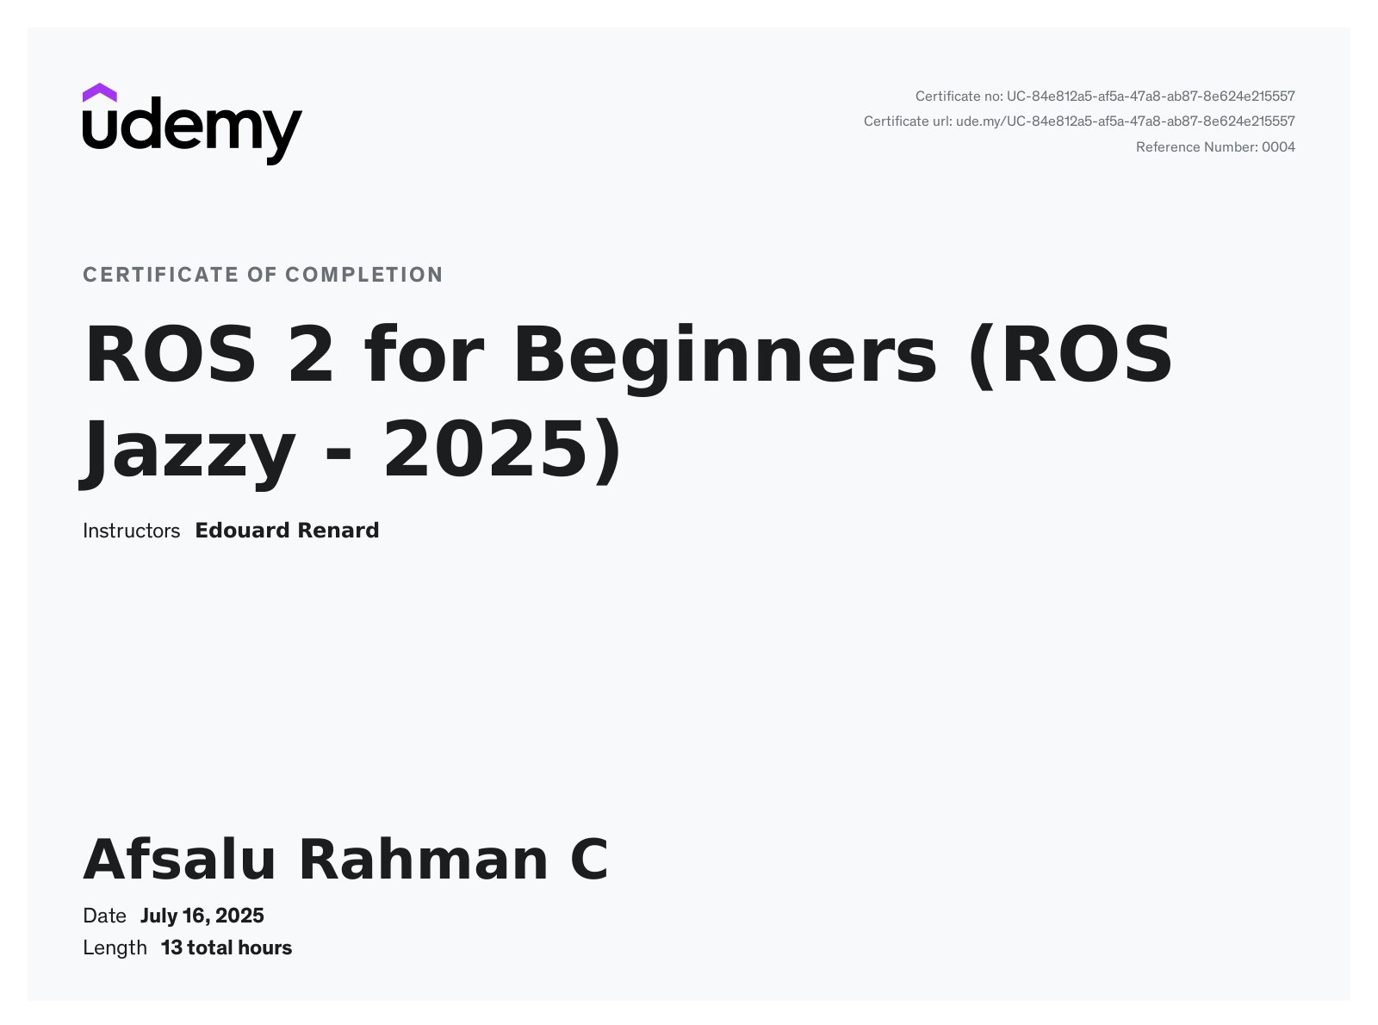

# 

# Section 7

### C++ vs Python Difference

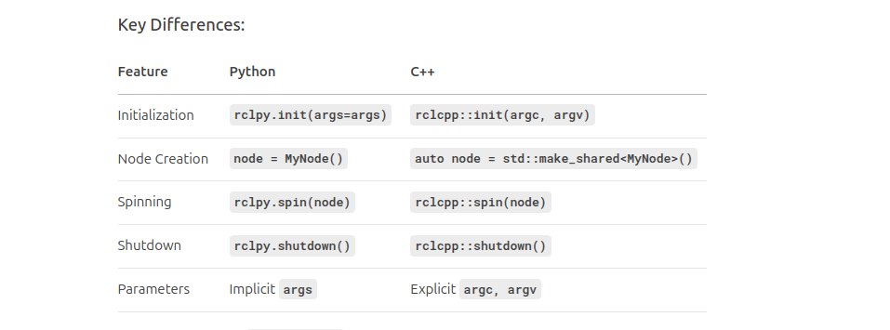

### Create a URDF for robot

##### simple box

<?xml version="1.0"?>

<robot name="my_robot">

<link name="base_link">

<visual>

<geometry>

<box size="0.6 0.4 0.2"/>

</geometry>

<origin xyz="0 0 0.1" rpy = "0 0 0"/>

</visual>

</link>

</robot>

*To run*

ros2 launch urdf_tutorial [display.launch.py](http://display.launch.py) model:=/home/afsalu-rahman-c/my_test_robot.urdf

##### Adding Color

<?xml version="1.0"?>

<robot name="my_robot">

<material name="blue">

<color rgba="0 0 0.5 1"/> <!-- 'a' is alpha which is transparency-->

</material>

<link name="base_link">

<visual>

<geometry>

<box size="0.6 0.4 0.2"/>

</geometry>

<origin xyz="0 0 0.1" rpy = "0 0 0"/> <!-- origin is the offset-->

<material name = "blue" />

</visual>

</link>

</robot>

#### Combine two links with a joint

###### Without joint

<?xml version="1.0"?>

<robot name="my_robot">

<material name="blue">

<color rgba="0 0 0.5 1"/> <!-- 'a' is alpha which is transparency-->

</material>

<material name="grey">

<color rgba="0.5 0.5 0.5 1" />

</material>

<link name="base_link">

<visual>

<geometry>

<box size="0.6 0.4 0.2"/>

</geometry>

<origin xyz="0 0 0.1" rpy = "0 0 0"/> <!-- origin is the offset-->

<material name = "blue" />

</visual>

</link>

<link name = "second_link">

<visual>

<geometry>

<cylinder radius="0.1" length="0.2"/>

</geometry>

<origin xyz="0 0 0" rpy="0 0 0"/>

<material name="grey" />

</visual>

</link>

</robot>

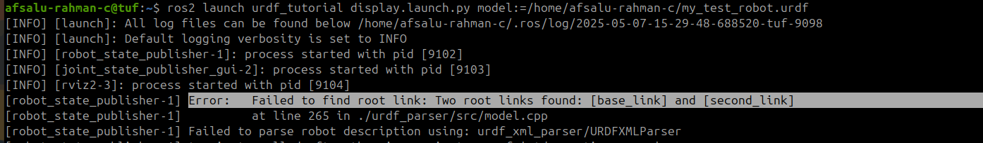

###### just ok

<?xml version="1.0"?>

<robot name="my_robot">

<material name="blue">

<color rgba="0 0 0.5 1"/> <!-- 'a' is alpha which is transparency-->

</material>

<material name="grey">

<color rgba="0.5 0.5 0.5 1" />

</material>

<link name="base_link">

<visual>

<geometry>

<box size="0.6 0.4 0.2"/>

</geometry>

<origin xyz="0 0 0.1" rpy = "0 0 0"/> <!-- origin is the offset-->

<material name = "blue" />

</visual>

</link>

<link name = "second_link">

<visual>

<geometry>

<cylinder radius="0.1" length="0.2"/>

</geometry>

<origin xyz="0 0 0.1" rpy="0 0 0"/>

<material name="grey" />

</visual>

</link>

<joint name="base_second_joint" type="fixed">

<parent link="base_link"/>

<child link="second_link"/>

<origin xyz = "0 0 0.2" rpy="0 0 0"/>

</joint>

</robot>

#### Another

<?xml version="1.0"?>

<robot name="my_robot">

<material name="blue">

<color rgba="0 0 0.5 1"/> <!-- 'a' is alpha which is transparency-->

</material>

<material name="grey">

<color rgba="0.5 0.5 0.5 1" />

</material>

<link name="base_link">

<visual>

<geometry>

<box size="0.6 0.4 0.2"/>

</geometry>

<origin xyz="0 0 0.1" rpy = "0 0 0"/> <!-- origin is the offset-->

<material name = "blue" />

</visual>

</link>

<link name="third_link">

<visual>

<geometry>

<box size="0.1 0.1 0.1"/>

</geometry>

<origin xyz="0 0 0" rpy = "0 0 0"/>

<material name = "blue" />

</visual>

</link>

<link name = "second_link">

<visual>

<geometry>

<cylinder radius="0.1" length="0.2"/>

</geometry>

<origin xyz="0 0 0.05" rpy="0 0 0"/>

<material name="grey" />

</visual>

</link>

<joint name="base_second_joint" type="fixed">

<parent link="base_link"/>

<child link="second_link"/>

<origin xyz = "0 0 0.2" rpy="0 0 0"/>

</joint>

<joint name="second_third_joint" type="fixed">

<parent link="second_link"/>

<child link="third_link"/>

<origin xyz = "0 0 0.2" rpy="0 0 0"/>

</joint>

</robot>

#### 

#### Different types of joint

Refer URDF xml (URDF for ROS1 and ROS2 are same)

#### color code

**Basic Colors:**

1. **Red** – 1 0 0 1
2. **Green** – 0 1 0 1
3. **Blue** – 0 0 1 1
4. **Yellow** – 1 1 0 1
5. **Cyan** – 0 1 1 1
6. **Magenta** – 1 0 1 1
7. **White** – 1 1 1 1
8. **Black** – 0 0 0 1

**Extended Colors:**

1. **Gray** – 0.5 0.5 0.5 1
2. **Orange** – 1 0.5 0 1
3. **Purple** – 0.5 0 0.5 1
4. **Pink** – 1 0.75 0.8 1
5. **Brown** – 0.6 0.4 0.2 1
6. **Lime** – 0.75 1 0 1
7. **Teal** – 0 0.5 0.5 1
8. **Olive** – 0.5 0.5 0 1
9. **Maroon** – 0.5 0 0 1
10. **Navy** – 0 0 0.5 1
11. **Gold** – 1 0.84 0 1
12. **Silver** – 0.75 0.75 0.75 1

**Notes:**

* **Format**: R G B A (Red, Green, Blue, Alpha).
* **Alpha (A)**: 1 = opaque, 0 = transparent.